SITE SURVEY - INDEPENDENT RADIO NEWS

1. Site Information

Location of Survey | SCC Ref No:322691
Company :IRN | To be Surveyed: 11/07/14 Time:13.00
Road : 24 28 Oval Road | Arranged with: Sue Coates
Town : London | Tel :0207 284 9816
County:Middx | Fax :
Postcode:NW1 7DT | E Mail:
Site contacts: | Building management contacts:
1 Name: Chief Pandya | 1 Name: :Chief Pandya
Dept:Building Manager | Dept: Building Manager
Ext: | Ext:
2 Name: | 2 Name:
Dept: | Dept:
Ext: | Ext:

2. Building Information - Landlord / Agent
(N.B. It is the responsibility of the site contacts to obtain Landlords or buildings permission for the dish.)

Company interest in premises? | Owned : |  | Leased :
 | Freehold : |  | Tenant :
Owner of Premises
Company : | Contact :
Telephone : | Fax :
Agent for Premises  Company :  Telephone : | Contact:  Fax :
Has consent been obtained? | Yes / No
Is further action required?  Details : | Yes / No

3. Satellite Details

Satellite: | Sirius II | Location: | 5° East

4. Local Authority Planning Permissions

Are accurate plans, elevations and ordinance survey plans available? |  | Yes / No
If Yes, obtain the relevant copies. If No, state reason and where they might be obtained from:
Reason:
Company :
Contact :
Address :
Telephone :
Fax :

Height of dish above ground level in metres ? |  |  | 25 metres
Is the proposed dish location in your opinion likely to cause problems with these local permissions? | Yes / No
If Yes, give details:

Local planning authority is:
Address:

Can the proposed dish location be viewed by adjacent, higher buildings? (N.B. This may affect the local permissions.) | Yes / No
Is the building listed:  Conservation area: | Yes / No  Yes / No
If Yes, give details:

5. Proposed Satellite Dish Location

Describe dish location:
(N.B. Not on front of building or detract, obstruct or interfere with windows, doors, logo's or signage etc.)

Dish to be mounted on the top floor plantroon on wall mount existing old dish may be removed if not new dish to go next to it

Is the full arc viewable from this position? | Yes / No
If No, draw/state obstructions and satellites affected:
Is there any possibility of future blockage caused by trees or future building works? Yes / No

If Yes, give details:

Specify best type of antenna mount for site:
Wall : Pole : NPR : | Cladding | Special :
Penetrating : Non-Penetrating :  Is structural survey required: | Yes / No
If special, give details and sketch a drawing of proposed special mount on the back of this form.

Detail building structure at dish position:
Brick Stone Concrete Asphalt | Cladding | Other:
Condition of above: GOOD
Is there easy access for equipment and blocks etc:  Detail if No : | Yes / No
Is a ladder required? | Yes / No
If Yes, state length required:

Scaffold : | Yes / No
Is any special equipment required?  If Yes, give details: | Yes / No
6. IF Cabling Requirements
(N.B. Line amps and cable joins cannot be used for service.)

Will wall penetration be required for the I.F. cable? Yes / No 11mm
(If Yes, give details of hole size, wall thickness and sealant required);

6TH Floor will need to be drilled to allow the cable into the 5th floor riser 11mm hole required None of the floors have fire stop and are open all the way down to ground.

( This must be pointed out to site contact and agree method proposed, or alternative access via ducts, conduits and risers etc )

Cable length required from dish to receiver location : 50 metres
(N.B. CT167 cable must be used)

Describe cable route and fixing methods from dish to the receiver :

The cable on the roof will be fixed to the building with French bolts round to entry point with AC pipes into building. Once in the building the wooden panel on 6th Floor kitchen will be removed and the cable pulled out into the kitchen area and then into the trunking (Existing) and round to the riser and a hole drilled between 6th and 5th floors (This to be done at 7am first thing)

Once in the riser all other floors have gaps between floors and the cable will be fixed to the existing cable tray.

On the ground floor the cable will exit the riser go above the false ceiling and across to behind reception. The false ceiling has panels that drop down to allow the cable to pass over but rods will be required.

Once behind reception the uplighters can be moved and you will see the Orange cat 6 cables which are the route to the rack in the comms room behind reception and have a rack in this location which may be the final location but the manager could not confirm this. If the rack is to be located in any other part of the office cable route will be above the false ceiling and the cable length will have to be confirmed from the proposed rack location to the confirmed location.

Fixings Required:

Clips Cable Ties Saddles Conduit Other:

Conduit amount required: mtrs Time to install hrs:

7. Receiver Location

Describe the Receiver location within the premises, including floor level and room identification:

Ground Floor final location TBC

Equipment to be installed: Tandberg Nokia PC Yes / No

Is there room for the Receiver: Yes / No PC Equipment: Yes / No

Installed to: Shelf Desk Equipment rack Cupboard Other:

Has the site representative agreed this location: Yes / No

Can system be networked from this location: Yes / No
(You must advise the site contact that it's their responsibility to make room to house the receiver and PC equipment).

Are there two mains power sockets available: Yes / No
(N.B. it is the responsibility of the site to arrange uninterrupted mains power sockets).

Comments:

Nearby telephone sockets: Yes / No Trunking required: Yes / No

Is this room locked: Yes / No Key holder is:

Access / Trunking comments:

8. General

Was full access made available to complete the survey: |  | Yes / No
If No, give details:
Can the installation proceed immediately? |  | Yes / No
If No, give details:

Indicate the hours installation services can be performed:

Monday - Fri | 7.AM |  | 6PM
Saturday - Sunday | AM |  | PM
Indicate any access or security restrictions:  Parking arrangements required:  ( if yes details) |  | Yes / No METERS OUT FRONT
Estimate the number of hours to complete installation: | 8 | Hrs

Use this for relevant notes:

Will need to connect to lightning field 3m tape required Square Joiner and bracket to mount to dish 5 clips

9. Sketches (N.B. The following sketches are to drawn to a high standard at the time of the site survey.)

An aerial view of building showing the proposed dish position, existing dishes their size and service, direction of south, adjacent roads, cable routes and distances in metres.

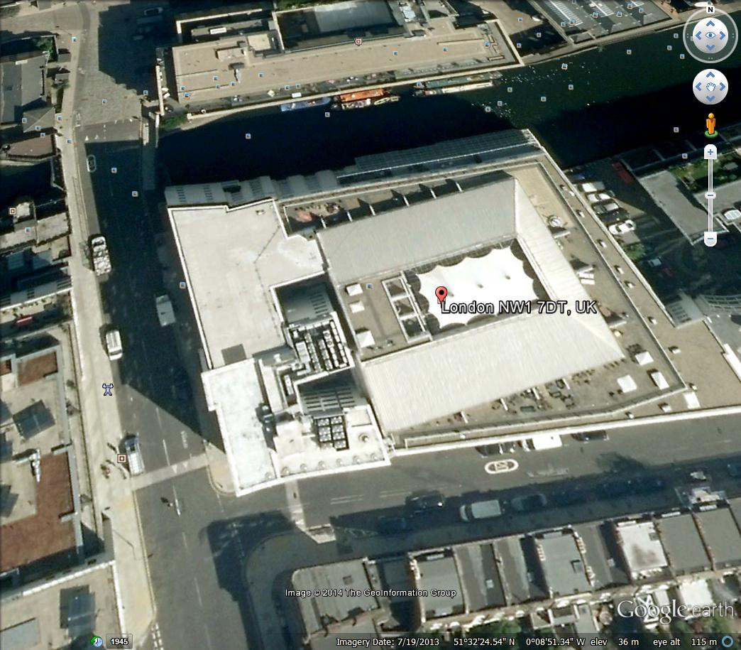
Dish Location on plant room wall LOS 5 East ladder from 6th floor to roof from internal

CDM OVERVIEW AND RISK ASSESSMENT
Nature of Works: IRN FULL INSTALL |  |  |  |  |  |  | Small Business: G |  |  | New Estates: G
 |  |  |  |  |  |  | Major Business: G |  |  | Special Projects: G
Can the above Project Be Managed from the Generic File of the Principal Contractor?
Yes: G |  |  |  |  |  |  | No: G |  |  | N/A: G
Can the above Project Be Managed from the Generic File of the Principal Contractor with Attached Specific Risks?
Yes: G |  |  |  |  |  |  | No: G |  |  | N/A: G
Does above Project Need a Specific CDM File to Be Created? If Yes, CDM File to Be Created Before the Job Is Issued.
Yes: G |  |  |  |  |  |  | No: G |  |  | N/A: G
Pre-construction Consultation: |  |  |  |  |  |  | Date: |  |  | Authorised By:
Return of Risk Assessments (if req.) |  |  |  |  |  |  | Date: |  |  | Authorised By:
Authorisation Certificate Issued: |  |  |  |  |  |  | Date: |  |  | Authorised By:
CDM RISK ASSESSMENTS
No. |  | Activity, Process, Material |  |  |  |  | Hazard |  | Initial Rating | Actions Taken by Designer to Reduce Risk Rating |  | Final Rating
1
2
3
4
 |  | Severity |  |  |  | RISK RATING KEY
 |  | L | M | H |  | Severity |  | Likelihood |  |  | Risk Rating
Likelihood | H | 2 | 3 | 3 |  | L = Other Injury or Illness |  | L = Very Seldom or Never |  |  | 1 = Low Risk  No Action Required
Likelihood | M | 1 | 2 | 3 |  | M = Injury or Illness Causing Short Term Disability |  | M = Reasonably Likely |  |  | 2 = Medium Risk - Action Req Unless Good Reason
Likelihood | L | 1 | 1 | 2 |  | H = Fatality/major Injury Causing Long Term Disability |  | H = Certain or near Certain |  |  | 3 = High Risk  Action Required

10. Photographs

The following photographs must be taken at site and submitted with the survey:
(N.B. Without these photographs, the survey will not be considered complete.)

Two different elevations of the building. | The dish location.
The property in relation to the surrounding area. | Any existing dishes.
The external cable entry point. | A view from the dish looking south at eye level.
Proposed receiver location.
( When the photographs are developed please indicate all dish positions, cable runs etc, by drawing on photocopies of the photo’s)

11. Non-essential Extras

Give details of other Non-essential extras / reasons to prevent installation if any :

12. Survey Sign-Off form.
(N.B. This sign off form must be signed by both the customer and survey engineer.)

Survey engineer:

Name :Paul Tompkins Signature :

Date : 11/07/2014

I hereby declare that I have read, understand and accept the details identified in this Survey, by signing this form I authorise SCC International and SMS to order Equipment and proceed with the Standard installation.

I confirm that I am an authorised signatory.

Customer Authorised Signatory

Name : Signature :

Date : Position :

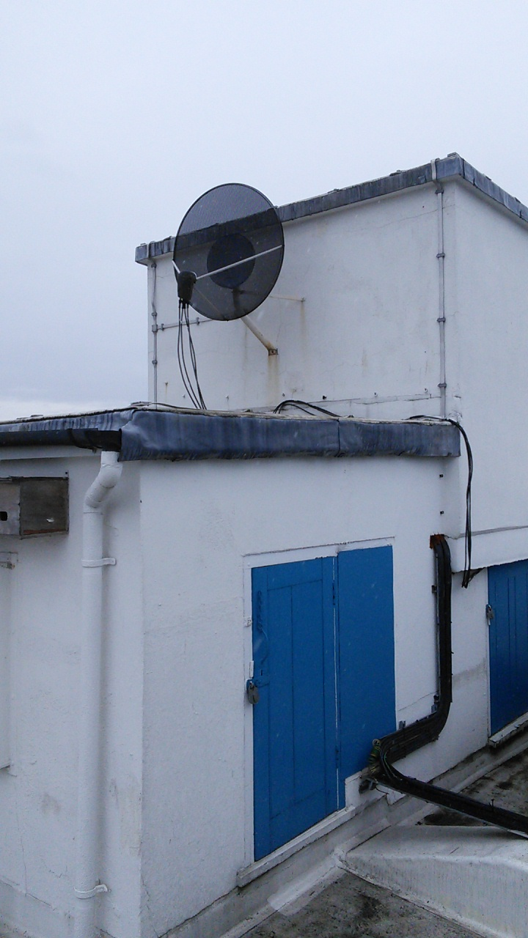
Existing dish maybe removed New location if dish stays Cable route
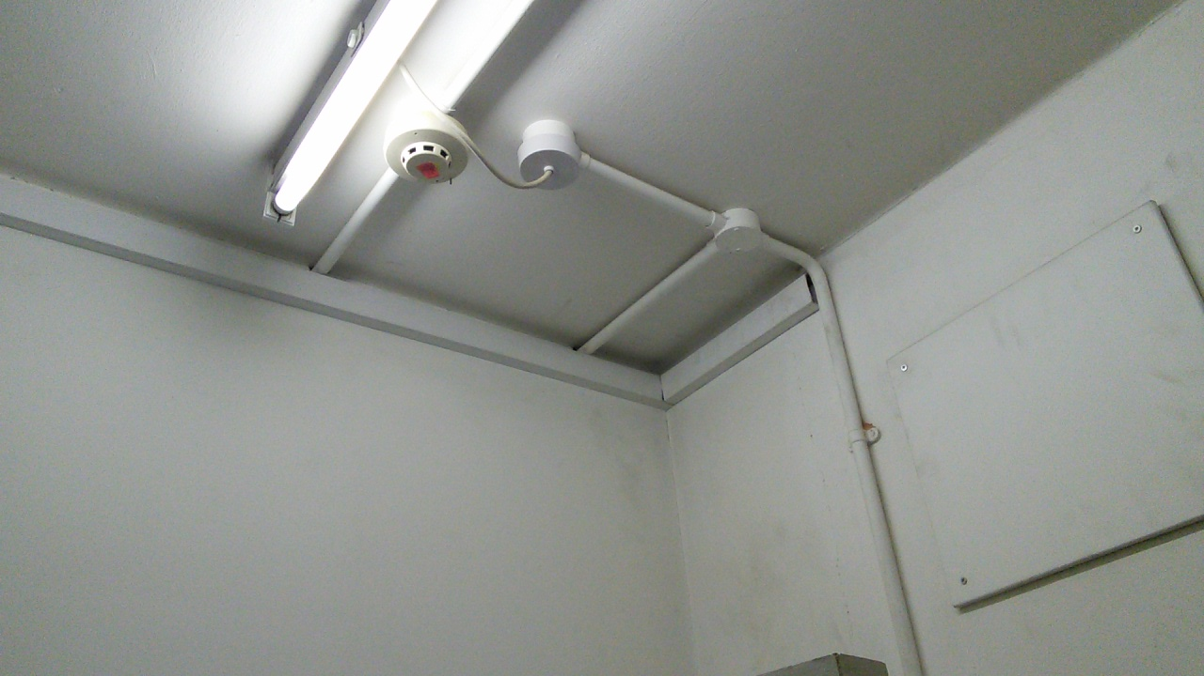
Internal entry point remove panel and then drill into riser from trunking run cable in trunking to riser

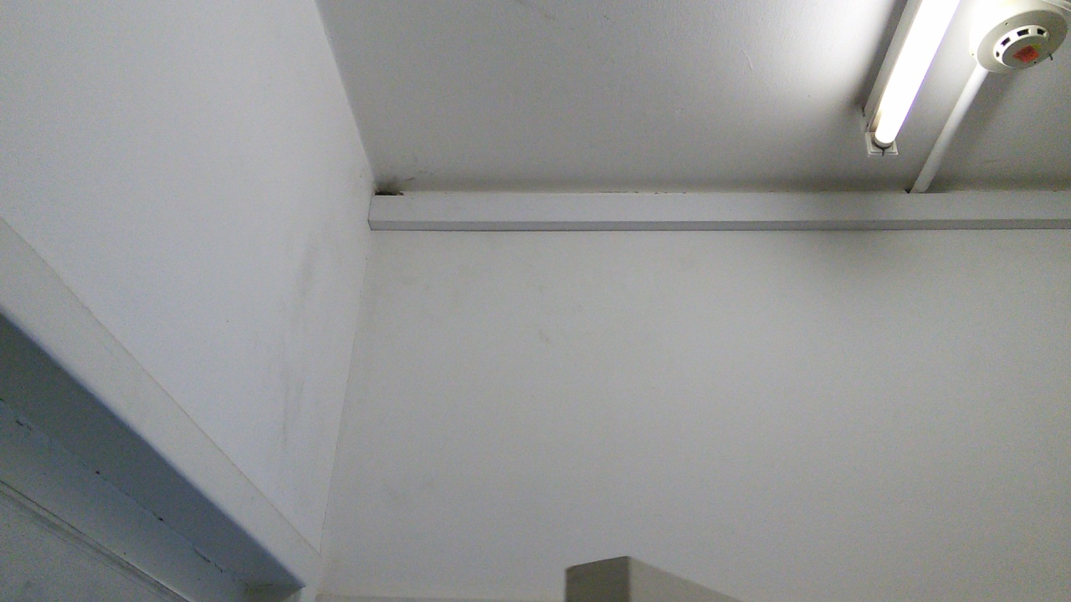
Trunking into riser

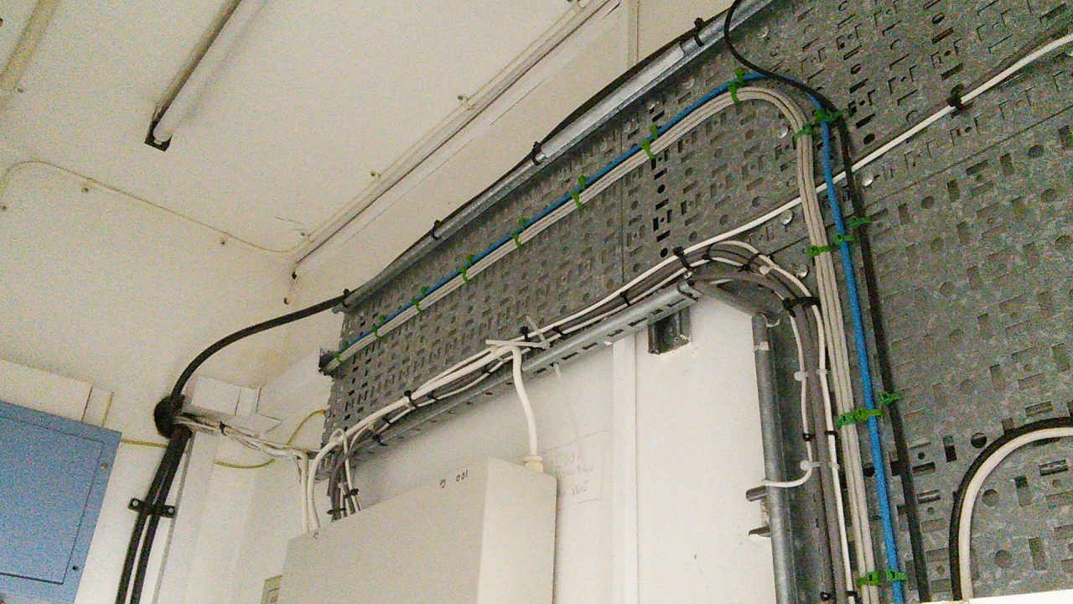
Entry point into 6th floor riser and cable tray route

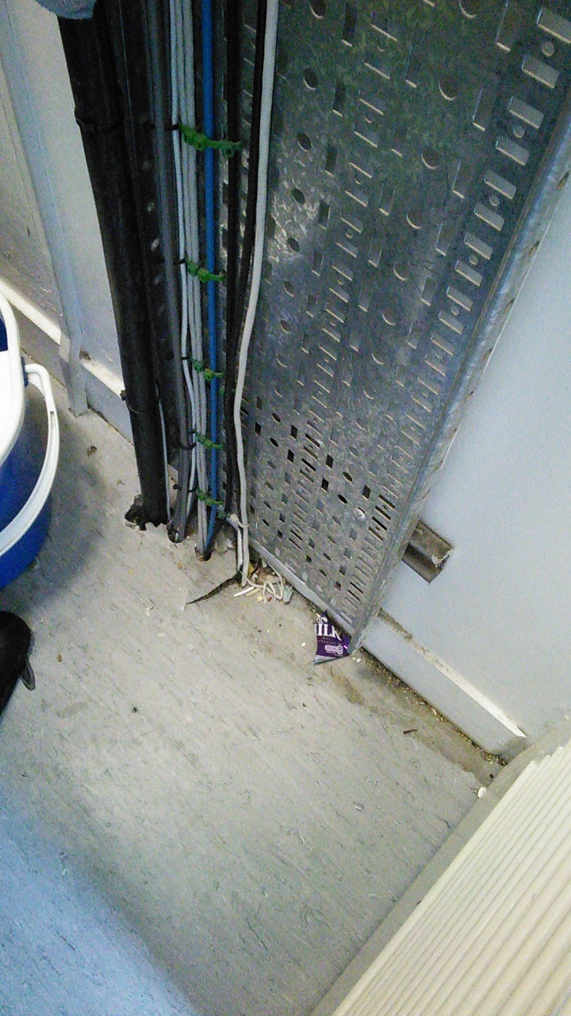
This location may require one hole drilled but all other floors are OK
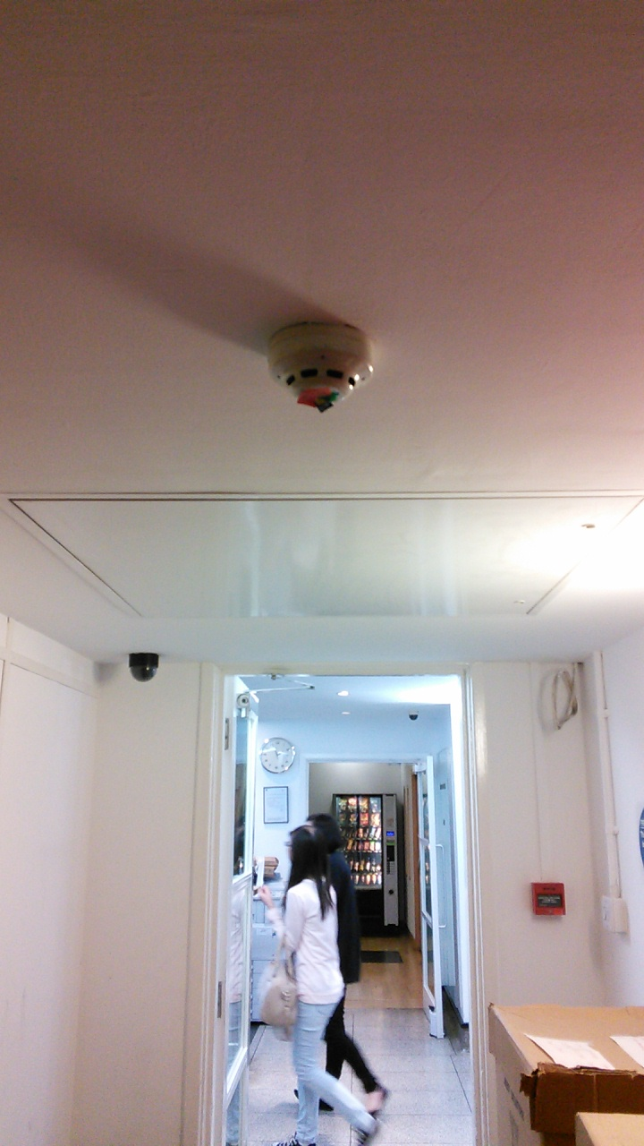
Ground floor route above ceiling and drop down panels

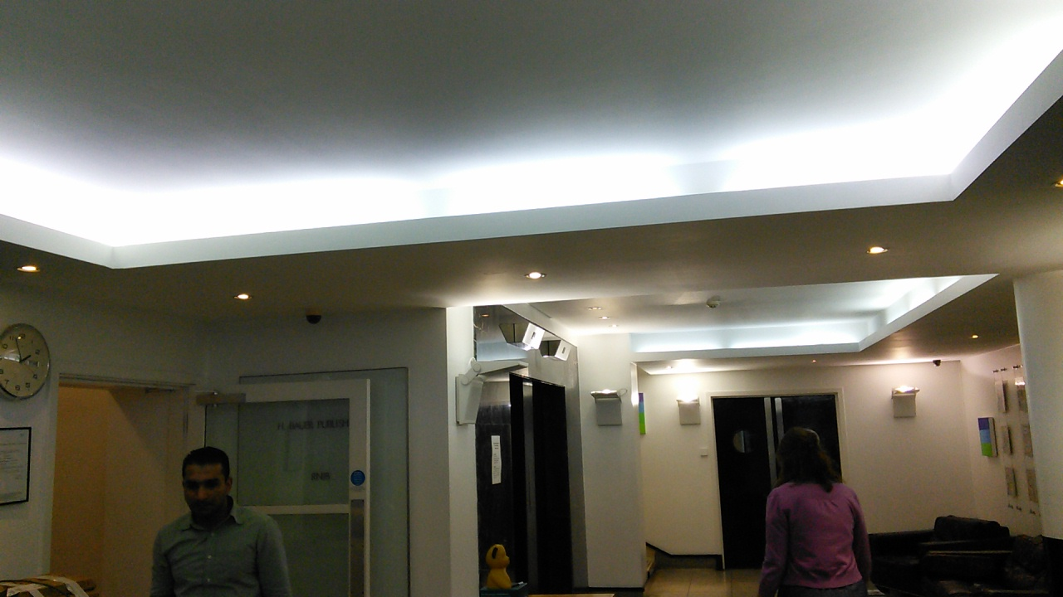

Cable route in lighting well above reception
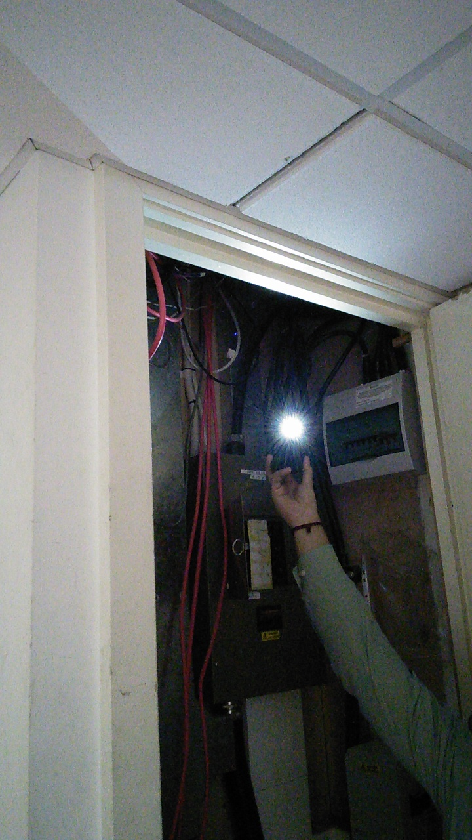
Riser in office behind reception and then above false ceiling

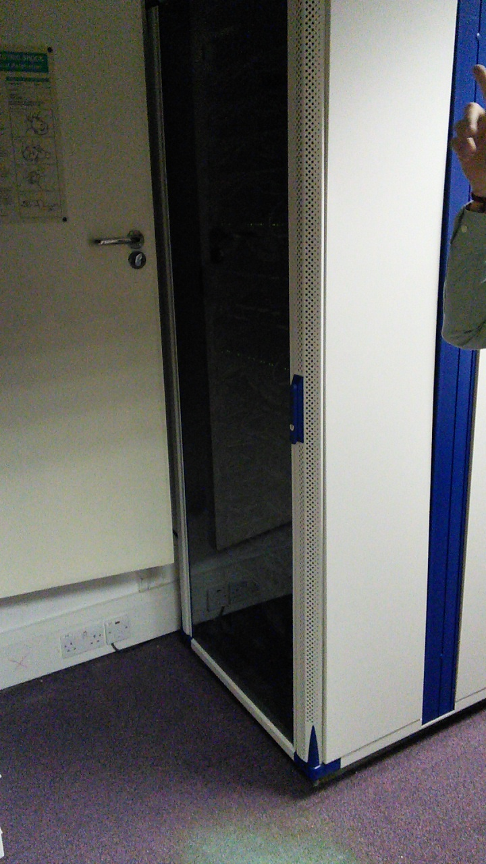
Rack that may be used
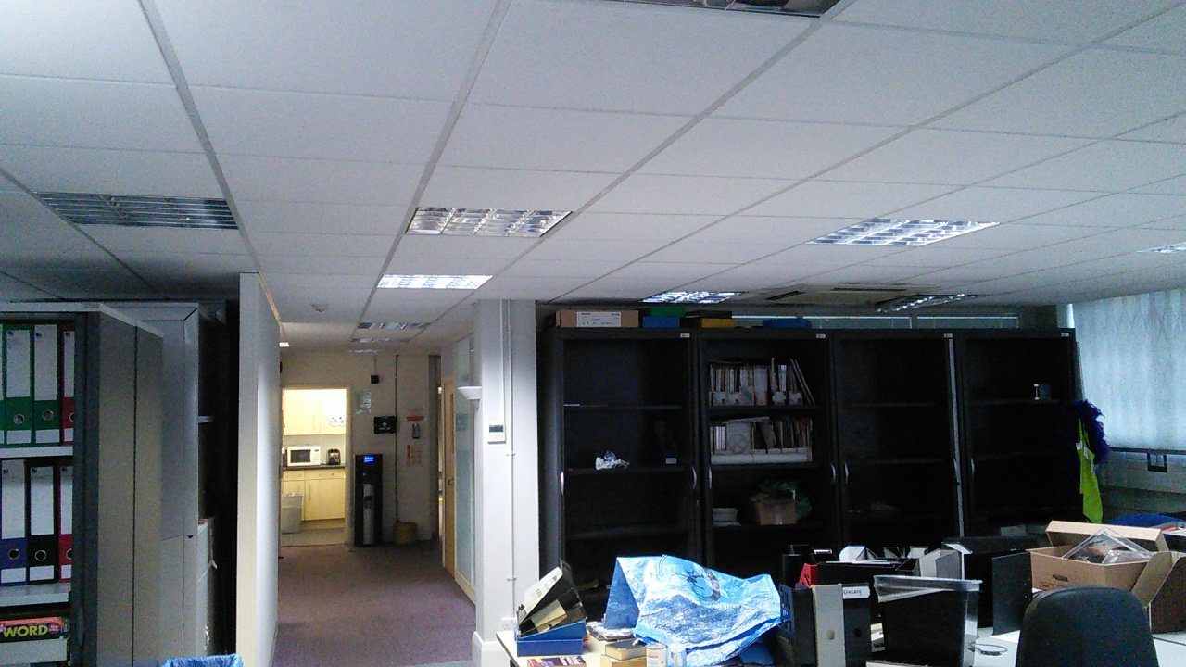
Office area at the moment looking back to reception

Contacts: Rob Wickings / Steve Jones
SCC International, 1 Fieldings Road, Cheshunt, Herts. EN8 9TL.
Tel 01992 642255 Fax 01992 641655 e-mail stevejones@sccico.uk

