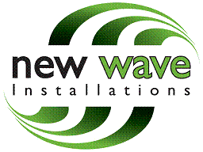

Camden Council
Development management
Camden Town Hall Extension
Argyle Street
London
WC1h 8EQ

New Wave Installations, Hope Street
Rotherham, S60 1LH
Tel: 01709 821 757

25/07/2014

Dear Sir / Madam

Ref: Pizza B Ltd. 53 Camden High Street, Camden, London, NW1 7JH
Our Ref: E011802 Planning Portal Ref: PP-03454739

We wish to apply for planning permission at the above site where we have to installed an ATM & ILLUMINATED SIGN. We are enclosing a planning application for this installation.

The cheque for the fee £305.00 for the FULL PLANNING and ADVERTISEMENT CONSENT will be posted today.

We look forward to receiving written confirmation of the registration of this application together with a receipt for the statutory fee.

I trust the above is satisfactory, however if you require any further information please do not hesitate to contact me.

Yours sincerely,

Amy Powell
Planning Coordinator
NewWave Installations Ltd

