Design & Access Statement
E011802 – Pizza B Ltd, 53 Camden High Street, Camden, London, NW1 7JN

This Design and Access Statement has been prepared on behalf of Cashzone in support of an application submitted for:
The retention of an Automated Teller Machine and Illuminated sign.

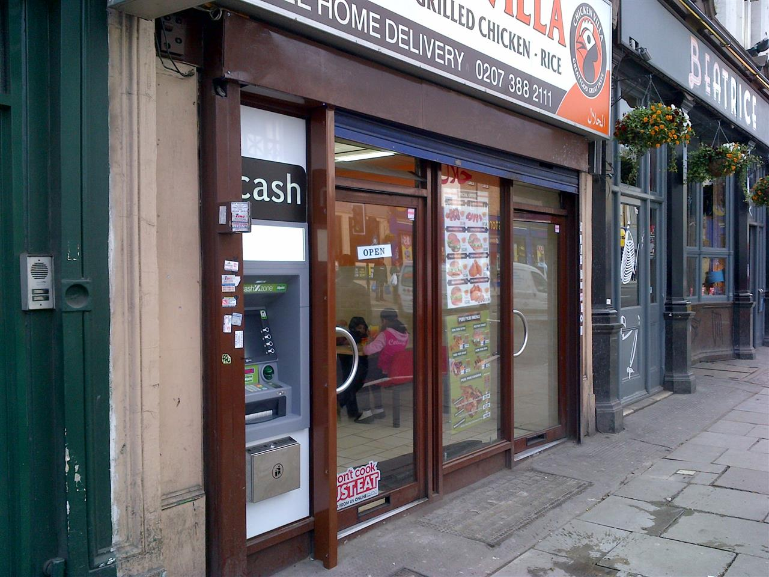

Appearance

The site is located through the left hand window of a food takeaway on Camden High Street. The ATM is positioned through the window to the left of the customer entrance, the window of which has no special historical or architectural features. The immediate area is primarily commercial, with flats and offices above the high street shops, but we consider that the installation of an ATM at this location would not be detrimental to them.

Use

The purpose of the installation of this Automated Teller Machine is to provide a 24 hour banking facility for the local community and visitors to the area.

Scale

N/A

Layout

The installation of the ATM has not altered the basic design of the building.
We have removed an existing glazing panel. In the remaining void we have installed (a new mullion and smaller glazing panel) an external security wall (see NW0207 External security wall construction in attachments) with a laminate finish. The colour of this panel is white and was chosen to best blend with the existing shop front design. An aperture was formed in this for the ATM face.
We consider that this would not be detrimental to the existing street scene.

Amount

This is not a new structure, but the installation of an ATM in an existing shop.

Landscaping

This is not relevant as the installation does not require it.

Design Principals

The ATM is of standard design as located in many areas throughout the UK and is accepted as a necessary facility. There are a number of mandatory standards which apply, relating to the position of the ATM, it’s visibility, ambient lighting, building structure, building security features, ATM anchoring, safe strength.

Designing out Crime

We install and anchor the ATMs in accordance with National Guidelines.

Site approval by the Cash In Transit Company has been obtained. They have considered routes to and from the ATM, ensuring there is protection of their staff and of any staff or customers at the site. Paramount in their review has been the welfare of their staff and the persons they come into contact with.

The area where the ATM has been installed is a well-lit open area in full view of pedestrians aiding natural surveillance.

Access

The access to the site and other properties has not been affected.

In designing this application, we have taken into account the needs of able and disabled users. The ATM is set at a height that makes it accessible for all users and has space to the front for a wheel chair.
Key 5 has raised markings for blind persons to identify the centre key.

Car parking availability has been considered:

