Mr Brendan Robinson
11 Belsize Terrace
Hampstead
London
NW3 4AX
11 Belsize Terrace  Hampstead  London  NW3 4AX |  | Application Ref: 2014/3227/P
 |  | Please ask for: Niall Sheehan
 |  | Telephone: 020 7974 3968
 |  | 24 July 2014

Dear Sir/Madam

DECISION

Town and Country Planning Act 1990 (as amended)

Full Planning Permission Granted

Address:
Basement and ground floor
56 Belsize Lane
London
NW3 5AR

Proposal:
Change of use of part ground and the basement floors from shop (Class A1) to veterinary surgery (sui-generis)
Drawing Nos: Existing: 1 Basement Floor Plans-1B(dated 09/05/14), 2 Ground Floor Plans-1A(dated 09/05/14).
Proposed: 1 OS Site Plan(dated 09/05/14), 2 Proposed Basement Floor Plan-2B(dated 09/05/14), 3 Proposed Ground Floor, New Build Shop Layout (dated 18/06/14).

The Council has considered your application and decided to grant permission subject to the following condition(s):

Condition(s) and Reason(s):

1 | The development hereby permitted must be begun not later than the end of three years from the date of this permission.  Reason: In order to comply with the provisions of Section 91 of the Town and Country Planning Act 1990 (as amended).
2 | The development hereby permitted shall be carried out in accordance with the following approved plans  Proposed: 1 OS Site Plan(dated 09/05/14), 2 Proposed Basement Floor Plan-2B(dated 09/05/14), 3 Proposed Ground Floor, New Build Shop Layout (dated 18/06/14).  Reason:  For the avoidance of doubt and in the interest of proper planning.
3 | This permission is personal to Mr.Brendan Robinson and shall endure for the period of their occupation only. On Mr.Brendan Robinson vacating the premises the use of the entire ground and basement floors shall revert to A1 retail.  Reason: In recognition of the special circumstances of the applicant and to accord with the London Borough of Camden Local Development Framework Core Strategy, the London Borough of Camden Local Development Framework Development Policies and Camden Planning Guidance 5.

Informative(s):

Your proposals may be subject to control under the Building Regulations and/or the London Buildings Acts which cover aspects including fire and emergency escape, access and facilities for people with disabilities and sound insulation between dwellings. You are advised to consult the Council's Building Control Service, Camden Town Hall, Argyle Street WC1H 8EQ, (tel: 020-7974 6941).

Noise from demolition and construction works is subject to control under the Control of Pollution Act 1974. You must carry out any building works that can be heard at the boundary of the site only between 08.00 and 18.00 hours Monday to Friday and 08.00 to 13.00 on Saturday and not at all on Sundays and Public Holidays. You are advised to consult the Council's Compliance and Enforcement team [Regulatory Services], Camden Town Hall, Argyle Street, WC1H 8EQ (Tel. No. 020 7974 4444 or on the website http://www.camden.gov.uk/ccm/content/contacts/council-contacts/environment/contact-the-environmental-health-team.en or seek prior approval under Section 61 of the Act if you anticipate any difficulty in carrying out construction other than within the hours stated above.

In dealing with the application, the Council has sought to work with the applicant in a positive and proactive way in accordance with paragraphs 186 and 187 of the National Planning Policy Framework.

You can find advice about your rights of appeal at:

http://www.planningportal.gov.uk/planning/appeals/guidance/guidancecontent

Yours faithfully
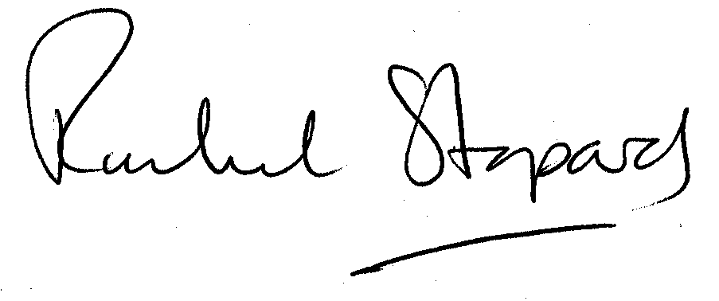
Rachel Stopard
Director of Culture & Environment

