Mr. Ed Britton |  |  |   Regeneration and Planning  Development Management  London Borough of Camden  Town Hall  Judd Street  London  WC1H 8ND  Tel 020 7974 4444  Textlink 020 7974 6866  planning@camden.gov.uk  www.camden.gov.uk/planning
GL Hearn
280 High Holburn
London
WC1V 7EE
280 High Holburn  London  WC1V 7EE |  | Application Ref: 2014/4584/A
 |  | Please ask for: Jenna Litherland
 |  | Telephone: 020 7974 3070
 |  | 25 July 2014

Dear Sir/Madam

DECISION

Town and Country Planning Act 1990

Advertisement Consent Granted

Address:
O2 Centre
255 Finchley Road
London
NW3 6LU

Proposal:
Display of 5 x non-illuminated banner signs on the columns of the Finchley Road elevation, 4 x non-illuminated banner signs on the columns of the car park elevation, and 42 x non-illuminated dual banner sign on the existing lamp post in the car park.

Drawing Nos: Site location plan; document entitled 'O2 Shopping Centre, London, NW3 - External banner signs - Application for Advertisement Consent' by AIR design dated 20 May 2014

The Council has considered your application and decided to grant consent subject to the following condition(s):

Conditions and Reasons:

1 | No advertisement is to be displayed without the permission of the owner of the site or any other person with an interest in the site entitled to grant permission.  Reason: - As required by regulation 2(1) and Schedule 2 of the Town & Country Planning (Control of Advertisements) (England) Regulations 2007.
2 | No advertisement shall be sited or displayed so as to  (a) endanger persons using any highway, railway, waterway, dock, harbour or aerodrome (civil or military);  (b) obscure, or hinder the ready interpretation of any traffic sign, railway signal or aid to navigation by water or air; or  (c) hinder the operation of any device used for the purpose of security or surveillance or for measuring the speed of any vehicle  Reason: - As required by regulation 2(1) and Schedule 2 of the Town & Country Planning (Control of Advertisements) (England) Regulations 2007.
3 | Any advertisement displayed and any site used for the display of advertisements, shall be maintained in a condition that does not impair the visual amenity of the site.  Reason: - As required by regulation 2(1) and Schedule 2 of the Town & Country Planning (Control of Advertisements) (England) Regulations 2007.
4 | Any structure or hoarding erected or used principally for the purpose of displaying advertisements shall be maintained in a safe condition.  Reason: - As required by regulation 2(1) and Schedule 2 of the Town & Country Planning (Control of Advertisements) (England) Regulations 2007.
5 | Where an advertisement is required under these Regulations to be removed, the site shall be left in a condition that does not endanger the public or impair visual amenity.  Reason: - As required by regulation 2(1) and Schedule 2 of the Town & Country Planning (Control of Advertisements) (England) Regulations 2007.

Informative(s):

Reason for granting advertisement consent:

The proposed banner advertisements are considered appropriate in terms of size, design, number and location. Paragraph 8.7 of CPG1 states that advertisements will generally only be acceptable at ground floor level or below, however given the context of the site and the design and scale of the building, it is not considered the sign will appear visually obtrusive. The advertisement will have a consistent design 'language' across the site which is welcomed. The proposal will not impact on neighbour amenity nor would it be harmful to either pedestrian or vehicular safety.

The planning history of the site has been taken into account when coming to this decision.

As such, the proposed development is in general accordance with policies CS5, CS14 and CS17 of the London Borough of Camden Local Development Framework Core Strategy, and policies DP24 and DP26 of the London Borough of Camden Local Development Framework Development Policies. The proposed development also accords with policies 7.4 and 7.6 of the London Plan 2011; and paragraphs 14, 17, 56 -67 of the National Planning Policy Framework.

In dealing with the application, the Council has sought to work with the applicant in a positive and proactive way in accordance with paragraphs 186 and 187 of the National Planning Policy Framework.

You can find advice in regard to your rights of appeal at:
http://www.planningportal.gov.uk/planning/appeals/guidance/guidancecontent

Yours faithfully
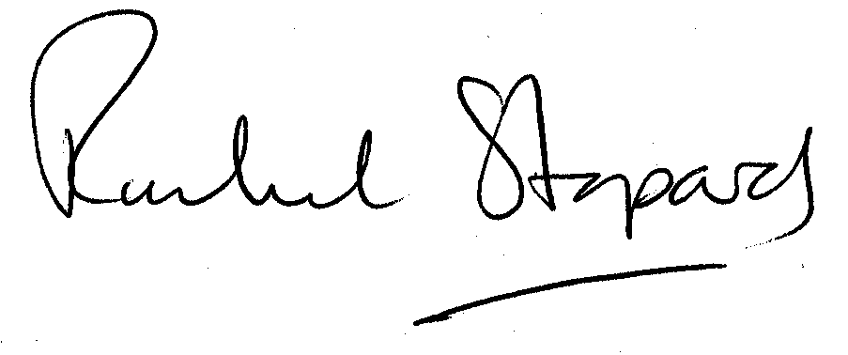
Rachel Stopard
Director of Culture & Environment

