Objection to Application 2014/4321/P
Bruges Place, 15 - 20 Baynes Street NW1 0TF

The site, Bruges Place, is located directly adjacent to Camden Broadway Conservation Area with its entrances on Randolph Street and Baynes Street. The map below shows the boundaries of the conservation area, and highlights the site in red.

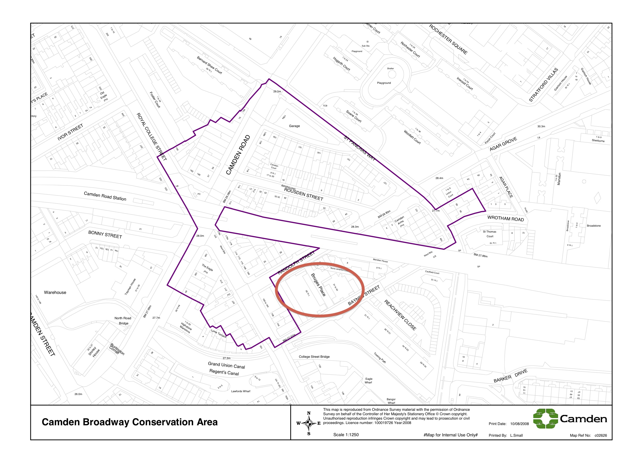

1. Impact of amendments to Bruges Place on the site itself
Purpose-built in 1987-9 by Jestico & Whiles, it has featured in publications such as "The buildings of England" (London 4: North by Bridget Cherry and Nikolaus Pevsner), "Industry in the City" (Witherford Watson Mann for Design for London), AJ (15/7/87), B, Housing Design Awards 1989, and "The RIBA Book of British Housing: 1900 to the present day" as a positive example of vertically mixed business and residential uses:

"Bruges Place demonstrates that light industrial uses and housing can be combined, provided access to both is carefully organised. The former Second World War bombsite was zoned by the planners for industrial use even though it was surrounded by housing. They preferred two-storey industrial development but the architects successfully argued that the urban grain of the area dictated the development should be of mixed use and four storeys in height." (The RIBA Book of British Housing: 1900 to the present day, p.64)

The irreversible change of such a valuable precedent into the exact opposite of what it was designed for would be a big loss to the area, both architecturally and characterisically. The whole design and layout of the site is founded on the principle of mixing 2 levels of business use with residential on top. The architects carefully seperated entrances, so that the business units could function well whilst maintaining ana ppropriate domestic and welcoming point of arrival for the ersidents. Converting one of these office levels to residential would render it inappropriate and poor quality for its new purpose.

2. Impact of loss of commercial space on Randolph Street/ Baynes Street
"The Camden Broadway Conservation Area is a small area comprising a mix of commercial and residential uses." (p.5, Camden Broadway Area Appraisal and Management Strategy)

The location of the commercial uses mentioned above is not limited to the main roads lining the Conservation Area boundaries (Camden Road , St Pancras Way and Royal College Street). A key characteristic of this area is the presence of small, independant businesses, existing alongside the quiet residential C19 neighbourhood layout.

Whilst just outside the area's boundary, Bruges Place forms an important part of this character. The loss of a significant number of small office units, such as Bruges Place, directly adjacent to the Conservation Area, would have a negative impact on the character of our Conservation Area. This needs to be seen in connection with the loss of another large commercial site at 79 Camden Road / 86-100 St Pancras Way, which the council approved on 20th March for change to 100% residential.

As the mix of business and resindetial uses form a big part of Camden Broadway's character, it is in the interest of the CAAC to protect them, and we object to the change of use of yet more commercial spaces into residential.

3. Need for residential amenities
A large number of residential units are currently in the process of being created (ranging from near completion to planning application stage) in close proximity to Camden Broadway Conservation Area:

27 units at Bruges Place, 15-20 Baynes Street
54 units at Shirley House, 25-27 Camden Road (decision pending)
54 units at Twyman House, 31-39 Camden Road (almost complete)
164 units at 79 Camden Road / 86-100 St Pancras Way (approved)
244 additional units at Agar Grove Estate (approved)
170 units at Hawley Wharf (approved)

It is unclear how residential amenities such as schools and doctors will be provided for the new residents of these 713 new flats and houses, in an area that is experiencing ever-decreasing primary school intake distances as well as the closure of one GP surgery.

