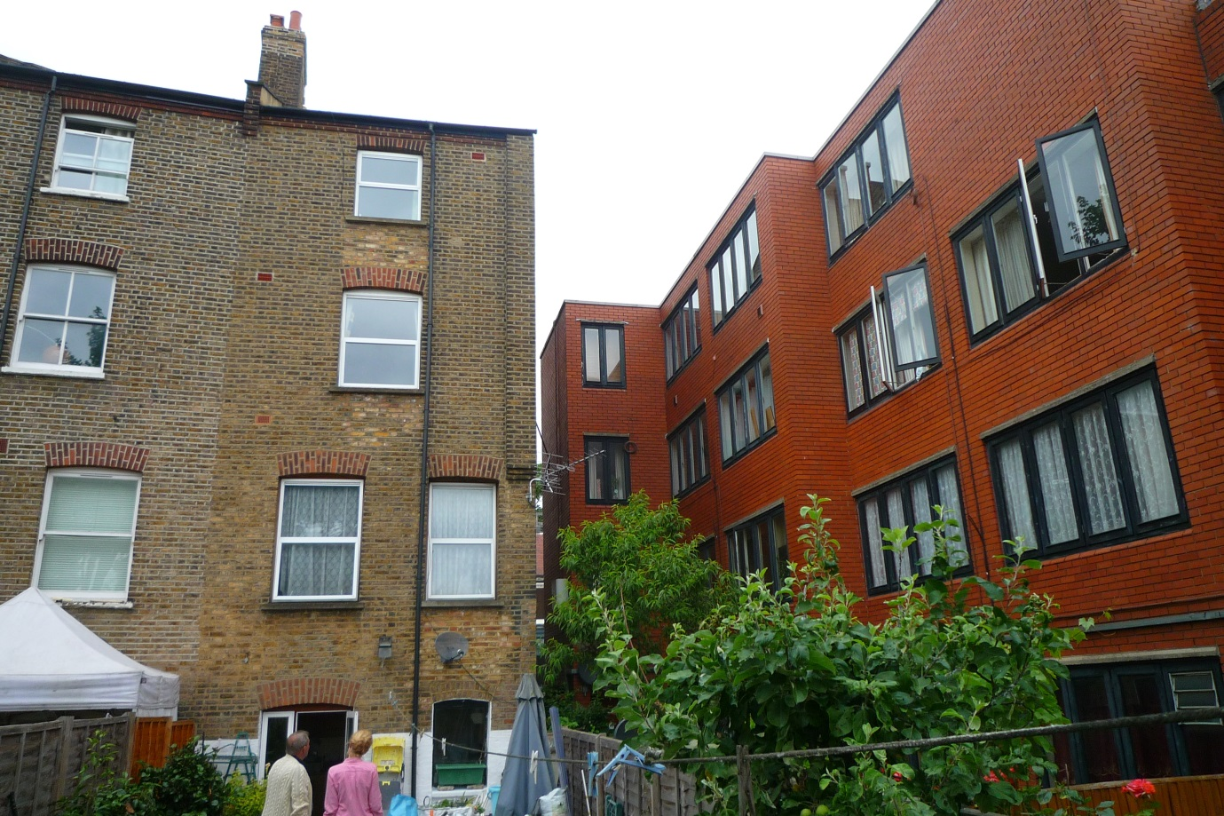

PLANNING APPLICATION FOR A DORMER TO THE REAR OF 124a MILL LANE

App Ref 2014/5412

SUPPORTING DOCUMENT

REAR GARDEN AND NEIGHBOURING PROPERTY