HERITAGE STATEMENT
2 Lansdowne Terrace, London, WC1N 1AS

Evidence of its heritage value:

Listed building details (per Camden Council web site):
Location: (East side) Nos.1-4 (Consecutive) and attached railings
Street: Lansdowne Terrace
Grade: II
Reference No: 798-1-101391
Date of listing: May 14 1974
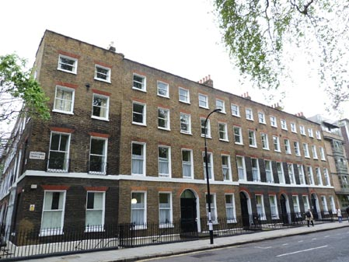
Description:
Terrace of 4 houses. 1794. By James Burton. Nos 1, 4 and upper part of Nos 2 and 3 refaced mid C20 in facsimile.
Darkened brick with evidence of tuck pointing, refacing in multi-coloured stock brick. Plain stucco band at 1st floor level. 4 storeys and basements. No.1, double fronted with 5 windows; Nos 2-4, 3 windows each. Wide, round-arched doorways with panelled jambs (No.1 with brackets), mutule cornice-heads, fanlights and panelled doors. Gauged red brick flat arches to recessed sash and casement windows, latter C20 with small horizontally set rectangular lights and metal glazing bars. Parapets.
INTERIORS: not inspected.
SUBSIDIARY FEATURES: Nos 1 to 3, attached cast-iron railings with urn finials to areas.

The building is also within the Bloomsbury Conservation Area (BCA) and is referred to in the BCA Appraisal & Management Strategy.
It is worth noting that these buildings were constructed by probably the most prolific Georgian builder in London, James Burton, who was responsible for building much of the Foundling Hospital Estate and the adjacent Bedford and Skinners’ Estates, as well as important terraces in Regent’s Park, most of Regent’s Street and St Leonard’s-on-Sea. (Refs: LMA, ‘Survey of London’ and John Summerson’s ‘Georgian London’)

The case for installing the plaque on this building:
Horizon Magazine was a highly influential publication, as evidenced by the long list of ‘A’ list writers who contributed it to it (see background paper). Orwell’s connection with the building is also strong having been a frequent ‘visitor’ and contributor to the magazine and having slept on site during the Blitz.

Preservation of the listed wall:
The material and method we use for fixing the plaque to the wall is non-invasive, unlike plaques installed by English Heritage, which require a large area of brickwork to be cut away.
This means that the fixative will not harm the brick-work and the plaque may be carefully removed at a later date, if necessary, without damaging the brickwork.

August 2014

