|  |  |  |  |
| --- | --- | --- | --- |
|  |  |  |  |
| Gresley Trust |
| Fao. Mr. Andrew Dow  Wyverns  Newton-on-Ouse  York  North Yorks  YO30 2BR |
| Application Ref: **2014/4569/L** | | |
|  | Please ask for: **Antonia Powell** | | |
| Telephone: 020 7974 **2648** | | |
|  | | |
| 3 September 2014 | | |

Dear Sir/Madam

DECISION

Planning (Listed Building and Conservation Areas) Act 1990

**Listed Building Consent Granted**

Address:

**Kings Cross Station**

**Euston Road**

**London**

**N1 9AP**

Proposal:

Erection of bronze statue of Sir Nigel Gresley and installation of wall plaque on western concourse.

|  |
| --- |
| Drawing Nos: Design and Access Statement dated 09/07/2014; Photo sheets x 4 of proposed statue in position; Drwg Nos. GST1 issue 1; GST2 issue 1, plan showing proposed site location of statue; Location plan - CAP-0133 rev 05. |

The Council has considered your application and decided to grant Listed Building Consent subject to the following condition(s):

Conditions And Reasons:

|  |  |
| --- | --- |
| 1 | The works hereby permitted shall be begun not later than the end of three years from the date of this consent.  Reason: In order to comply with the provisions of Section 18 of the Planning (Listed Buildings and Conservation Areas) Act 1990. |
| 2 | All new external and internal works and finishes and works of making good to the retained fabric, shall match the existing adjacent work with regard to the methods used and to material, colour, texture and profile, unless shown otherwise on the drawings or other documentation hereby approved or required by any condition(s) attached to this consent.  Reason: In order to safeguard the special architectural and historic interest of the building in accordance with the requirements of policy CS14 of the London Borough of Camden Local Development Framework Core Strategy and policy DP25 of the London Borough of Camden Local Development Framework Development Policies. |
| 3 | The works hereby approved are only those specifically indicated on the drawing(s) referred to above.  Reason: In order to safeguard the special architectural and historic interest of the building in accordance with the requirements of policy CS14 of the London Borough of Camden Local Development Framework Core Strategy and policy DP25 of the London Borough of Camden Local Development Framework Development Policies. |

Informative(s):

|  |  |
| --- | --- |
|  | Reasons for granting listed building consent. [Delegated]  The proposed development is in general accordance with the London Borough of Camden Local Development Framework Core Strategy, with particular regard to policy CS14 (Promoting high quality places and conserving our heritage); and the London Borough of Camden Local Development Framework Development Policies, with particular regard to policy DP25 (Conserving Camden's heritage). For a more detailed understanding of the reasons for the granting of this listed building consent, please refer to the officer report. |

You can find advice about your rights of appeal at:

<http://www.planningportal.gov.uk/planning/appeals/guidance/guidancecontent>

Yours faithfully

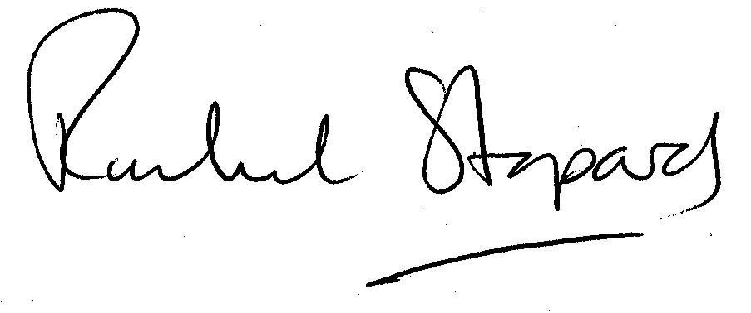

Rachel Stopard

Director of Culture & Environment