D O N A L D S H E A R E R C H A R T E R E D A R C H I T E C T S
Scholars’ House, Shottery Brook Office Park, Timothys Bridge Road, Stratford upon Avon, Warwickshire CV37 9NR
Tel 01789 294560 Fax 01789 294549 e-mail: donald@ds-architects.demon.co.uk

Our Ref 1099BA001 | Date: 27th August, 2014

DESIGN AND ACCESS STATEMENT

for

Erection of 9 no. Flats

On
The Land Adjoining 42 Falkland Road, Camden NW5

a. Introduction / Context

The initial application established the change of use from a redundant electric sub station and seven garages to form two houses onto this site. The site until recently was owned by Camden, who produced a Design Statement on 5th of January 2012 and subsequently sold the site in July 2012. The Design Statement noted the acceptability of a change of use to residential providing this was in the form of an extension to the existing terrace and maintained a “gap” between the perpendicular Lady Margaret Road buildings and the end of the extended terrace.

The initial approved design allowed for a winged roof, concealed by a parapet, which has a degree of vulnerability due to the low level and leaf fall from adjacent trees. The terrace already has a mansard at number 40, hence the application to alter the design of house 2 to have two levels of accommodation within a redesigned mansard roof. This revised design will not eliminate leaf fall issues but it will materially reduce these through the increased height of the upper surface and by removing the funnel effect of the winged roof gathering all the windblown leafs into a single gutter.

A new application which did not materially change any of the external volumes up to parapet level has recently been approved. This application follows on though through the same reasoning as on the house 2 Mansard approved design, with alterations limited to the house1 having a mansard and house 2 repeating house 1’s massing form to provide the terrace with a book end, visual end stop.

This new application seeks to utilise more effectively the external amenity space to the front of the property, whilst increasing the volume of accommodation on this brownfield site in compliance with the aims of the NPPF. The amenity space at the front of the property is useful primarily in creating distance privacy between the dwelling and the street. It has no effective functional use for children playing safely or other related amenity functions that are not better suited to the larger rear amenity spaces already established. By introducing lightwells at the front of the property we are using the design cues already established in the area on adjoining roads such as Lady Margaret Road.

These combined alterations we respectfully submit, are in policy terms material improvements and will allow a combined increase of 1,030 sqft in floor area, allowing mainly two bedroom flats in 9 dwellings to be created instead of the two approved at present, ensuring that the overall amenity of this unit is improved over the design approved at present.

This design is illustrated below

b. Physical Context

This site comprises a disused former electricity sub-station and seven garages (Camden’s Planning Statement inaccurately described the site as being a car park omitting that the cars are parked in built enclosures). It is located at the end of a terraced block of three storey properties facing onto Falkland Road. The site is bounded on its eastern side by the rear garden of 13 Lady Margaret Road and its two storey rear outrigger a clear 6M from the site boundary, with only a rear ground floor bay window intruding into this space. The main three storey built form of 13 Lady Margaret Road is a total of 9M from the site boundary.

To The North of the site, on the opposite side of Falkland Road lie the properties 15 to 19 Lady Margaret Road. These properties that lie perpendicular are larger in scale having full three storey outriggers and gabled roof forms with dormers to provide 4 storey accommodations.

The Street layout in this part of Camden and many other locations within Greater London where the 19th century developer terraces evolved traditionally have ‘gaps’ between the terraces. The speculative developers of the 19th Century would be delighted to reflect that their vehicles of profit are now included within the Kentish Town Conservation Area.

Having fully assessed the Planning Statement dated 5th January 2012 a detailed appraisal of the typical “gaps” in the NW5 location of the site was seen as essential prior to any design work commencing. There is already a “gap” which forms the rear garden of 13 Lady Margaret Road which is 6M in length (accepting that the 2.5M high bay window does not materially intrude into this dimension). The design proposed for the lightwells although not indigenous to Falkland Road is a recurring feature within the local area and indeed throughout Camden within buildings of the same period. Being a corner site and a new development we appraised that the addition of lightwells would be a subtle and pleasing feature given its end of terrace location adjacent to Lady Margaret Road where this is an established feature. This not only increases the amenity for the future occupiers of the properties but also improves local identity. We appreciate that this is an appraisal which is open to subjective interpretation, however even if subjectively our assessment is challenged, we respectfully submit that the benefits of the additional 1,000 sqft of accommodation, which will allow the proposals to fully embrace policy to encourage two bedroom flat type of dwellings. This we respectively submit would outweigh any subjective harm attributed to this mansard that is mostly hidden behind the parapet most of which is already the subject of the approvals.

Our original study looked at the following locations :-

- Ascham Street NW5 (8M gap)
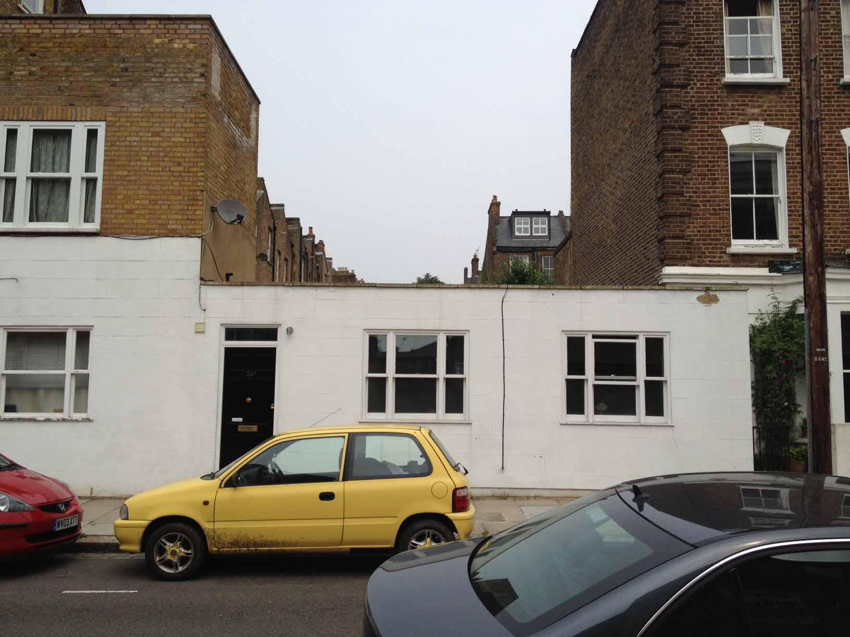

- Leverton Street NW5 (7M gap)
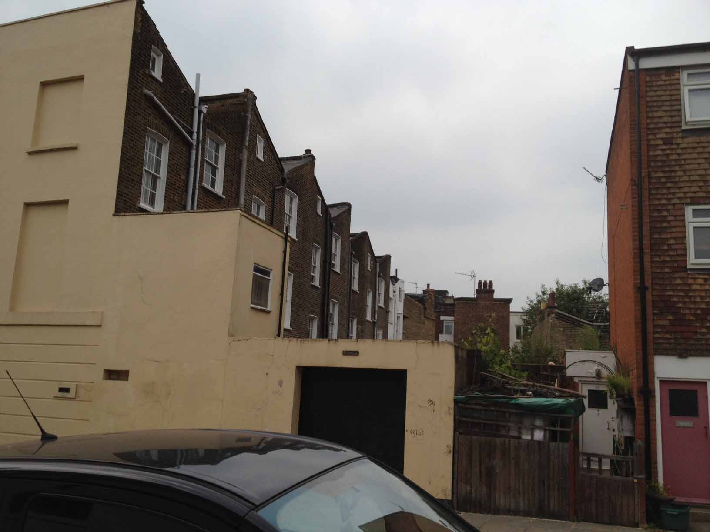

- Dunollie Road NW5 (7M gap)
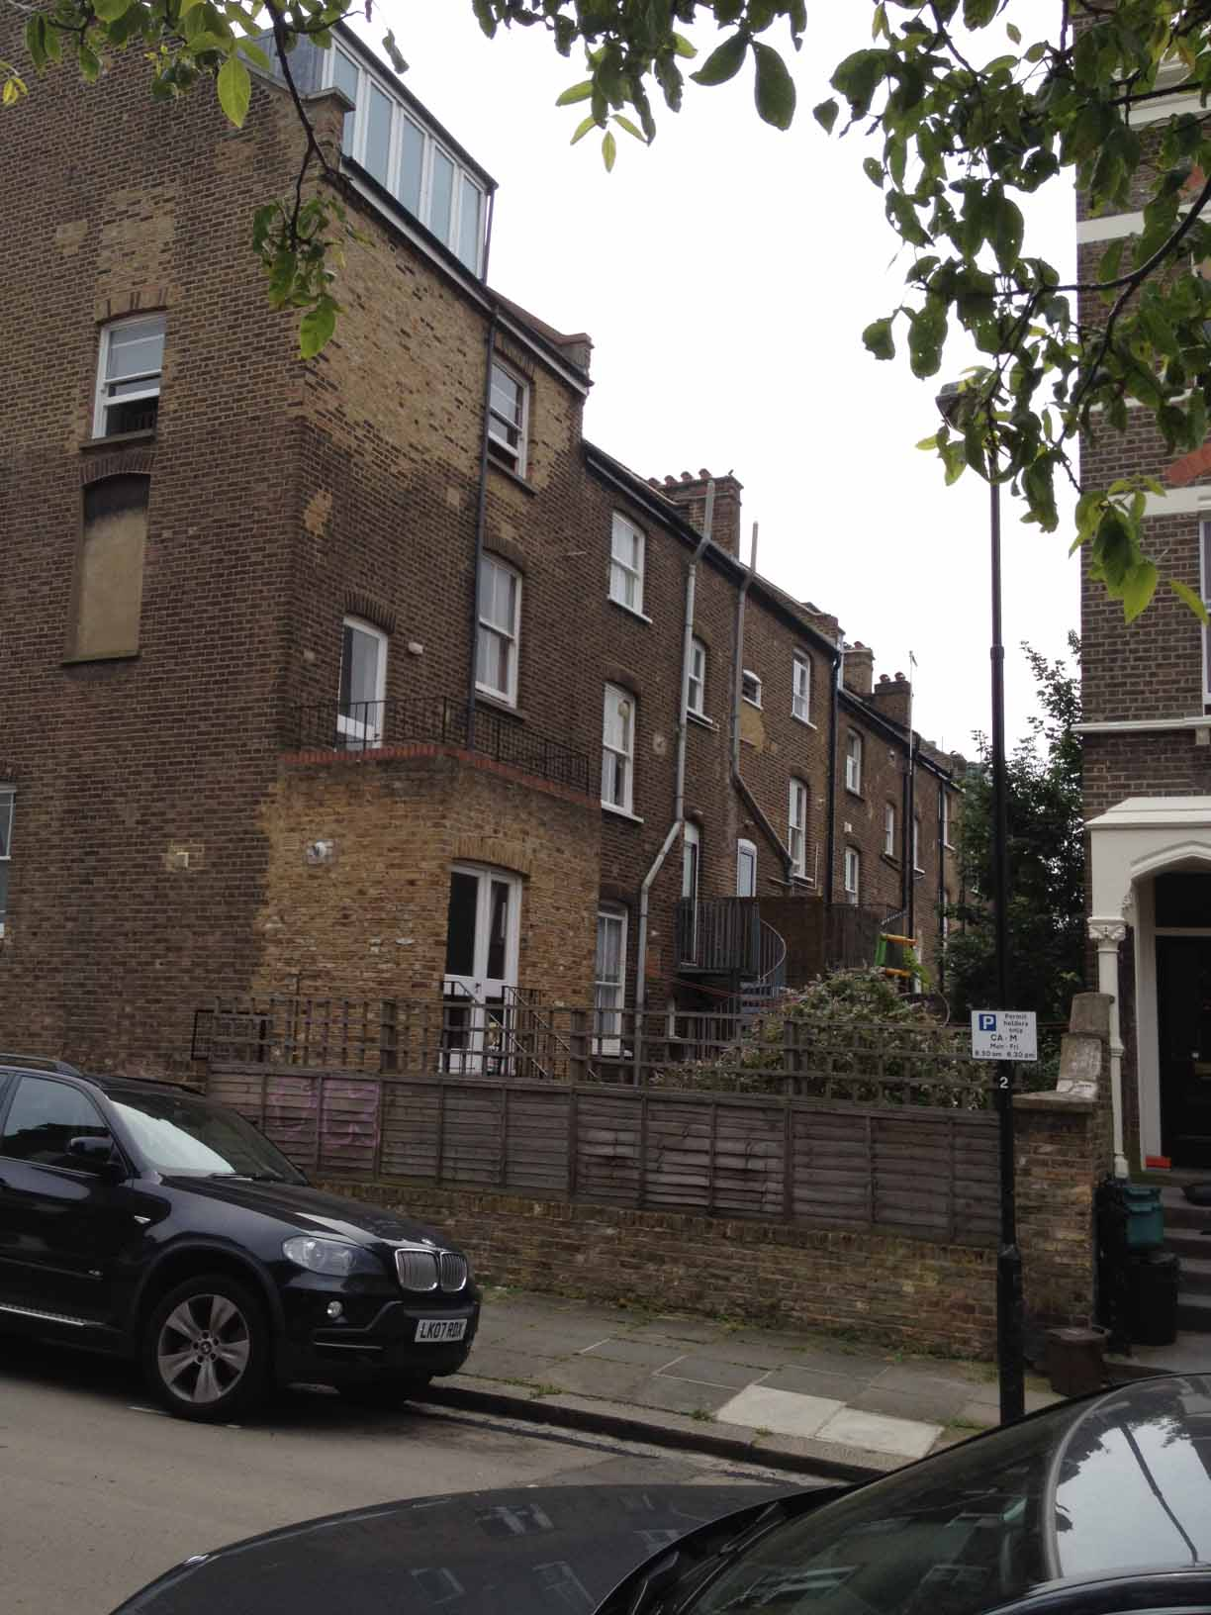
- Countess Road NW5 (6.5M gap)

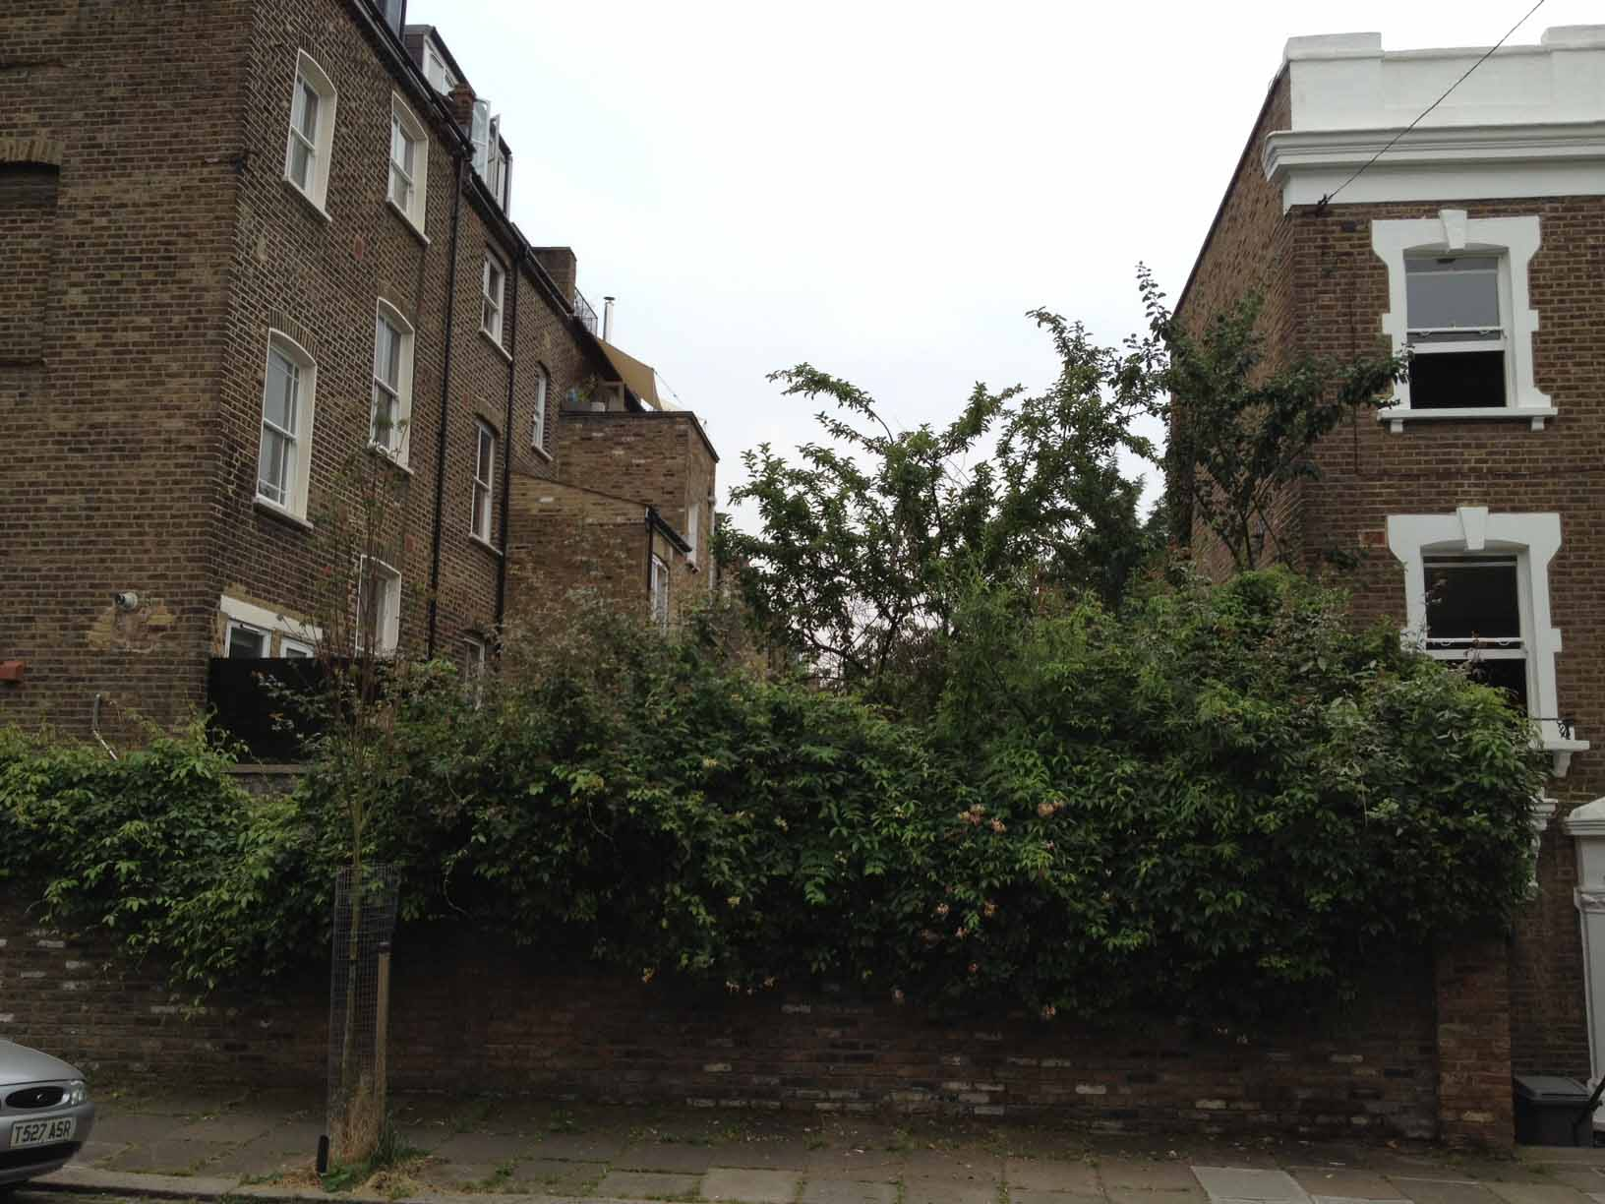

- 70 Countess Road NW5 (6.5M gap)

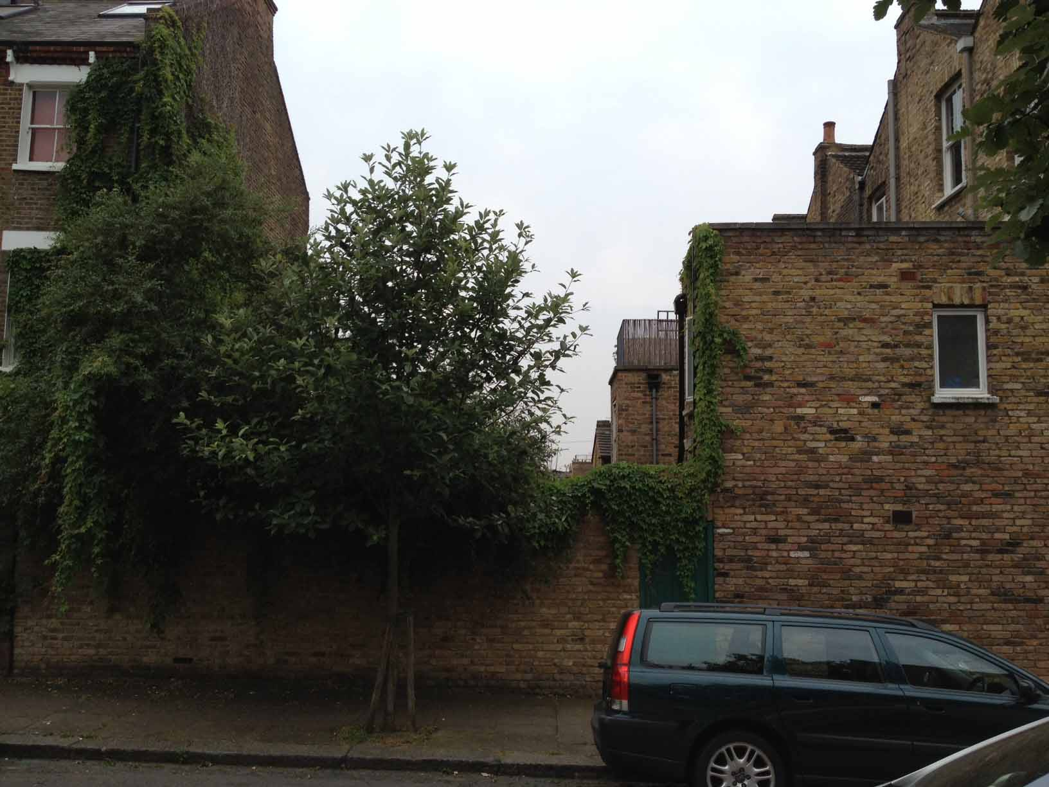

- Leverton Street NW5 (6.5M gap)

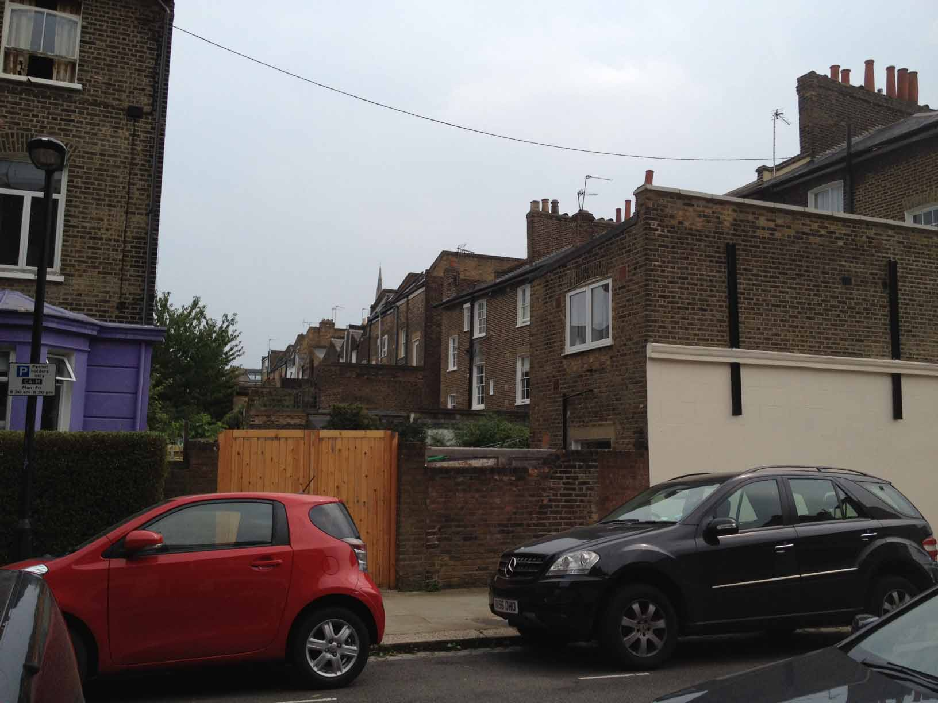
- Danollie Road NW5 (5.5M gap)

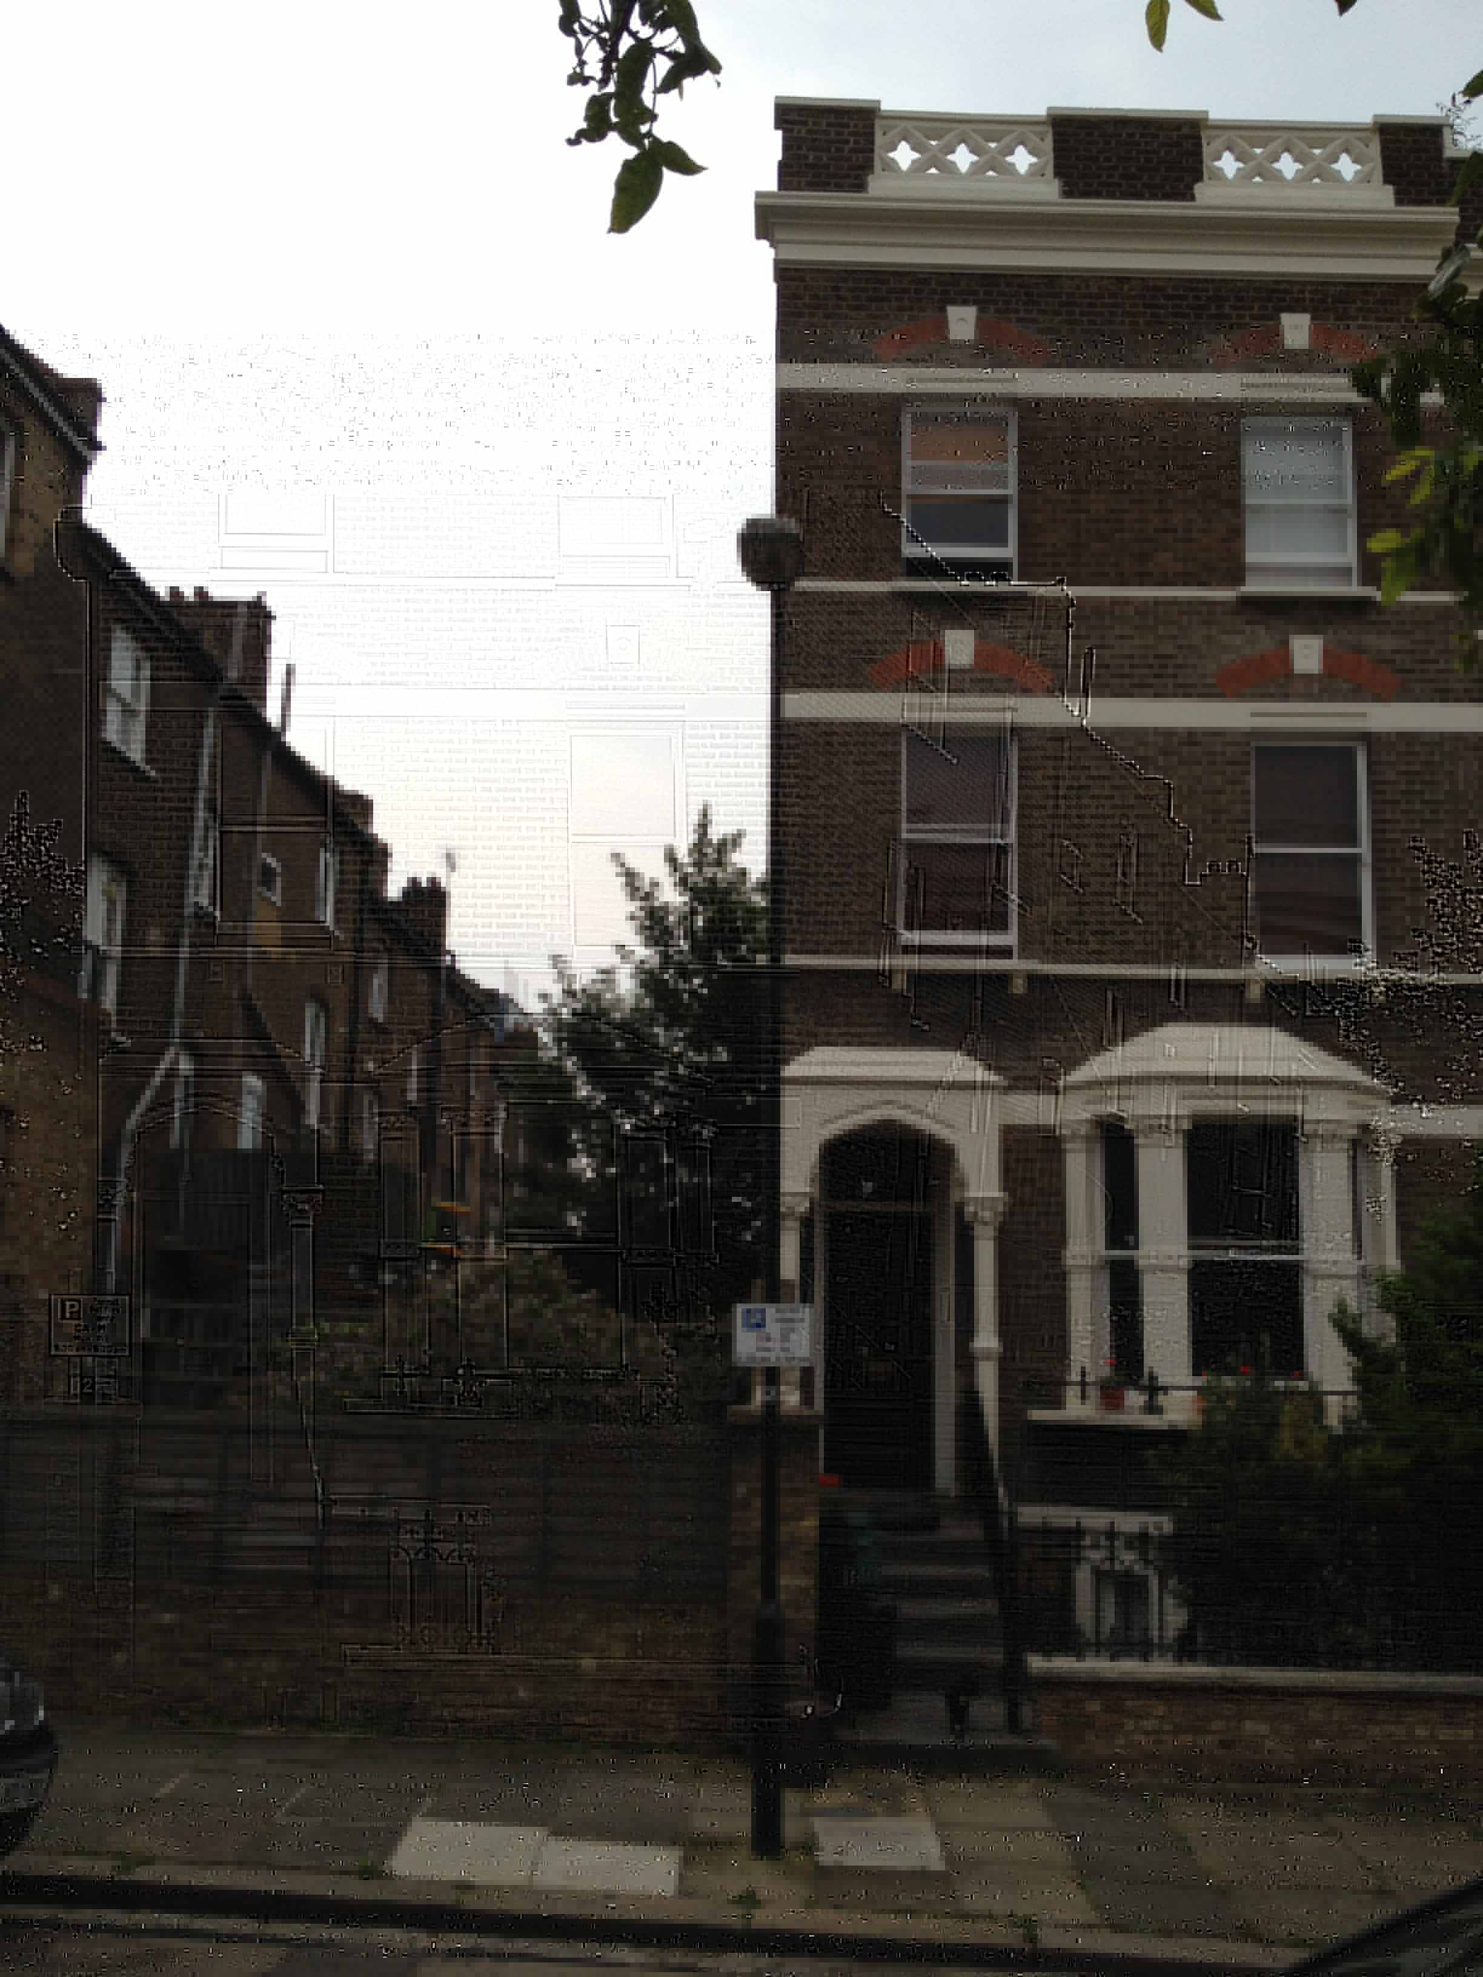

This study concluded that on adjoining streets end of terrace gaps varied generally between 5.5M and 8M where the Streets could be considered to have been developed in accordance with Core Strategy to make best use of developable land. The permission already granted is not in accordance with the historic pattern as it has a broken parapet line at the terrace end, instead of the historic continuous parapet. This application addresses this by ensuring that the parapet of the terrace is continuous, combined with the double mansard roof completing the composition acting as an effective visual bookend to the disjointed roofscape through the piecemeal mansards already extablished on the terrace above the parapet line.

This is particularly evident on Streets which are built to considerably higher densities than at Falkland Road often having accommodation on up to 5 levels utilising lower ground floors, or basements with lightwells fronting the street giving no material planning adverse effects to the character of these areas.

Clearly building the full width of the existing site would still leave a contextually acceptable and meaning full end of terrace “gap” of 6M which is the primary urban design feature which is unaltered with this application.

The Planning Statement dated 5th January 2012 also considered the rights of daylighting and sunlight on adjoining existing properties, together with Privacy and townscape considerations and concluded that a larger “gap” than the 6M was appropriate although it did not define this leaving up to the designers to create a flexible solution.

This study has now been considered in greater detail by the original consultants GVA. This further detailed study identified the functions of the rooms within all the Lady Margaret Road properties lying perpendicular and closest to the site boundaries. This further GVA study informed that there would be no material adverse effects for the proposed gable / mansard profile and its proximity to the adjoin properties all as detailed in the Appendixes GVA study.

The final consideration is the fact that the site already has its full width built with the single storey garages and electric substation. The Planning Statement dated 5th January 2012 although silent on this matter, gives no indication that full width single storey development of the remaining site beyond the extended terrace would be unreasonable and did not define any restrictions relating to the use of lightwells or basements. The GVA study has now been extended to the proposed built form to ensure that all the proposed rooms have appropriate levels of natural daylight to meet environmental health and all other associated statutory protocols.
C. Planning Policy Context

Planning Statement dated 5th January 2012 produced by Camden is attached to this submission as it gives clear conclusions, in relation to all Planning Policy in the context of this application which has been developed to embrace this document.

It is important to note that the 2012 GVA study concluded that a building the same height as the existing terrace parapet could be acceptable over the whole width of the site. The form was informed by this study assumed the adjoining properties had habitable room behind all window openings on all levels. The result of this assumption meant a conclusion that a diminishing building depth would be appropriate the closer the building was to the boundary, however the more detailed GVA study now in this D&A study informs a depth as now proposed.

The original proposals principally replace an existing building, to improve its visual amenity by creating forms massing and volumes that are not only sympathetic to the adjacent Victorian and Edwardian exiting buildings, but nearly identical. The subsequent applications have all been based on two houses developing additional floor space.

Planning policy encourages re-use of existing properties and their extension providing this does not encroach on the amenities of neighbouring properties and does not detract from the character of an area. Policy over recent years has focussed on the efficient re-use of brown field (previously developed sites) to ensure that these sites are redeveloped efficiently and appropriately to reduce pressure to build on the Greenbelt.

The start point for the original design proposals was to identify if the changes would have any adverse effects on the adjoining properties. The existing building is considered to be an incongruous form that introduces forms and materials incompatible with the Victorian and Edwardian traditional brick and rendered forms adjacent to the site in a manner that is considered detrimental to the aesthetic harmony of the street scene. The most serious of these aesthetic incongruities are the scale and proportions of the windows and other fenestration elements of the garages and sub station visible on the street façade.
It is submitted, that by the new proposals further intensifying this residential use to nine units now, policy will support this, due to the additional accommodation created making effective use of this Brown field site which is located within close proximity of Rail, Tube and bus transport hubs, as well as having extensive leisure, employment, retail, commercial, possibilities within between 1 and 10 minutes’ walk of this site.

This new proposal seeks to provide better use of the site resource with additional accommodation of nine instead of two dwellings. The increase 1000sq ft increase in area is allocated to amenity use within the detailed internal layouts to ensure as many of the units as possible can be two bedrooms and comply with the space standards demanded by Camden, which will also ensure the limited external amenity space is further mitigated, when the weather dictates that the widely available public external adjacent facilities are less appropriate to use.
In policy terms this proposal is desirable as it not only provides more efficient use of this brownfield site but by also adopting a staggered unit plan form, we are able to propose a range of unit sizes therefore complying more closely with the UDP which seeks all development sites to accommodate a range of different unit sizes.

Amenity space has been carefully appraised within the unique context of this site, whilst taking full account of the rich hinterland of leisure facilities within a very short walk, such as Cantelowes Gardens under 500M away. The readily available parkland and child friendly play facilities make family use in this location possible as well as the more desirable single / two occupant use identified by policy. The quality and diversity of these facilities mitigates the usual need for on-site amenity space.

On behalf of our client it is accepted that car permit capping obligation will be desirable, taking special account of the local employment, recreation and transport facilities readily available.
Refuse storage will be provided at the front of the property and cycle storage will be available in all units.

POLICIES SUPPORTED BY THE APPLICATION

CORE STRATEGY

Camden Policy CS6.9 identifies that their housing target, for additional housing in self-contained flats or houses will need to rely on changes of use from other use classes as a major contributor for the Borough to achieve the targets outlined in the Core strategy. This proposal will assist this policy 6.9, without relying on change of use to the same degree as anticipated when policy was devised.

Camden Policy CS6.16 reinforces this point in noting that 2,500 self-contained homes are planned to be provided by windfall sites of less than 10 homes such as this application site.

Camden Policy CS6.18 clearly states the priorities to be considered when housing change of use applications are made. The proposals fall under consideration of this clause as this also covers extending an existing use. The policy identifies that only some uses are to be protected and housing will not automatically over ride. These uses are stated as industry, warehousing, community uses and shops, all of which are within a few minutes’ walk of this site. The Core strategy in this is further reinforcing the Councils sustainability credentials, by being selective in the employment forms to be protected thus allowing the policy to react to the flexibility of the markets to rebalance the proportion of people residing close to their place of employment, reducing commuting, thus congestion and emissions within the Borough.

Camden Policy CS8 seeks to ensure that the Borough retains a strong economy. Paragraph b) is particularly relevant to this proposal as it is a windfall site which is located to existing employment centres, which will reduce the need for commuting to these employment centres thus supporting these employment centres, thus safeguarding their existence.

Camden Policy CS6.39 identifies that new housing of three and four bedrooms will be the medium priority 2 bedroom is high priority. The earlier approval is for one 4 bedroom unit and one 3 bedroom unit. This application alters this mix from the Core Strategy medium priority to mainly two bedroom high priority use, when taking account of the amenities surrounding the site, such as Cantelowes Gardens under 500M away, we believe that the form of the proposals in terms of unit mix is encouraged by the Core strategy in respect of this .

Camden Policy CS8.2 notes that 80% of all employees come from outwith the Borough. This clearly demonstrates that apart from Camden residents not having all the skills required within the Borough, that this figure is so high due to a severe shortfall in the housing available to employees within Camden, proportionate to the employment placements available. The proposals are in support of the objectives of this policy to bring a greater degree of skills required to Camden, by providing family friendly housing close to by employment and amenities appropriate for families.

Camden Policy CS 8.4 to 8.7 clearly states that there will be an increasing demand for offices, although this will be in established areas around the public transport hubs of Kings Cross Euston and Holborn. This site at Falkland Road is a considerable distance away from these transport hubs, but a short walk from Kentish Town Station which has direct lines to these stations. This clarifies the essential links between the market demands for offices close to primary transport links. Where local transport needs are well catered for, then policy 8.4 to 8.7 can be interpreted to support this application for residential accommodation that is well located for the local transport infrastructure which will reduce the demands for commuting from outside the borough to these additional offices in and around Kings Cross Euston and Holborn.

Policy DP24

Para. 24.12 highlights that it is where townscape is particularly uniform attention should be paid to responding closely to the prevailing scale form and proportions and materials. In areas of low quality or where no pattern prevails, development should improve the quality of an area and give a stronger identity.

We submit that the design closely relates to the scale and detailing of the pre existing buildings surrounding the site. The proposals achieve the aims of this policy the detailed elements have been carefully appraised to effectively embrace the requirements of PPS1 which demand that Local planning authorities should not attempt to impose architectural styles or particular tastes and they should not stifle innovation..

Policy DP25

This policy deals with Conservation areas. For the reasons detailed above in our commentary on DP24 & PPS1 the design proposals have chosen to follow rather than innovate to significantly enhance the setting of the conservation area and therefore comply with all the requirements of DP25. Whilst removing the visual compromise of the existing garage court and sub station.

Policy CS14

This policy generalises the detail set out in policy DP24. In our commentary on DP24 & PPS1 the design proposals we established beyond all reasonable doubt that the proposals will significantly enhance local character and distinctiveness and therefore complies with all the requirements of policy CS14.

Policy CS13

The form of the front south facing façade has been considered in the context of policies CS13 to ensure that sustainability possibilities for all sites is maximised. The open south facing unobstructed façade is a very infrequent but welcome opportunity in Camden which is recognised in CS13. Naturally this must be limited by the surroundings scale thus ensuring that the proposals are consistent in all respects with the demands of CS13, CS14, DP24 and PPS1 through the creation of a reinforced unique identity, hence the reasons for having bay windows on 1st floor as well as ground floor and basement, despite this not being the pattern of the rest of the terrace. This is further justified by being a clear urban marker to complete the 3 storey terraced form utilising a subtle existing detailed form combined with the traditional mansard forms now proposed creates an effective “bookend”.

Policy CS5
This policy supports the creation of nine dwellings; policy CS5 of the Core Strategy clearly identifies the need for additional dwelling houses and encourages these to be sustainable, as additionally noted in CS13 above

Policy DP26

identifies that:
Camden’s Core strategy seeks to sustainably manage growth so that it takes place in the most appropriate locations and meets our needs while continuing to conserve and enhance the features that make Camden such an attractive place to live.”
In respect of DP26 the design proposed has its impact on neighbours and future developments adjacent carefully assessed. We cannot envisage any development on adjacent sites that could be prejudiced by the proposals.

POLICY CONCLUSION

The application should be considered favourably in the light of all the Core strategy policies noted above which the proposals are consistent with the aspirations of these policies.
The policy statement dated 5th Jan 2012 gives a clear template for the design parameters of this site and is further informed now by the more indepth GVA study now appendixed to this D&A Statement.

There is a proportionate shortage of 2 bedroom units of accommodation in the area, which this proposal resolves by creating a new units with a combined greater floor area than the existing dwelling plus an additional similarly sized unit to the site.

d. Involvement / Evaluation / Design Process

The initial feasibility study identified that in this part of London the market requires mixed dwelling sizes arranged in a cohesive cluster which offer the most energy efficient envelope for several dwellings, whilst having a much reduced Carbon Footprint as a result of the shared walls floors and roofs that reduces the amount of construction material whilst improving the like for like thermal efficiency of the development. Redeveloping an existing building with external alterations ensures that the carbon footprint for reuse is reduced to a minimum, by constructing the new walls in the most thermally efficient materials available. The site was considered appropriate to redevelop as nine dwellings given the constraints of the site

The start point for us to develop this design was to attach greater emphasis to the need to provide additional dwellings located close to good public transport links and amenities.
The units are designed to have heat and power generation designed in a balanced manner within the Passivhuas design methods. This will substantially reduce, not only the Carbon footprint of the dwellings, but also the site orientation can be most effectively capitalised on by having the larger glazed areas facing south, with the smaller glazed openings facing north which not only reduces energy loss but ensures more effective acoustic suppression. This latest design submission refinement sought to improve passive solar gain from the additional south facing frontage solution which achieved this improvement over the previously approved design .
e. Use .

This site was used for seven garages and a sub station post war.

f. Layout

The layouts have been designed to use the available proposed internal space as efficiently as possible. Service areas and uses are stacked vertically for efficiency and compatibility reasons.
Cycle storage is within the dwellings to encourage the residents to use sustainable transport options.

g. Scale

The approved designs form a bridging element between the dominant adjoining properties in a manner that enhances their townscape visual context.
By creating two residential units on site, this will ensure that by being small family unit accommodation with adjacent recreation and employment opportunities, this will reduce congestion and carbon emissions, which form key objectives of Camden’s Core Strategy adopted in 2010.

The proposals for the basement and light wells make no material alteration to the physical scale of the proposals when viewed from adjoining buildings or the wider public domain, which has been established through earlier applications.

h. Appearance

It is accepted that the approved scheme will resolve the visual incompatibility of the previously fractured urban fabric, backed up by decisions made by Camden on sites within the local area such as 1 Regis Road that also used the “bookend theory”.

i. Landscaping

The property at present has all hard landscaped. No changes are proposed to this basic strategy as a result of our appraisal of the existing surrounding buildings and their associated amenity features concluded that substantial landscape features, such as trees, were on balance considered to not to be suitable for this location due to the adverse effects they would impose on both existing structures and the reduction in the solar gain which contributes to the performance standards of adjoin properties.

The existing trees adjoin the site were carefully assessed and non were deemed being materially compromised both in terms of their canopy or root bowl by the small amount of additional excavation required by the proposals over that already needed for implementation of the approved development. The basement structure has been designed to integrate the foundation structure into the basic envelope of the basement.

Controlled Landscaping was however considered appropriate to use moveable planters, thus assisting privacy, whilst creating a flexible softening of the building.

j. Access

The property is just a short 200M walk from the urban centre on Kentish Town Road. Kentish Town Main Line station just 150M away and in the same location is a main bus route, the property is extremely well located to utilise the existing bus rail and tube infrastructure.

The new properties will be formed internally, taking full account where possible of the aspirations of “Lifetime Homes”, in terms of accessibility, access doorways, bathroom facilities, and level access between inside and outside.

Cycle storage, refuse and general storage areas lie at entrance floor levels.

Recycling storage is located at the front of the property to ensure it is accessible for both residents and collection.

Donald Shearer

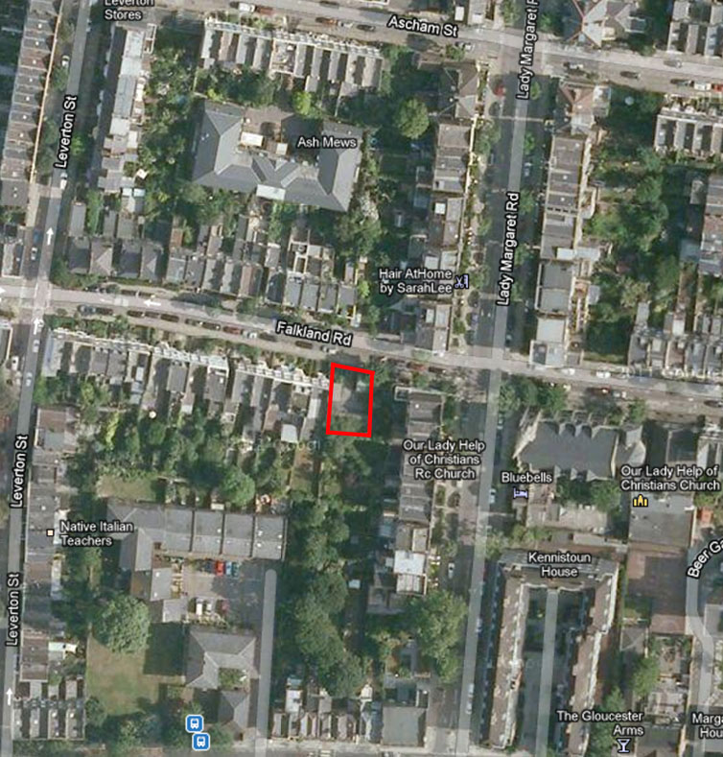

Satellite Image of the Site (Red denotes Boundary)

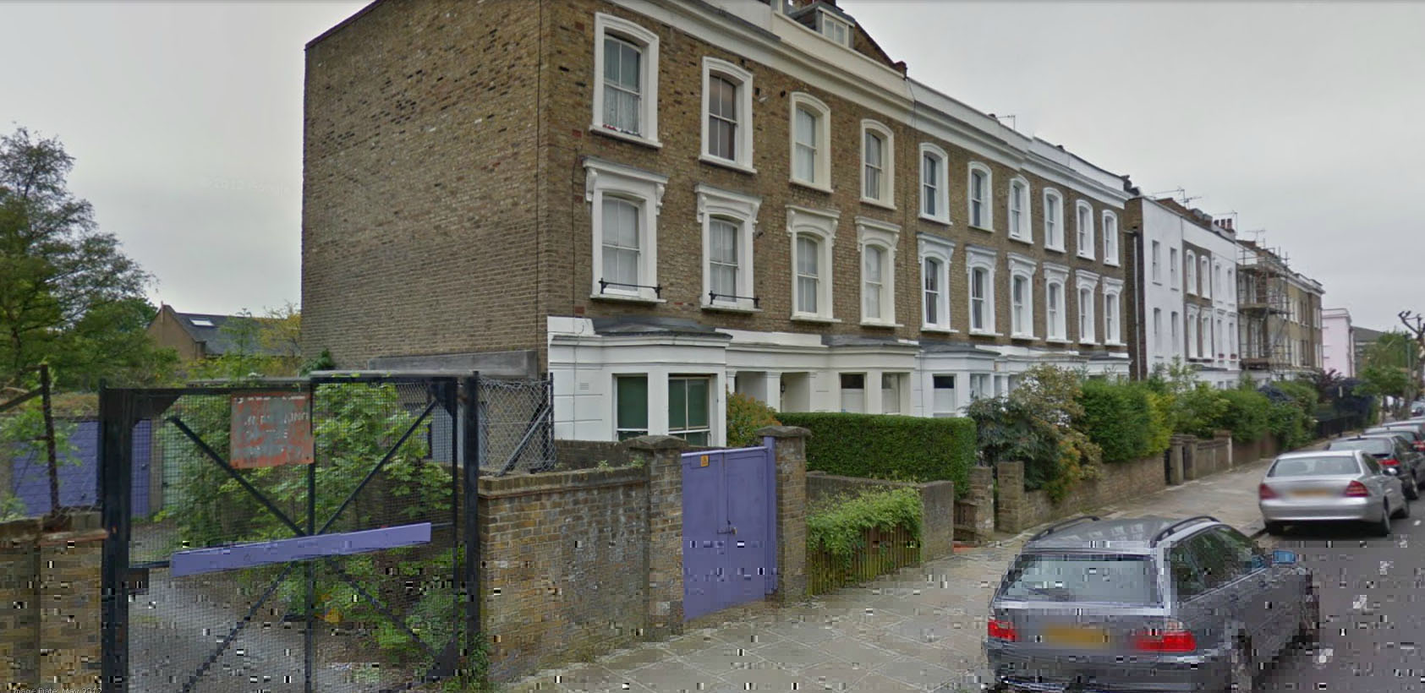

Photograph of vehicular entrance to Garages (Left), gated entrance to disused Electrical Sub-station (Foreground - Centre) and 42 Falkland Road (Background – Centre) with the remainder of the terrace to the right.

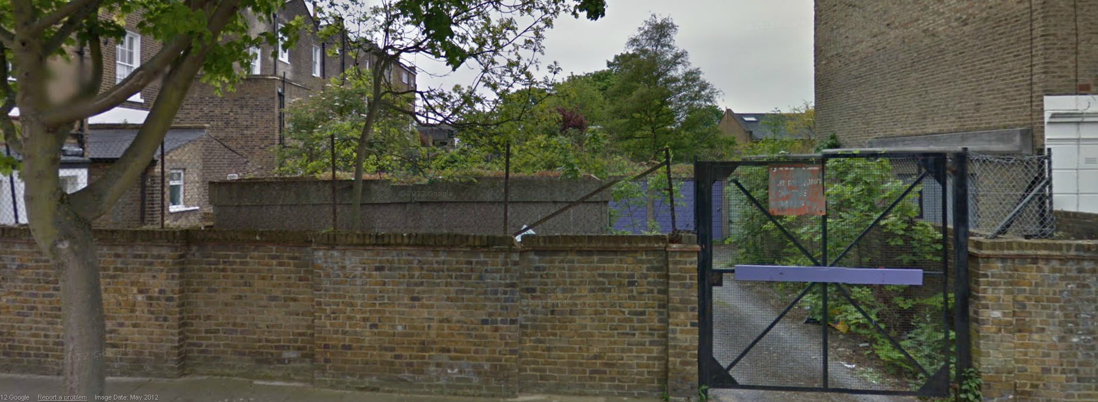

Photograph of the Garages and disused Electrical Sub-station (Centre) with the bay window at the rear of 13 Lady Margaret’s Road to the left and 42 Falkland Road to the right.

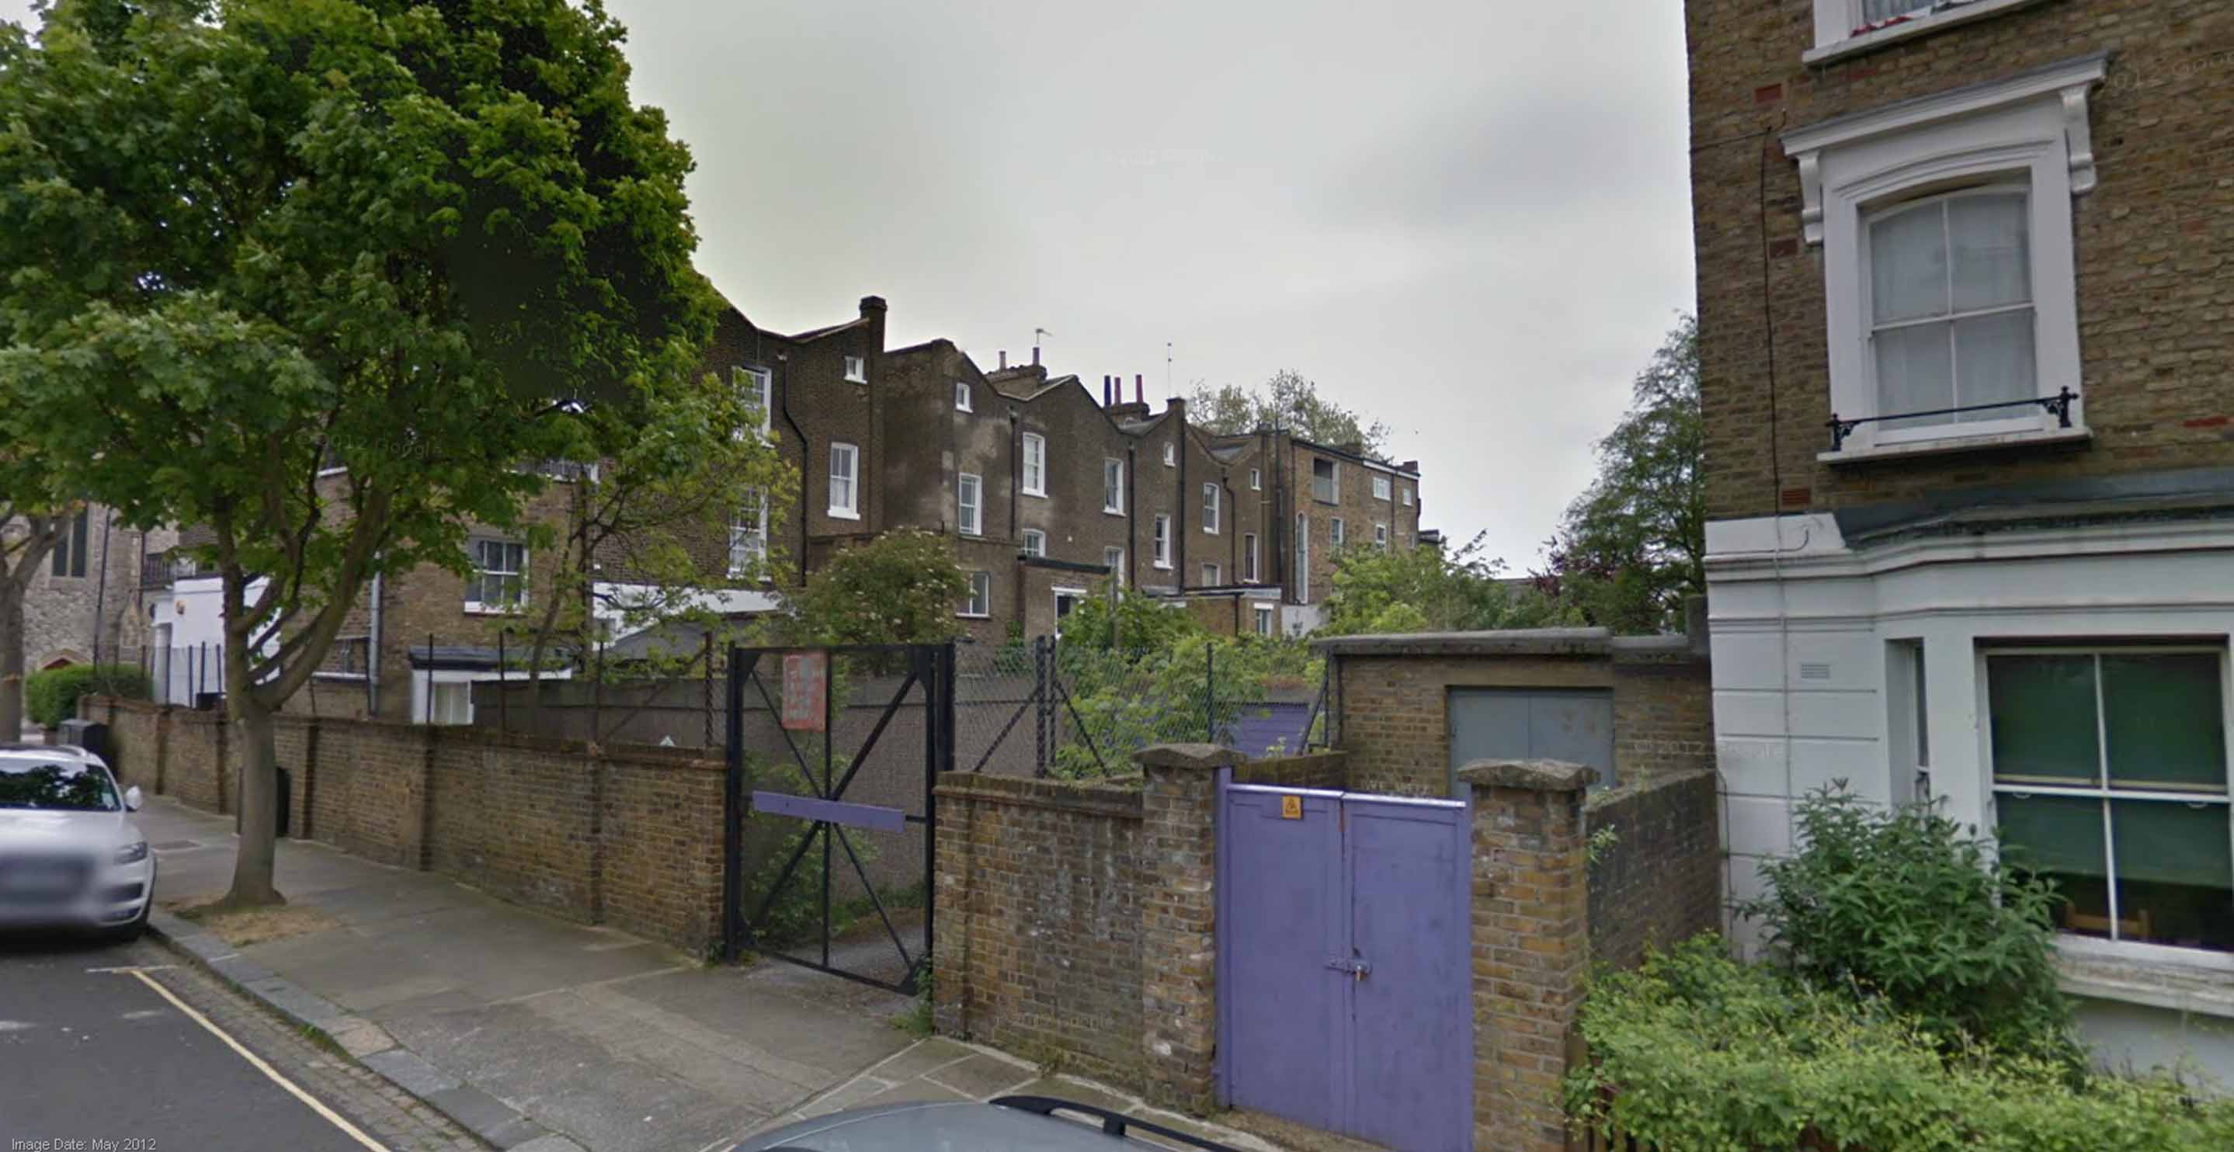

Photograph of vehicular entrance to Garages (Left of centre), the gated entrance to the disused Electrical Sub-station (Right of Centre) and 42 Falkland Road (Right). To the far left is the rear of 13 Lady Margaret’s Road with the remainder of the terrace in the background.

Appendix 1 – Letter from Daniel Rose Planning Ltd
