List entry Summary
This building is listed under the Planning (Listed Buildings and Conservation Areas) Act 1990 as amended for its special architectural or historic interest.
Name: NUMBERS 1-49 AND ATTACHED RAILINGS
List entry Number: 1379228

Location
NUMBERS 1-49 AND ATTACHED RAILINGS, 1-49, KELLY STREET
The building may lie within the boundary of more than one authority.
County | District | District Type | Parish
Greater London Authority | Camden | London Borough
National Park: Not applicable to this List entry.
Grade: II
Date first listed: 14-May-1974
Date of most recent amendment: Not applicable to this List entry.

Legacy System Information
The contents of this record have been generated from a legacy data system.
Legacy System: LBS
UID: 478596

Asset Groupings
This list entry does not comprise part of an Asset Grouping. Asset Groupings are not part of the official record but are added later for information.

List entry Description

Summary of Building
Legacy Record - This information may be included in the List Entry Details.

Reasons for Designation
Legacy Record - This information may be included in the List Entry Details.

History
Legacy Record - This information may be included in the List Entry Details.

Details
CAMDEN
TQ2884NE KELLY STREET 798-1/54/959 (South side) 14/05/74 Nos.1-49 (Odd) and attached railings
GV II
Terrace of 25 houses. Mid C19. Stucco with rusticated ground floors. EXTERIOR: 2 storeys. 2 windows each except No.49 with additional recessed entrance bay. Round-arched doorways with panelled doors and keystones with broken forward cornices continuing as a band at 1st floor level and breaking forward over ground floor tripartite sashes where supported by enriched console brackets. Wide bracketed sills mostly with elaborate cast-iron guards. No.49, square-headed doorway with stucco doorcase of panelled pilasters surmounted by enriched console brackets supporting a cornice; fanlight and panelled door. Moulded band at 1st floor level continuing as a plain architrave down the sides of the ground floor triparite sash with wide bracketed sill and elaborate cast-iron guard. 1st floor sashes round-arched with architraved heads and nailhead keystones, margin glazing and bracketed sills with elaborate cast-iron guards. No.49, 1st floor with lugged architrave 4-pane sashes with vermiculated keystones and bracketed sills with elaborate cast-iron guards. Cornice and blocking course except Nos 43-49 with parapets. INTERIORS: not inspected. SUBSIDIARY FEATURES: attached cast-iron railings to areas.
Listing NGR: TQ2882884605

Selected Sources
Legacy Record - This information may be included in the List Entry Details

National Grid Reference: TQ 28828 84605

Map
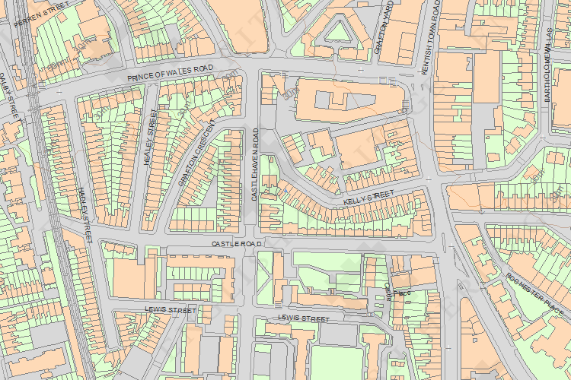
© Crown Copyright and database right 2014. All rights reserved. Ordnance Survey Licence number 100024900.
© British Crown and SeaZone Solutions Limited 2014. All rights reserved. Licence number 102006.006.
The above map is for quick reference purposes only and may not be to scale. For a copy of the full scale map, please see the attached PDF - 1379228.pdf - The pdf will be generated from our live systems and may take a few minutes to download depending on how busy our servers are. We apologise for this delay.
This copy shows the entry on 26-Sep-2014 at 02:00:17.
Back to results

