List Entry Summary
This building is listed under the Planning (Listed Buildings and Conservation Areas) Act 1990 as amended for its special architectural or historic interest.

Name: PAKENHAM ARMS PUBLIC HOUSE

List Entry Number: 1113240

Location
PAKENHAM ARMS PUBLIC HOUSE, 1, PAKENHAM STREET
The building may lie within the boundary of more than one authority.
County: Greater London Authority
District: Camden
District Type: London Borough
Parish:

National Park: Not applicable to this List entry.

Grade: II

Date first listed: 14-May-1974

Date of most recent amendment: Not applicable to this List entry.

Legacy System Information
The contents of this record have been generated from a legacy data system.

Legacy System: LBS

UID: 477690

Asset Groupings
This List entry does not comprise part of an Asset Grouping. Asset Groupings are not part of the official record but are added later for information.

List Entry Description

Summary of Building
Legacy Record - This information may be included in the List Entry Details.

Reasons for Designation
Legacy Record - This information may be included in the List Entry Details.

History
Legacy Record - This information may be included in the List Entry Details.

Details
CAMDEN
TQ3082SE PAKENHAM STREET
798-1/96/1262 (West side)
14/05/74 No.1
Pakenham Arms Public House
GV II
Public house. Late C19. Red brick with rusticated stucco
dressings. On a corner site, designed to match earlier
terraces in Calthorpe Street. 3 storeys. 1 window, 1 window on
bowed corner and 2-window return to Calthorpe Street. Public
house frontage of red granite pilasters carrying entablature;
entrance on corner with part glazed panelled door and similar
panels to either side. 2nd and 3rd floor window bays stepped
forward from corner, with rusticated quoins. 1st floor
windows; outer bays architraved, tripartite sashes with
cornices and segmental pediments; inner bays architraved
sashes with cornices and triangular pediments. Moulded 2nd
floor sill band. Architraved 2nd floor sashes, outer bays
tripartite. Entablature and projecting cornice following the
stepping of the bays. INTERIOR: not inspected.
Listing NGR: TQ3090382416

Selected Sources
Legacy Record - This information may be included in the List Entry Details.

Map

National Grid Reference: TQ 30903 82416
The below map is for quick reference purposes only and may not be to scale. For a copy of the full scale map, please see the attached PDF - 1113240.pdf - Please be aware that it may take a few minutes for the download to complete.
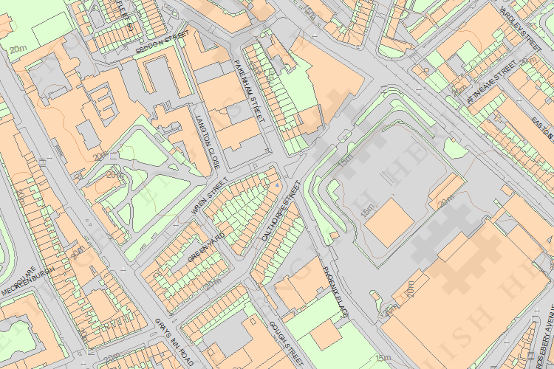
© Crown Copyright and database right 2012. All rights reserved. Ordnance Survey Licence number 100019088.
© British Crown and SeaZone Solutions Limited 2011. All rights reserved. Licence number 102006.006.

This copy shows the entry on 24-Jul-2014 at 05:29:21.

