Enforcement Delegated Report |  |  |  |  | Receipt date: | 4th February 2014
Officer |  |  |  | Enforcement Case
Gary Bakall |  |  |  | EN14/0149
Breach Address |  |  |  | Photos & Other material
15 Gayton Crescent, London, NW3 1TT |  |  |  | Attached in Idox
PO 3/4 | Area Team Signature |  | C&UD | Authorised Officer Signature

Alleged Breach
Erection of rear extensions without benefit of permitted development, built after Oct 2008.
Recommendation(s): |  | Issue an enforcement notice requiring the removal of the rear extensions and making good the rear elevation of the property.
Priority: |  | P2

Site Description
A detached 3 storey building with basement located on the south side of Gayton Crescent at the junction with Willow Road. The property is surrounded by garden amenity space although at the rear this is quite limited but is larger on the south side adjacent to no. 14 Gayton Crescent and no. 41 Willow Road. The building has lightwells at the front in common with other houses on the south side of Gayton Crescent. The building’s brick surface is painted in common with others in the locality.

The building is not listed but is in the Hampstead Conservation Area and the buildings no. 1-15 Gayton Crescent are identified in the Hampstead Conservation Area Statement as making a positive contribution to the character and appearance of the Hampstead Conservation Area. An Article 4 Direction recently introduced into Hampstead C.A. withdraws most permitted development rights pertaining to the front of the property.

To the east lies nos. 33-41 Willow Cottages a detached terrace of 2-storey houses with painted and rendered finish. These building are Grade II listed.

Investigation History
EN08/0799 - Fence removed and used as parking space-opened 11/09/2008 closed 29/09/2008 as permitted development.

EN09/0054 - 3 storey extension built without no p.p. – opened 04/02/2009 closed as no breach 28/02/2011

EN10/0856 – Demolition of wall to create off street parking – opened 07/09/2010 closed as p.d. 10/08/2012

EN11/0901 – Substantial works carried out for more than 12 months with no planning, can anything be done to bring the works to a conclusion and a wall has been removed and a vehicle mounts the curb and parks on a small piece of garden. – opened 30/09/2011 closed 30/11/2012 as permitted development.

EN12/0618 – Removal of 1 X holly tree on the front corner of the property covered by TPO – opened 11/07/2012 closed 26/02/2013 as no record could be found of TPO on Holly Tree.

EN12/1053 – Property in poor condition, possible s215 – opened 06/12/2012 closed Feb 2014

EN13/0482 – Removal of Holly Tree with TPO – opened 08/05/2013

EN13/1075 – Removal of front boundary railings – opened 26/09/2013

Relevant policies / GPDO Category
LDF Core Strategy and Development Policies

CS5 – Managing the impact of growth and development
CS14 – Promoting high quality places and conserving heritage/conservation areas
DP24 – Securing high quality design
DP25 – Conserving Camden’s heritage/conservation areas
DP26 – Managing the impact of development on occupiers and neighbours

Camden Planning Guidance
CPG1: Section - ! Introduction; 2 Design excellence; 3 Heritage; 4 Extensions;

Hampstead Conservation Area Statement 2001

Assessment
Planning history:
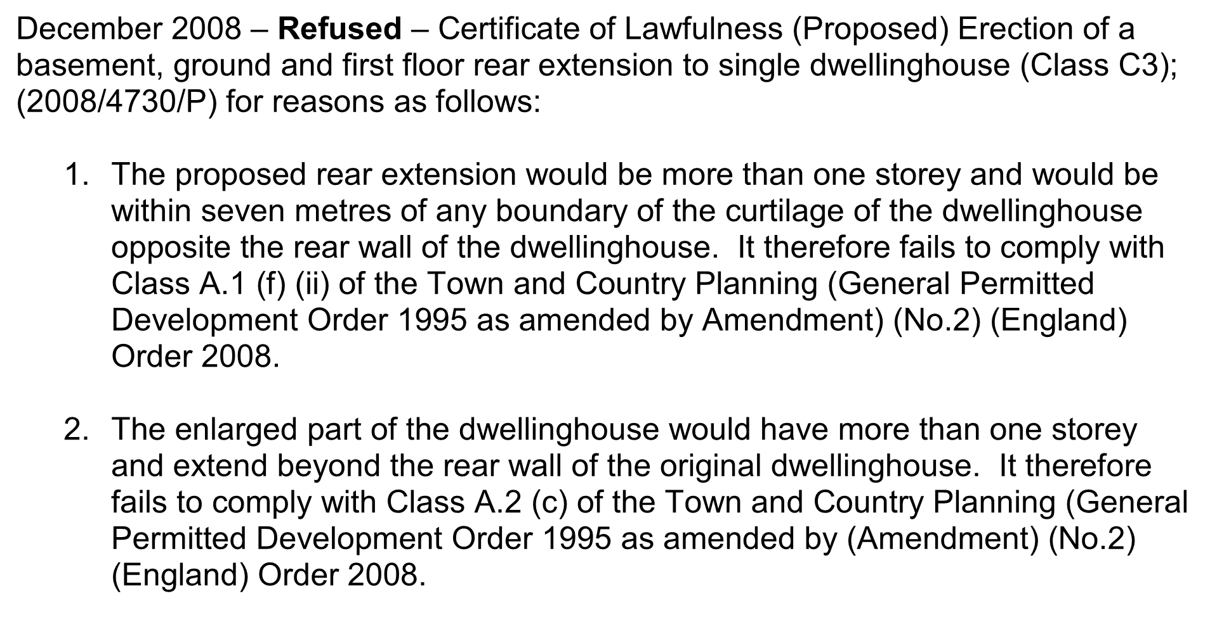
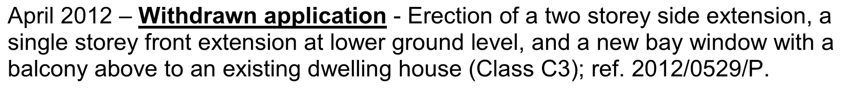
June 2013 – Refused- Planning application for erection of a two storey side extension on south side, including erection of a new bay window plus new access with balcony and stone coping on north side; and erection of single-storey lean-to extension at lower ground level rear to an existing dwelling house. For following reason;
‘The proposed extensions, by virtue of their scale, location and design would result in the loss of the visual gap between the property and No 14 Gayton Crescent, harmful to the symmetry and character of the host building, the character and appearance of the Hampstead Conservation Area, and the setting of the grade II listed buildings to the rear in Willow Road, contrary to policies CS14 (promoting high quality places and conserving our heritage), DP24 (securing high quality design) and DP25 (conserving Camden's heritage) of the London Borough of Camden Core Strategy and Local Development Framework Development Policies.’
Issues:
The main planning issues are the effect the design of the rear extension has on the property, the street scene, neighbouring listed buildings and the Hampstead C.A.
The property originally had a two storey rear extensions with a balcony area on top flanked by two single storey extensions. At some point these three extensions have been demolished and replaced with a central full height extensions whose roof is connected with the main roof and holds the staircase for the property. To the north and adjacent to this extension is a three storey extension that terminates in a balcony for the top floor bedroom. On the south of the central full height staircase compartment is a single storey extension. These three extensions have been rebuilt approximately in the footprint of the original extensions, protruding approximately a metre and half from the rear elevation of the main house.

When the matter was investigated in 2012 as part of EN11/0901 the owners claimed that the two larger extensions were constructed in the summer and early autumn of 2008 under the General (Permitted) Development Order 1995 before the Order was amended in October 2008 and the single storey extension was built in early 2009. Evidence to support this claim was produced in response to a Planning Contravention Notice and subsequently the applications for Certificates of Lawfulness for an existing development was applied for the rear extensions. These applications generated local interest and evidence was submitted from neighbours to show that the three extensions were not completed until much later. In light of this evidence it has been decided to treat the three rear extensions as one development and issue an enforcement requiring its removal.
The extensions are much larger than those they replaced and dominate the rear elevation.

Recommendation:
That the Head of Legal Services be instructed to issue an Enforcement Notice under Section 172 of the Town & Country Planning Act 1990 as amended, and officers be authorised in the event of non-compliance, to prosecute under section 179 or appropriate power and/or take direct action under 178 in order to secure the cessation of the breach of planning control

The notice shall allege the following breaches of planning control:

The erection of a three part rear extension ranging from full height to single storey

WHAT ARE YOU REQUIRED TO DO:

Remove the three part extension and make good the rear extension

PERIOD OF COMPLIANCE:
3 Months

REASONS WHY THE COUNCIL CONSIDER IT EXPEDIENT TO ISSUE THE NOTICE:

