List Entry Summary
This building is listed under the Planning (Listed Buildings and Conservation Areas) Act 1990 as amended for its special architectural or historic interest.

Name: NUMBERS 1-22 AND ATTACHED RAILINGS

List Entry Number: 1330368

Location
NUMBERS 1-22 AND ATTACHED RAILINGS, 1-22, REGENTS PARK TERRACE
The building may lie within the boundary of more than one authority.
County: Greater London Authority
District: Camden
District Type: London Borough
Parish:

National Park: Not applicable to this List entry.

Grade: II

Date first listed: 14-May-1974

Date of most recent amendment: Not applicable to this List entry.

Legacy System Information
The contents of this record have been generated from a legacy data system.

Legacy System: LBS

UID: 477854

Asset Groupings
This List entry does not comprise part of an Asset Grouping. Asset Groupings are not part of the official record but are added later for information.

List Entry Description

Summary of Building
Legacy Record - This information may be included in the List Entry Details.

Reasons for Designation
Legacy Record - This information may be included in the List Entry Details.

History
Legacy Record - This information may be included in the List Entry Details.

Details
CAMDEN
TQ2883NE REGENT'S PARK TERRACE
798-1/76/1385 Nos.1-22 (Consecutive)
14/05/74 and attached railings
GV II
Terrace of 22 houses. c1840-50. Yellow stock brick with
rusticated stucco ground floors. Nos 1-21 form a symmetrical
facade with slightly projecting end houses. 4 storeys and
basements. 2 windows each. Square-headed doorways with
cornice-heads, fanlights and panelled doors. Entrance to No.1
on right hand return with stucco portico having pilasters,
cornice and parapet; round-arched door way. Architraved
sashes; 1st floor with cornices and continuous cast-iron
balconies, 2nd floor with cornices. Plain stucco sill bands to
2nd and 3rd floors. Stucco modillion cornice and blocking
course.
No.22: rusticated stucco. 2 storeys and basement. 1 window.
Projecting stucco portico with balustraded parapet. Cornice
with balustraded parapet.
INTERIORS: not inspected.
SUBSIDIARY FEATURES: attached cast-iron railings with foliated
finials to areas.
Listing NGR: TQ2862883819

Selected Sources
Legacy Record - This information may be included in the List Entry Details.

Map

National Grid Reference: TQ 28628 83819
The below map is for quick reference purposes only and may not be to scale. For a copy of the full scale map, please see the attached PDF - 1330368.pdf
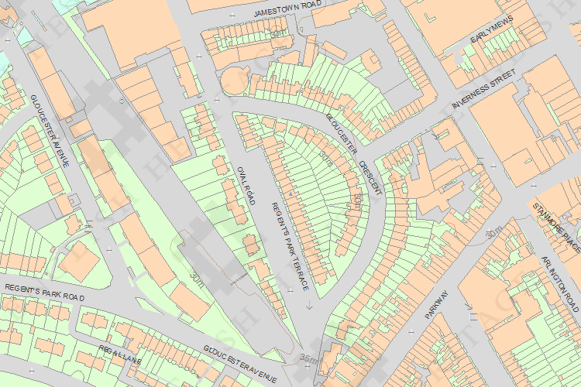
© Crown Copyright and database right 2012. All rights reserved. Ordnance Survey Licence number 100019088.
© British Crown and SeaZone Solutions Limited 2011. All rights reserved. Licence number 102006.006.

This copy shows the entry on 24-Oct-2013 at 12:08:27.

