Date: 04 April 2014  Application/Serial No: 04/2/0531A  Your reference: n/a | Building Control  Culture & Environment  London Borough of Camden  Town Hall Extension  Argyle Street  LONDON  WC1H 8EQ  DX 161055 KINGS CROSS 4  Telephone: 020 7974 2363  Facsimile: 020 7974 5603  Textphone: 020 7974 6866  building.control@camden.gov.uk  www.camden.gov.uk/buildingcontrol
Kingsley Napley LLP
ATTN Vanessa Rhodes

EMAIL: vrhodes@kingsleynapley.co.uk

Dear Ms Rhodes

The Building Act 1984 and the Building Regulations
Premises: 139 York Way, London, N7 9LG
Serial number: 04/2/0531A

Proposed building work or material change of use:

Demolition of buildings and construction of new building on 139 Yorkway (Commercial unit on ground floor and 10 flats above).

Please find enclosed the certificate of completion of works in relation to the above application.

There is a fee of £50.00 for each search, retrieval and copy Certificate supplied. Please forward your payment, totalling £50.00, to the above address, making any cheque payable to “London Borough of Camden”.

A receipt for your payment may be provided upon request. Please quote the above mentioned serial number when applying for the receipt.

Yours sincerely
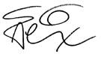
Technical Support Phone: 020 7974 2363
Email: building.control@camden.gov.uk
Enc. Completion certificate
Date: 20th December 2007  Application/Serial No: 04/2/0531A | Building Control  Culture & Environment  London Borough of Camden  Town Hall Extension  Argyle Street  LONDON  WC1H 8EQ  DX 161055 KINGS CROSS 4  Telephone: 020 7974 2363  Facsimile: 020 7974 5603  Textphone: 020 7974 6866  building.control@camden.gov.uk  www.camden.gov.uk/buildingcontrol
The Building Act 1984 and the Building Regulations
CERTIFICATION OF COMPLETION
- DETAILS OF WORK
Description:

Demolition of buildings and construction of new building on 139 Yorkway (Commercial unit on ground floor and 10 flats above).

Serial Number: 04/2/0531A
- LOCATION OF BUILDING
Address: 139 York Way, London, N7 9LG
- GIVING OF BUILDING NOTICE OR DEPOSIT OF PLANS
A Building Notice was received or a Deposit of Plans made on 17 March 2005 in accordance with Regulation 12 of the Building Regulations.
- COMPLETION
The work was seen to have been completed on 20 December 2007.
- COMPLIANCE WITH BUILDING REGULATIONS
It is certified that the building works described above have been inspected and, so far as the officers of the Council have been able to determine, the requirements of the Building Regulations are satisfied.

“This certificate is evidence, but not conclusive evidence, that the requirements specified in the certificate have been complied with.”
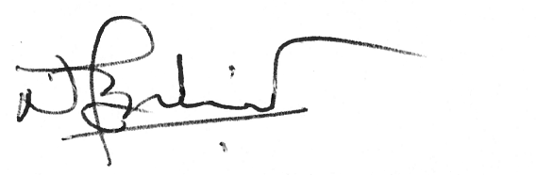
pp
Ms Slavica Maksimovic Phone: 020 7974 6936 (9am to 5pm Mon to Fri only)
Email: Slavica.Maksimovic@camden.gov.uk

