**MIDDLETON & ASSOCIATES**

CONSULTING STRUCTURAL AND CIVIL

ENGINEERING TECHNOLOGISTS

P.O. BOX 13070

CASCADES 3202

PIETERMARITZBURG

SOUTH AFRICA

929-2

# **MTT**

# **ALUMINIUM FRAME TENT STRUCTURE**

# **Up to 10m METER SPAN**

# **STRUCTURAL ASSESSMENT**

CLIENT

**MTT LTD**

**New germany, Durban South Africa**

NOVEMBER-2006

PAGE 1

# MTT Pty Ltd

# ALU-TENT

# ALUMINIUM TENT STRUCTURES

**ASSESSMENT SUMMARY**

This report is based on technical information supplied by MTT LTD, and inspections performed on erected structures.

The standards adopted for the design assessment are based generally on the SOUTH AFRICAN CODES OF PRACTICE FOR LOADING OF BUILDINGS, and THE SOUTH AFRICAN ALUMINIUM FEDERATION RECOMMENDATIONS FOR DESIGN OF ALUMINIUM STRUCTURES.

Analyses of the structures were carried out using a Computer Aided Structural Frame Analysis Program, different load combinations being adopted to establish critical areas of the design.

Frames are available in 3m & 5m modules, a 5m evaluation is attached as Appendix 4.4.

Wind loading, in accordance with S.A.B.S. 0160, has been based on a minimum design speed of 28m/s (100kph) corresponding to 62 mph, with a 5 year recurrence period.

The TERRAIN CATEGORY selected is 2, American equivalent c.

The live load allowance of 80 kg applied as indicated in the calculations is for lighting, heating and ventilation equipment.

PAGE 2

**THE FOLLOWING CONCLUSIONS WERE ARRIVED AT**:

1. THE MAIN FLEXURAL ELEMENTS OF THE TENT FRAMES ARE ADEQUATE BASED ON THE ANALYSIS PERFORMED IN ACCORDANCE WITH THE LOADINGS DESCRIBED IN THE REPORT.
2. THE FRAMES ARE CAPABLE OF WITHSTANDING WIND PRESSURES UP TO 0.29 KN/m2, WITH A WIND SPEED OF 28 m/s IN A TERRAIN CATAGORY 2.

Refer to appendix 4.3 for wind loads, pressures and pressure co-efficient.

**THE FOLLOWING RECOMMENDATIONS ARE MADE:**

1. It is important that the P.V.C. covering is correctly installed and maintained in a taut enough condition to prevent ponding of rainwater.
2. The purlins must at all times be securely fixed against the rafters.
3. The bracing cables OR portal beams are to be installed so as to remain taut at all times.
4. The structure should be erected on firm ground and securely anchored at all times. In the case of integral flooring and walling this will provide sufficient weight to negate staking.
5. Suitably experienced and responsible persons should undertake the erection of the structure.

PAGE 3

# TABLE OF CONTENTS

**PART 1 GENERAL DESCRIPTION**

**PART 2 STRUCTURAL ANALYSIS**

**PART 3 STRUCTURAL CALCUALATIONS**

**PART 4 APPENDICES**

PAGE 4

## PART 1 GENERAL DESCRIPTION

1.1 DESCRIPTION

1.2 DESIGN CRITERIA

1.3 DESIGN ASSUMPTIONS

1.4 MATERIAL SPECIFICATIONS

1.5 MAIN FRAME SECTION & SECTION PROPERTIES

1.6 ANALYSIS

1.7 LOAD CASES CONSIDERATIONS

1.8 LOAD COMBINATIONS

PAGE 5

# **PART 1 GENERAL DESCRIPTION**

**INTRODUCTION**

THIS ASSESSMENT IS PRIMARILY TO PROVIDE A BASIS OF ACCEPTANCE OF THE STRUCTURAL ADEQUACY OF THE MTT 8M,12,AND 15M METER ALU-TENT FRAME TENT

**1.1 DESCRIPTION**

**STRUCTURAL FRAME**

THE FRAME IS A PORTAL CONFIGURATION, CONSTRUCTED OF EXTRUDED

ALUMINIUM RECTANGULAR HOLLOW SECTIONS

KNEE AND APEX CONNECTIONS ARE ACHIEVED WITH STEEL INSERTS

ANCHORAGE AGAINST UPLIFT IS BY MEANS OF ANCHOR RODS INTO THE SUP‑

PORTING GROUND THROUGH THE COLUMN BASE PLATES

**COVERING**

COVERING IS PVC SHEET WITH EDGE BEADING TO FIT INTO GUIDES FORMED

WITH THE ALUMINIUM EXTRUSION. SOLID WALLING ALONG SIDES AND GABLES CAN BE USED IN CONJUNCTION WITH PVC WALLING.

**PURLINS**

PURLINS ARE ALUMINIUM EXTRUDED HOLLOW SECTION WITH STEEL CLIPS

**BRACING**

BRACING FIELDS FOR LONGITUDINAL STABILITY ARE ACHIEVED WITH CROSS

BRACING CABLES AT RAFTER LEVEL AND VERTICAL BETWEEN SELECTED

COLUMNS(THIS WALL BRACING CAN BE REPLACED WITH PORTAL BEAMS WITH ONE BEAM REQUIRED EVERY 4 SECTION).

PAGE 6

**1.2 DESIGN CRITERIA**

**LOAD ASSUMPTIONS**

SELF WEIGHT

|  |  |
| --- | --- |
| ALUMINIUM MASS | 2700 KG/m3 |
| PVC | 1.0 KG/m2 |

IMPOSED LOADING

POINT LOADS

|  |  |
| --- | --- |
| 8m FRAME | 80KG PLACED AT APEX |

**WIND LOADING** AS PER SOUTH AFRICAN STANDARD

CODE OF PRACTICE FOR THE GENERAL PROCEDURES

AND LOADINGS TO BE ADOPTED FOR THE DESIGN OF

BUILDINGS SABS 0160

RETURN PERIOD 5 YEAR OCCURENCE

TERRAIN CATAGORY 2

**1.3 DESIGN ASSUMPTIONS**

THE TENT ARE CLASSIFIED AS TEMPORARY STRUCTURES

SNOW LOADING IS NOT CONSIDERED. SHOULD SNOW OCCUR, REMOVAL BY IN‑

TERNAL HEATING OR OTHER ACCEPTABLE MEANS SHALL BE EMPLOYED

ADEQUATE LATERAL RESTRAINT IS PROVIDED BY THE PVC CONNECTION TO

THE EXTRUSION TOGETHER WITH THE PURLIN CONNECTIONS TO PREVENT

LATERAL INSTABILTY OF THE RAFTER SECTION

ADEQUATE PRESSURE RELIEF FOR INTERNAL PRESSURE IS AVAILABLE AT

EAVES LEVEL

NO DOMINANT LEEWARD OR WINDWARD OPENINGS

PAGE 7

**1.4 MATERIAL SPECIFICATION**

|  |  |
| --- | --- |
| ALUMINIUM | ALLOY AND TEMPER 6061‑T6 |
| STEEL | GRADE 300W |

**1.5 MAIN FRAME SECTION AND SECTION PROPERTIES**

|  |  |  |  |
| --- | --- | --- | --- |
| DIE NUMBER | H5395 | H5376 | H5344 |
| MOMENT OF INERTIA Ixx E6mm4 | 1,30 | 3.623 | 12.89 |
| MOMENT OF INERTIA Iyy E6mm4 | 0,33 | 0.697 | 1.95 |
| SECTION MODULUS Zxx E3mm3 | 30,9 | 50.25 | 143.3 |
| RADIUS OF GYRATION ryy mm | 20 | 25 | 28 |
| AREA A mm2 | 1,16 | 1.47 | 2.46 |
| SELF WEIGHT KG/m | 3,13 | 3.97 | 6.64 |

PAGE 8

**1.6 ANALYSIS**

STRUCTURAL ANALYSIS IS BY COMPUTER USING STIFFNESS MATRIX PROGRAM

COMPUTOR SOFTWARE IS BY **PROCON SOFTWARE CONSULTANTS**

STRESS ANALYSIS IS BASED ON ALLOWABLE STRESS DESIGN IN ACCORDANCE

WITH RECOMMENDATIONS BY ALUMINIUM FEDERATION OF SOUTH AFRICA

(ALUMINIUM DESIGN GUIDE 1 STATIC STRUCTURES)

**1.7 LOAD CASES CONSIDERED**

1 SELF WEIGHT OF PVC (SELF WEIGHT OF SECTION INCLUDED IN PROGRAM)

2 IMPOSED LOAD ( LIGHTING ETC)

3 WIND TRAVERSE (AGAINST SIDE ELEVATION)

4 WIND LONGITUDINAL (AGAINST GABLE ELEVATION)

**1.8 LOAD COMBINATIONS**

1 LOAD COMBINATION C1 LOAD CASE 1 + 2 + SELF WEIGHT

(SELF WEIGHT PLUS IMPOSED LOAD)

2 LOAD COMBINATION C2 LOAD CASE 1 + 3 + SELF WEIGHT

(SELF WEIGHT PLUS TRANVERCE WIND)

3 LOAD COMBINATION C3 LOAD CASE 1 + 4 + SELF WEIGHT

(SELF WEIGHT PLUS LONGITUDINAL WIND)

PAGE 9

## PART 2 STRUCTURAL ANALYSIS

2.1 APPLIED LOADINGS

2.1A SELF WEIGHT OF SECTION

2.1B IMPOSED LOAD

2.1C WIND LOADS

2.1D PRESSURE COEFFICIENTS

* 3m MODULE

PAGE 10

**MIDDLETON AND ASSOCIATES CC**

**CALCULATION SHEET**

**REF: 929-2 DATE: 17-11-2006**

**TITLE: MTT TENT STRUCTURES**

# **PART 2 STRUCTURAL ANALYSIS**

**2.1 APPLIED LOADINGS**

**2.1A SELF WEIGHT OF SECTI**ON

H 5395 3,13 KG/m

H 5376 3.97 KG/m

H 5344 6.64 KG/m

SELF WEIGHT OF PVC 1,0 KG/m2 3,0 M MODULE = 3 KG/m

2.1B IMPOSED LOADS

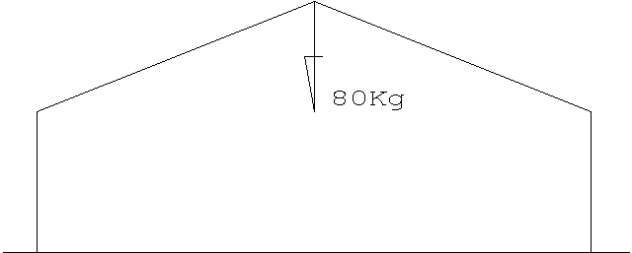

PAGE 11

**MIDDLETON AND ASSOCIATES CC**

**CALCULATION SHEET**

**REF: 929-2 DATE: 17-11-2006**

**TITLE: MTT TENT STRUCTURES**

**2.1C WIND LOADS**

VELOCITY 28 M/S (100 KMH) (62 MPH)

RETURN PERIOD 5 YEARS

WIND PRESSURE TERRAIN CATEGORY 2 0,289 KN/Mm2

REFER TO APPENDIX 4.3

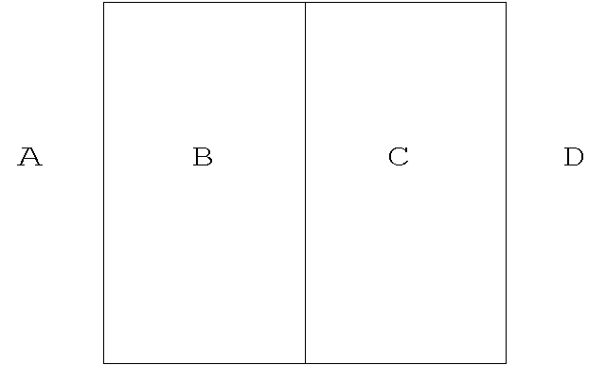**2.1D PRESSURE COEFFICIENTS**



TRANSVERSE LONGITUDNAL

PAGE 12

**MIDDLETON AND ASSOCIATES CC**

**CALCULATION SHEET**

**REF: 929-2 DATE: 17-11-2006**

**TITLE: MTT TENT STRUCTURES**

**3m MODULE**

LOADING ON FRAME MEMBERS KN/m TRANSVERSE WIND DIRECTION

VELOSITY = 28m/s

|  |  |  |
| --- | --- | --- |
| AREA | COEFFICIENT | LOAD |
| A | 0,7 | 0.61 KN/m |
| B | 0,5 | 0,43 KN/m |
| C | 0,4 | 0,35 KN/m |
| D | 0,2 | 0,17 KN/m |

LOADING ON FRAME MEMBERS KN/m LONGITUDINAL WIND DIRECTION

VELOSITY = 28 m/s

|  |  |  |
| --- | --- | --- |
| AREA | COEFFICIENTS | LOAD |
| A | 0.5 | 0,43 KN/m |
| B | 0.6 | 0,52 KN/m |
| C | 0.6 | 0,52 KN/m |
| D | 0.5 | 0.43 KN/m |
| E | 0.7 | 0,61 KN/m |
| F | 0.2 | 0.17 KN/m |

PAGE 13

## PART 3 STRUCTURAL CALCULATIONS

3.1 STRESS ANALYSIS

3.1A AXIAL AND BENDING RESISTANCE

3.1B ELEMENT DESIGN

3.2 BRACING CABLES

3.2A VERTICAL FIELD BRACING

3.2B RAFTER FIELD BRACING

3.2C FORCE IN EAVES

3.4 EAVE STRUT

3.5 UPLIFT ON COLUMN BASES

PAGE 14

**MIDDLETON AND ASSOCIATES CC**

**CALCULATION SHEET**

**REF: 929-2 DATE: 17-11-2006**

**TITLE: MTT TENT STRUCTURES**

# **PART 3 STRUCTURAL CALCULATIONS**

**STRESS ANALYSIS APPLIED LOADINGS**

WIND LOADS

|  |  |
| --- | --- |
| F | 1.01 |
| G | 0.72 |
| H | 0.58 |
| I | 0.29 |

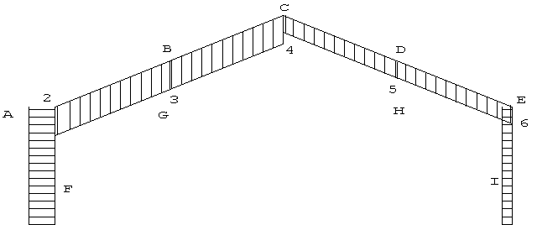

|  |  |
| --- | --- |
| A | 0.72 |
| B | 0.87 |
| C | 0.87 |
| D | 0.72 |

PAGE 15

**MIDDLETON AND ASSOCIATES CC**

**CALCULATION SHEET**

**REF: 929-2 DATE: 17-11-2006**

**TITLE: MTT TENT STRUCTURES**

**8M FRAME STRUCTURE 3,0M MODULE**

**WIND LOADS**

**3.1 STRESS ANALYSIS**

**SECTION PROPERTIES**

CODE No.: H 5395

SECTION MODULUS AXIS X-X 30.9 E3 mm3

MINIMUM RADIUS OF GYRATION 20 mm

CROSS SECTIONAL AREA 1.16 E3 mm2

**3.1A AXIAL AND BENDING RESISTANCE**

**1 RAFTER**

RESTRAINED LATERALLY BY PURLINS AND PVC SHEETING

Pbc = 155 N/mm2

Pc = 138 N/mm2

Pt = 149 N/mm2

ALLOW 30% OVERSTRESS DUE SOLELY TO WIND

BENDING MOMENT Mr = 155x0.0309 = 4.79 KNM + 30% = 6.23 KNM

AXIAL FORCE Ar = 138 x 1.16 = 106 KN + 30% = 208 KN

PAGE 16

**MIDDLETON AND ASSOCIATES CC**

**CALCULATION SHEET**

**REF: 929-2 DATE: 17-11-2006**

**TITLE: MTT TENT STRUCTURES**

**2 COLUMN**

lb x Z / Iyy = 2400 x 0.85 x 30.9 x E3 / 330711 = 224

l /r = 2400 x 0.85 / 20 = 102

Pbc = 174.4 – 1.79 x 224^1/2 = 147.6 N/mm2 (Flexural Resistance)

Pc = 350 000 / 102^2 = 33.6 N/mm2 (Axial Resistance)

Bending Moment Mr = 147 x 0.0309 = 4.54 KNM + 30% = 5.90 KNM

Axial force Ar = 34 x 1.16 = 39 kn + 30% = 51 kn

**3 STEEL INSERT**

60 x 40 x 5 RHS (64 ON 20 DEG SLOPE)

SECTION MODULUS = 40 x 64^3 – 30 x 54^3 / 6 x 64 = 15.0 E3 mm3

CROSS SECTIONAL AREA = 0.94 E3 mm2

BENDING MOMENT Mr = 195 x 0.015 = 2.93 KNM + 30% = 3.8 KNM

AXIAL FORCE Ar = 195 x 0.94 = 183 KN + 30% = 238 KN

**4 5mm WELD**

E80XX ELECTRODE

SECTION MODULUS = 50 x 74^3 – 40 x 64^3 / 6 X 74 = 22.01 E3 mm3

CROSS SECTIONAL AREA = 1.14^3 mm2

BENDING MOMENT Mr = 165 x 0.33 = 3.63 KNM + 30% = 4.7 KNM

AXIAL BENDING Ar = 165 x 1.14 = 188 KN + 30% = 244 KN

PAGE 17

**MIDDLETON AND ASSOCIATES CC**

**CALCULATION SHEET**

**REF: 929-2 DATE: 17-11-2006**

**TITLE: MTT TENT STRUCTURES**

**3.1B ELEMENT DESIGN**

1. **RAFTER**

|  |  |  |  |  |
| --- | --- | --- | --- | --- |
| LOAD COMBINATION | Mx | Ax | Mx/Mr + Ax/Ar = | % x 100 |
| 1 | 1 | 0.6 | 1/4.79 + 0.6/160 = | 0.23 |
| 2 | 3.7 | -1.3 | 3.7/6.23 + -1.3/208 = | 0.60 |
| 3 | 2.8 | -2.4 | 2.8/6.23 + -2.4/208 = | 0.46 |

ALL LESS THAN 1 - OK

1. **COLUMN**

|  |  |  |  |  |
| --- | --- | --- | --- | --- |
| LOAD COMBINATION | Mx | Ax | Mx/Mr + Ax/Ar = | % x 100 |
| 1 | 1.1 | 0.8 | 1.1/4.54 + 0.8/39 = | 0.26 |
| 2 | 3.7 | -2.4 | 3.7/5.90 + -2.4/51 = | 0.67 |
| 3 | 2.8 | -2.7 | 2.8/5.90 + -2.7/51 = | 0.53 |

ALL LESS THAN 1 - OK

PAGE 18

**MIDDLETON AND ASSOCIATES CC**

**CALCULATION SHEET**

**REF: 929-2 DATE: 17-11-2006**

**TITLE: MTT TENT STRUCTURES**

1. **STEEL INSERT**

|  |  |  |  |  |
| --- | --- | --- | --- | --- |
| LOAD COMBINATION | Mx | Ax | Mx/Mr + Ax/Ar = | % x 100 |
| 1 | 1.1 | 0.8 | 1.1/2.93 + 0.8/183 = | 0.38 |
| 2 | 3.7 | -2.4 | 3.7/3.80 + -2.4/238 = | 0.98 |
| 3 | 3.8 | -2.7 | 3.8/3.80 + -2.7/238 = | 0.75 |

ALL LESS THAN 1 - OK

1. **5mm WELD**

|  |  |  |  |  |
| --- | --- | --- | --- | --- |
| LOAD COMBINATION | Mx | Ax | Mx/Mr + Ax/Ar = | % x 100 |
| 1 | 1.1 | 0.8 | 1.1/3.63 + 0.8/188 = | 0.31 |
| 2 | 3.7 | -2.4 | 3.7/4.72 + -2.4/244 = | 0.80 |
| 3 | 2.8 | -2.4 | 2.8/4.72 + -2.4/244 = | 0.61 |

ALL LESS THAN 1 – OK

PAGE 19

**MIDDLETON AND ASSOCIATES CC**

**CALCULATION SHEET**

**REF: 929-2 DATE: 17-11-2006**

**TITLE: MTT TENT STRUCTURES**

**Bending moments for Load Combination C1**

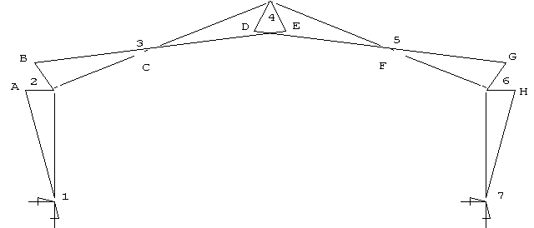

|  |  |  |  |  |  |  |
| --- | --- | --- | --- | --- | --- | --- |
| A = 1.1 |  | B = 1.1 |  | C = 0.1 |  | D = 0.9 |
| E = 0.9 |  | F = 0.1 |  | G = 1.1 |  | H = 1.1 |

**Axial Forces for Load Combination C1**

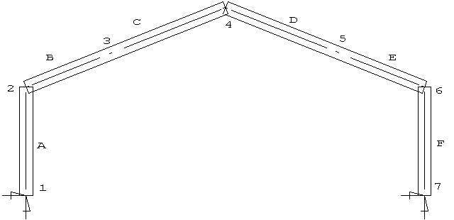

|  |  |  |  |  |
| --- | --- | --- | --- | --- |
| A = 0.8 |  | B = 0.6 |  | C = 0.6 |
| D = 0.6 |  | E = 0.6 |  | F = 0.8 |

PAGE 20

**MIDDLETON AND ASSOCIATES CC**

**CALCULATION SHEET**

**REF: 929-2 DATE: 17-11-2006**

**TITLE: MTT TENT STRUCTURES**

**Bending moments for Load Combination C2**

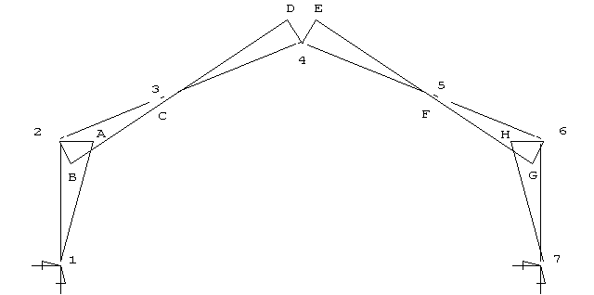

|  |  |  |  |  |  |  |
| --- | --- | --- | --- | --- | --- | --- |
| A = 3.7 |  | B = 3.7 |  | C = 0.1 |  | D = 1.1 |
| E = 1.1 |  | F = 1.0 |  | G = 1.3 |  | H = 1.3 |

**Axial Forces for Load Combination C2**

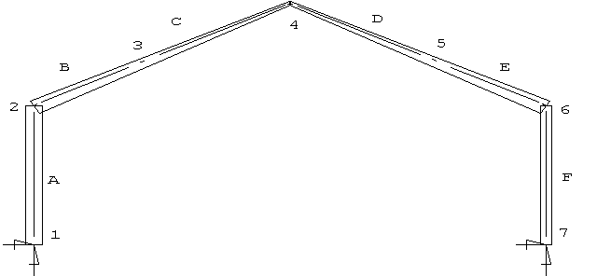

|  |  |  |  |  |
| --- | --- | --- | --- | --- |
| A = -2.4 |  | B = -1.3 |  | C = -0.9 |
| D = -0.8 |  | E = -1.1 |  | F = -1.6 |

PAGE 21

**MIDDLETON AND ASSOCIATES CC**

**CALCULATION SHEET**

**REF: 929-2 DATE: 17-11-2006**

**TITLE: MTT TENT STRUCTURES**

**Bending moments for Load Combination C3**

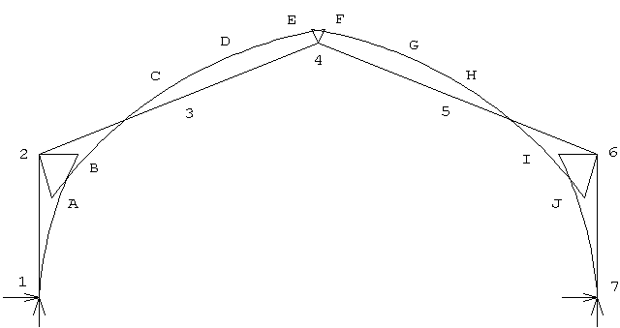

|  |  |  |  |  |  |  |
| --- | --- | --- | --- | --- | --- | --- |
| A = 2.8 |  | B = 2.8 |  | C = 0.7 |  | D = 0.8 |
| E = 0.8 |  | F = 0.7 |  | G = 2.8 |  | H = 2.8 |



**Axial Forces for Load Combination C3**

|  |  |  |  |  |
| --- | --- | --- | --- | --- |
| A = -2.7 |  | B = -2.4 |  | C = -1.9 |
| D = -1.9 |  | E = -2.4 |  | F = -2.7 |

PAGE 22

**MIDDLETON AND ASSOCIATES CC**

**CALCULATION SHEET**

**REF: 929-2 DATE: 17-11-2006**

**TITLE: MTT TENT STRUCTURES**

**3.2 BRACING CABLES**

BASED ON MAXIMUM TENSION ie 15M FRAME

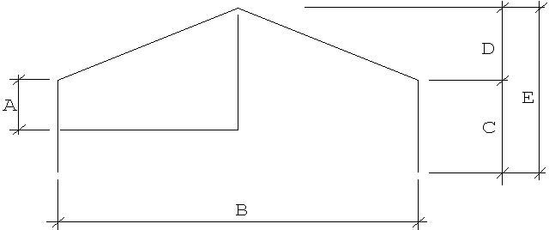

**3.2A VERTICAL FIELD BRACING** = 6mm DIA STEEL CA BLE

A = 1275mm B = 20000mm C = 2550mm

D = 3800mm E = 6350mm

Gable tributary area = 10 X 1.275 + 10 X 3.8 /2 = 32 m2

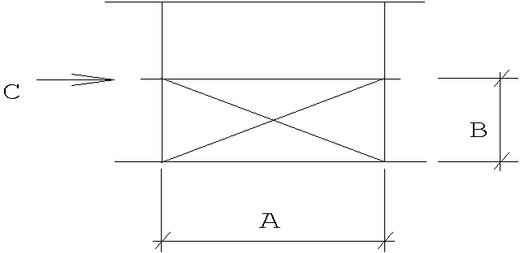Wind pressure at eaves = 0.289 x (0.7 + 0.2) x 32 = 8.32 KN

Force in cable = 8.32 / cos 26 deg = 9.27 KN

A = 5000mm

B = 2550mm

6MM cable S.W.L. = 3.7 KN (Factor of Safety 1:6) C = 8.32 KN

S.W.L. = 14.8 KN (Factor of safety 1:1.5) ANG = 26 DEG

**WORKING FACTOR OF SAFETY = 3.7 x 6 / 9.27 = 3.39**

ACCEPTABLE

PAGE 23

**MIDDLETON AND ASSOCIATES CC**

**CALCULATION SHEET**

**REF: 929-2 DATE: 17-11-2006**

**TITLE: MTT TENT STRUCTURES**

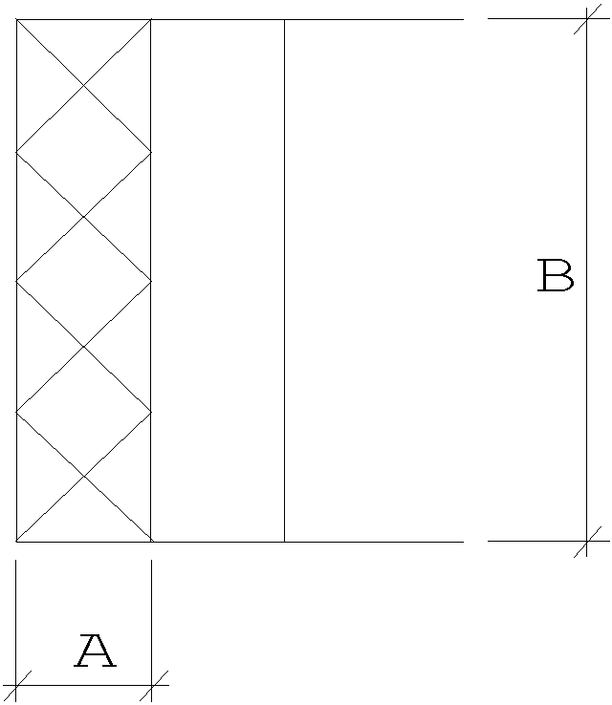**3.2B RAFTER FIELD BRACING**

A = 5000mm B = 20000mm

TRIBUTARY AREA OF RAFTERS = 20 x 1.275 + 20 x 3.8 / 2 = 64 m2

TOTAL WIND PRESSURE = 0.289 x (0.7 + 0.2) x 64 = 16.7 KN

**3.2C FORCE IN EAVES** = 8.35 KN

FORCE IN CABLE = 8.35 / COS 42 DEG = 11.24 KN

**WORKING FACTOR OF SAFETY = 3.7 x 6 / 11.24 = 1.98**

**ACCEPTABLE**

**3.4 EAVE STRUT**

SECTION = 138 x 58 x 2.5 ALUMINIUM RHS

MOMENT OF INERTIA Iyy = 0.0593 E6 mm4

CROSS SECTIONAL AREA = 955 mm2

RADIUS OF GYRATION R YY = 25 mm

L/r = 4900 / 25 = 196

Pc = 350 000 / 195^2 = 9.2 N/mm2

WIND FORCE = 8.35 KN

**Fc = 8.35 / 0.955 = 8.74 N/mm2**

**ACCEPTABLE**

**MIDDLETON AND ASSOCIATES CC**

**CALCULATION SHEET**

**REF: 929-2 DATE: 17-11-2006**

**TITLE: MTT TENT STRUCTURES**

**3.6 UPLIFT ON COLUMN BASES**

10m FRAME

|  |  |  |
| --- | --- | --- |
|  | LOADS IN KN | LOADS IN KN |
| LOAD COMBINATION | NODE 1 | NODE 7 |
| C2 | 2.3 | 1.5 |
| C3 | 2.7 | 2.7 |

PAGE 25

## PART 4 APPENDICIES

* 1. TENT CROSS SECTION & DIMENSIONS
  2. RAFTER & COLUMN STRUCTURAL SECTIONS
  3. WIND LOADINGS
  4. 10m FRAME WITH 5m BAY WIDTH

PAGE 26

**APPENDIX 4.1**

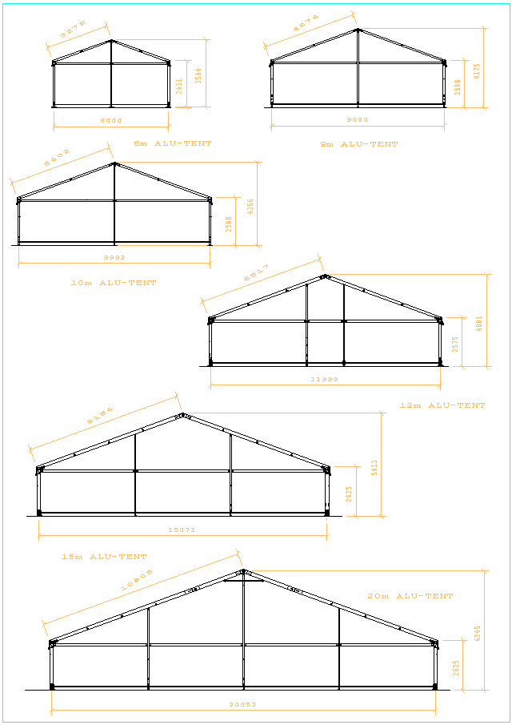**TENT SHAPE**

PAGE 27

**APPENDIX 4.2**

**APPENDIX 4.3**

**WIND LOADING**

**SABS 0160**

CLAUSE 4.5.2.4 TERRAIN CATEGORIES

CATEGORY 1

Exposed open terrain with few or no obstructions and in which the

average height of any objects surrounding the structure is

less than 1,5 m. this category includes open sea coasts and flat,

treeless plains with little vegetation other than grass

CATEGORY 2

Open terrain with well scattered obstructions having heights

generally between 1,5 m and 10 m. This category includes most

airfields, open parklands, and undeveloped sparsely built up out‑

skirts of towns and suburbs. It is the category on which the

regional basic design wind speed V is based

CATEGORY 3

Terrain with numerous closely spaced obstructions having the size

of domestic houses. This category includes well wooded areas and

suburbs, town and industrial areas, fully or partially developed

CATEGORY 4

Terrain with numerous large, high, closely spaced obstructions.

This category includes large city centres

Because of the large differences in wind speeds between Terrain

Categories 2 and 3, and where there is doubt whether the terrain

under consideration falls into Category 2 or 3, the design wind

speed may be obtained by interpolation between the values for

these two Categories

PAGE 28

CLAUSE 4.5.2.3 MEAN RETURN PERIOD

Nature of building or component Mean Return

Period, Years

All buildings other than those given below 50

Buildings which have a special post

disaster function, eg hospitals,

communications buildings etc 100

Buildings presenting a low degree of hazard

to life and other property in case of

failure, eg isolated towers, farm buildings

etc, side cladding to industrial buildings

and roof covering to all buildings 25

For analysis of serviceability considerations 10

Buildings and temporary works used only

during construction operations, eg formwork

and falsework, site offices, etc 5

TABLE OF WIND PRESSURES KN/M ON MEMBER

5 YEAR RETURN PERIOD

|  |  |  |
| --- | --- | --- |
| VELOSITY | PRESSURE | COEFFICIENTS |

|  |  |  |  |  |  |
| --- | --- | --- | --- | --- | --- |
| 28 m/s | 0.289 kn/m2 | 1.01 | 0.72 | 0.58 | 0.29 |
| 30 m/s | 0.315 kn/m2 | 1.10 | 0.79 | 0.63 | 0.32 |
| 31 m/s | 0.354 kn/m2 | 1.24 | 0.89 | 0.71 | 0.35 |
| 35 m/s | 0.429 kn/m2 | 1.50 | 1.07 | 0.86 | 0.43 |

PAGE 29