S. Sanschagrin

Flat 1

55 Frognal

London NW3 6YA

Camden

Regeneration and Planning Development Management

London Borough of Camden

Town Hall

Judd Street

London, WC1H 8ND

9 April 2014

For the attention of Mr Niall Sheehan

Dear Mr Sheehan,

**Reference: PLANNING APPLICATION NO 2014/1616/P**

*44 Frognal Lane: Proposed conversion of single dwelling into a larger dwelling with a self contained unit, extension and demolition of garage, by Mr. Jonathan Glassberg.*

Thank you for offering us an opportunity to express our views on this application. My property is located directly behind the proposed development side and I have examined the plans in detail. I wish to object strongly to the development under the current proposal. I would like to request that Camden Council refuse the planning application by Mr Glassberg. My objections are explained below.

**Policy DP2**

First of all, in relation to Policy DP2, I would like to point out that the proposal is misleading as it implies a creation of an addition housing unit. In fact, the extension to 44 Frognal Lane already functions as a separate unit, has its own separate entrance, an entry path and a front door (right behind the wall of my rear garden). My impression is that it has been used as a rental property as I’ve seen (and heard) different people using it in the last 4 years.

Therefore the proposal does nothing to improve the supply of housing in Camden. It merely increases the size (and of course value) of an already substantial luxury property. The enlarged extension is in fact designated to be a nanny’s flat, according to the drawings.

**Policy DP24**

Secondly, the proposal does not meet the requirement to give consideration to the proportions of the existing buildings, scale of neighbouring buildings, topography and trees. According to the proposal, the site is misleadingly defined as “essentially one of fairly remote large houses glimpsed behind wall, trees and hedges”.

This is simply not true. The plan of the area clearly shows that the site is already densely built on. In particular, 3 flats in 55 Frognal are situated less than 8 meters away from the proposed excavation / erection of a much taller dwelling replacing the existing 1 storey extension. The separate bungalow attached to 55 Frognal is adjacent to the boundary wall where the excavation works would start. 53 Frognal is also in direct proximity of the construction site. Importantly, for both 55 and 53 Frognal, west-facing rooms are most quiet in the building, benefiting from the view onto the garden and enjoying afternoon sun.

In fact, the entire proposal is not balanced in the assessment of its impact on surrounding properties. It focuses entirely the view from Frognal Lane and entirely ignores the severe negative impact to the neighbouring properties on its East and South, including:

1. **Structural damage from the ground movement as a result of the extensive excavation**

The excavation is proposed to start right at the boundary wall of 55 and 53 Frognal. For Nr 55, this is 0.5m away from the garden tiled with travertine, with brick / travertine decking against the back wall (see photo below).

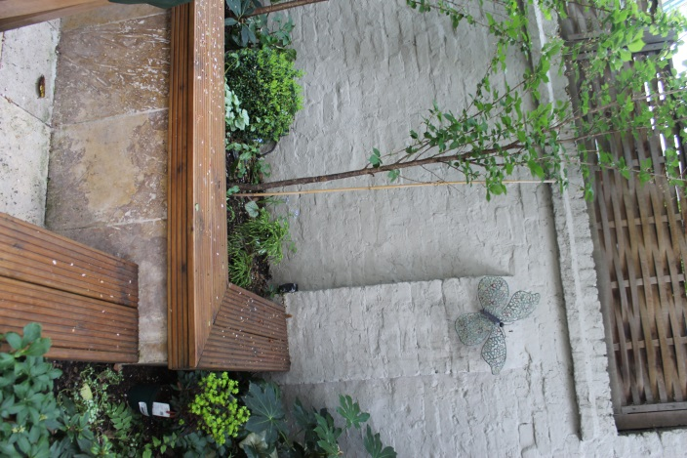

The garden was landscaped only 2 years ago. The movement at the base of the excavation is estimated at 10mm, according to the Basement Assessment, extending 3-4 times the excavation depth, i.e. all the way to the wall of 55 Frognal main building. Ground movement of this scale will cause multiple tile / brickwork cracks, resulting in a direct damage to the property.

Redecoration, masonry work and repointing might be required for the main building as well. This will be disappointing as 55 Frognal is just about to start expensive external refurbishment works.

1. **Significant loss of light to the main bedrooms and the garden due to the construction of a much taller separate unit and a ‘cupola’ section replacing the existing 1-storey extension at the back of 55-53 Frognal**

Although the height of the proposed ‘self-contained dwelling’ and the cupola section is not explicitly specified anywhere in the proposal, it is visible from the drawings that it is envisaged to be as high as the top of the tiled roof of the existing extension. The cupola part will be even higher, through the drawings selectively omit this detail.

At present, the tiled roof of the extension behind 55-53 Frognal extends to only ~50% of the rear garden of 55 Frognal, leaving a considerable gap of ~2.5m that allows sun through (see pictures below). Under the proposal, the gap will disappear entirely and the garden of 55 Frognal will lose all sunlight currently coming from the west. The impact will be drastic for the small (6m x 8m) garden that has 4 large trees on the south and west borders and already receives little sunlight being enclosed on 3 other sides by the surrounding properties / boundary wall.

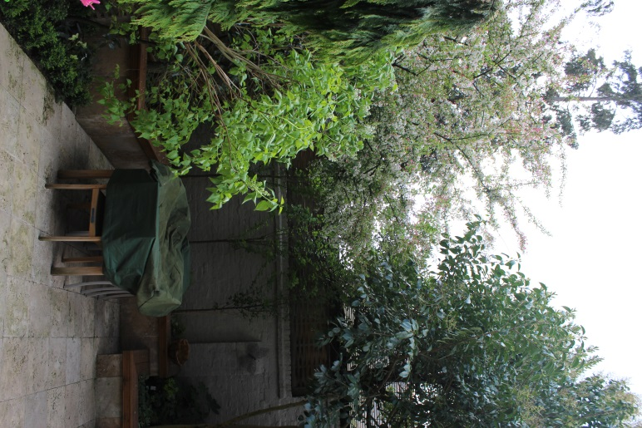 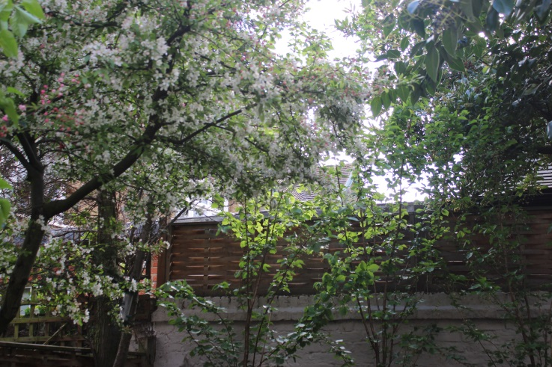

1. **Obstruction, loss of view and a complete enclosure of 55 Frognal back side; potential fire safety issues.**

The proposal involves extending the footprint of the existing extension all the way to the boundary wall of 55 – 53 Frognal. This means the tall wall will move 2 meters closer to 55 Frognal, resulting in over 20% reduction in the open space between the windows in the main bedrooms and the neighbouring dwelling. In addition to the abovementioned loss of light, this will become overbearing and create a sense of complete enclosure for 55 Frognal.

Importantly, the access to the back of 55 Frognal from the street will be lost. This is concerning: in the event of a fire hazard 2 main bedrooms on the ground floor will be completely inaccessible. This is a serious worry for me, particularly as I am a single parent living with 2 children whose bedroom is located at the back of the house.

1. **Health hazard from dust and dangerously high level of heavy metals found in the site’s soil. Loss of quality of life from being unable to use the garden for a prolonged period time given close proximity of demolition / extensive excavation works.**

I am particularly alarmed about the high reading on some toxic metals found on the site, e.g. 447 mg / kg for lead (and even higher maximum readings as per Risk Management Geological Report attached to the proposal). I am concerned that the extent of environmental pollution caused by the project will effectively prevent us from using our garden for the duration of the works and more generally cause a high level of pollution for the area as a whole.

1. **Adverse impact on the environment due to loss of trees.**

The proposal envisages cutting several deciduous trees at 44 Frognal Lane, which is a shame. In addition, where will be loss of vegetation in the gardens of 55-53 Frognal due to loss of light and digging close to the tree roots at the boundary wall.

1. **Adverse impact of the proposed features on the character of the neighbourhood and its skyline.**

The proposed tall cupola will alter the skyline of our area. Contrary to the report, this feature will be visible from Frognal Lane and will be directly in front of all neighbouring properties alongside Frognal. It will have an adverse effect on the character and appearance of the Conservation Area.

To summarise, I request that Camden Council refuse the Planning Applications and encourages Mr Glassberg to make changes to his proposal, taking into consideration the impact on neighbouring properties and on the environment.

I would like to point out that 44 Frognal Lane is a massive plot of perhaps 10,000 square meters. It is difficult to justify the need to extend the already substantial property in every dimension (up, down and depth-wise) in the way outlined the Proposal, causing obstruction, loss of light, loss of vegetation and potential structural damage to so many smaller and more enclosed neighbouring properties.

Specifically, it is hard to explain the rationale for digging the basement directly at the boundaries of the neighbouring properties and pushing the walls all the way to block neighbours’ gardens when there is so much space available for this purpose on the other side of the plot where such works would likely cause much fewer risks and concerns for the neighbours and the area as a whole.

If this application is to be decided by councillors, please take this as notice that I would like to speak (work permitting) at the meeting of the committee, at which this application is expected to be decided. Please advise me as soon as possible the date of the meeting.

Yours faithfully,

S. Sanschagrin

M: 07909 532 586