53 Frognal

London

NW3 6YA

Regeneration and Planning

Development Management

London Borough of Camden

Town Hall

Judd Street

London

WC1H 8 ND

11th April 2014

Dear Mr Sheehan

**Re: Planning Application Consultation 2014/1616/P**

**44 Frognal Lane, NW3 6PP**

*“Conversion of single dwelling into two self contained dwellings including partial demolition of the front extension and replacement with larger extension incorporating separate dwelling and single story side extension replacement with similar footprint involving demolition of existing single story garage”*

Thank you for your letter dated 27th March 2014 regarding the above planning application. Our home is adjacent to the proposed development site, along the East side, and am writing to request that Camden Council refuse this planning application from Jonathan Glassberg of Michael Burroughs Associates.

Before I state my specific objections as to the application, I would like to comment on certain omissions and statements in the Planning Application Consultation Letter, Design and Access and Heritage Statement as well as the Proposed Site Plan.

1. **PLANNING APPLICATION CONSULTATION LETTER**

The Planning Consultation Letter mentions a single storey side extension but no mention is made of the fact that the proposed side extension is to incorporate a basement which includes a swimming pool. The Application Letter is not a true reflection of the proposed works to 44 Frognal and is misleading.

**2. DESIGN & ACCESS STATMENT AND HERITAGE STATEMENT**

1. In the Design & Access Statment And Heritage Statement submitted for this application, **Paragraph 1** states that the proposal will involve the splitting of this home into a ‘slightly larger extension’ and that the single story extension will be replaced with a ‘similar footprint’ as well as the ‘construction of a basement’.

Looking at the proposed drawings it can be surmised that the proposed drawing shows a large extension and that the single story extension is of a much larger footprint and not of a ‘similar footprint’. When mentioning the single storey extension no mention is made of the proposed swimming pool.

1. Although **Paragraph 2** correctly states that the building is in a Conservation Area it does not identify that it is adjacent to a listed building, 51 Frognal.
2. **Paragraph 10** states that ‘the photo below shows that the local townscape is essentially one of *fairly remote* large house glimpsed behind wall, trees and hedges”. This area is not at all a “fairly remote” area; it is adjacent to 5 properties.

Looking at the photo it is clear that the 44 Frognal Lane is in very close proximity to 4 flats in 55 Frognal, 3 flats in 53 Frognal as well as 4 flats in 51 Frognal. In fact, our bedroom wall is just one meter away from the boundary wall; a bungalow on 55 Frognal is on the boundary wall, as is a listed summer house in 51 Frognal.

I must also state that the aerial photo does not clearly show the flat roof single storey flat at no 55, which adjoins 44 Frognal Lane.

1. According to **Paragraph 12**, the proposal contributes to **Policy DP2** as it is maximizing on the supply of housing on sites that are underused. At present, the existing extension is already a separate dwelling with its own private entrance. It therefore has already contributed to the supply of housing and extending it does not improve the housing situation.
2. **Paragraphs 13** states that according to **DP23**, Conservation Areas should “only permit development within conservation areas that preserves and enhances the character and appearance of the area” and **Paragraph 14** states that according to DP24 the Council requires that all developments consider “the scale of the neighbouring buildings” when alterations and extension are proposed.

These points have not been taken into consideration with this proposed application. The proposed extension and increase in height of the shared wall will completely obstruct light into the garden of 53 Frognal. This extremely high separating boundary wall will also add to overbuilding and sense of enclosure.

1. I must also point out a serious omission. On **page 9** the proposed replacements are shown in red. In the extension on the North/East side the cupola on top of the new dwelling is completely omitted from the red replacement roof. If comparing this to the **East Elevation of the Proposed Drawing** the cupola is higher than the cables on the roof. This serious omission in the Planning, Design, Access and Significance Appraisal does not give the true visual impact of the building to the neighbouring buildings and is very misleading.

**3. PROPOSED SITE PLAN**

1. The **Proposed Basement Plan** shows a large basement that is under a large portion of the front garden. The size of the basement appears to be disproportionate to the size of the host building. It is also against the boundary wall between both 55 and 53 Frognal. This will require an extensive portion of the garden to be excavated causing loss to trees and flowers as well as extensive excavation to the shared wall between the properties on Frognal Lane. Also the excavation would be in extremely close to the main bedroom in Flat 1, 53 Frognal.
2. The **Proposed First Floor Plan** shows the cupola on the extension and the flat roof running through the entire North/East perimeter. To achieve this flat roof around the perimeter the boundary wall would have to be raised from the existing height. This added height to the wall will further add to overbuilding and sense of enclosure. This will also have a serious impact on the amount of daylight/sunlight the neighbouring properties will receive. The photo below is of the main bedroom at Flat 1, 53 Frognal and its present proximity to an already high wall. The distance between the bedroom and the existing wall is just over 1m.

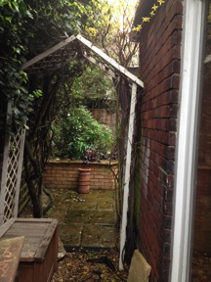

The photo below is of the main bedroom back window that faces west. This clearly shows it proximity to the shared wall. A higher wall than the existing wall will have a negative impact on the window.

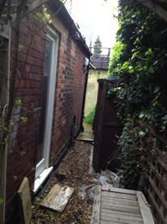

1. The **Proposed Second Floor Plan** shows how the roof configuration will alter. Particular notice should be taken to the North/East roof. The proposed roof is much closer and nearer to the neigbouring properties. The photos overleaf show the present North/East roof scape from 53 Frognal. Looking at the proposed roof on the **East Elevation** it is obvious that the proposed roof will be overbearing and have an oppressive effect to neighbouring properties and ours.

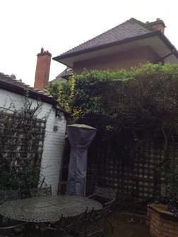

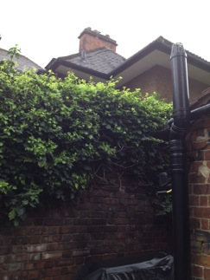

1. The **Proposed Elevations/2 East Elevation** shows the proposed new roofs as well as the cupola and the cables and the extension to the boundary wall. Compared to the Existing East Elevation a much smaller area is left open to allow sun light through. The photograph below shows the existing extension from the back garden of 53 Frognal.

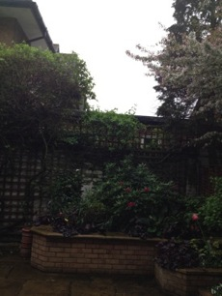

Below is the same aspect from the lounge of Flat 1, 53 Frognal. The proposed higher wall will block out the sunlight in both the windows below and the north facing patio window of the main bedroom.

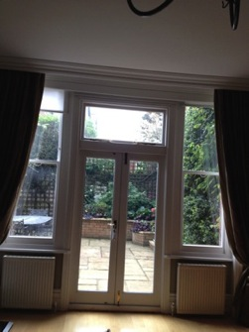

1. The **Front Elevation** for both the existing and the proposed have omitted the windows in Flat 2 of 53 Frognal. This is a serious omission as it does not give a true reflection of the impact this application will have on Flat 2, 53 Frognal. The photo below depicts the windows in Flat 2, 53 Frognal as well as the main bedroom extension and lounge patio doors of Flat 1.

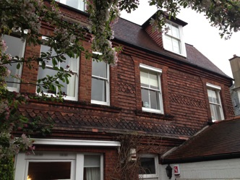

**OBJECTIONS**

I wish to object strongly to the proposed application and I herewith submit my objections which are:

1. By omitting mention of the proposed work to the basement, the **Application Work Notice letter** is in no way a true reflection of the proposed work.
2. Inaccuracies and Omissions of the cupola in the **Design & Access Statement And Heritage Statement** and the window aspect of Flat 2, 53 Frognal in the **Front Elevation** for both the existing and the proposed plans
3. The proposed, extremely large basement takes up a disproportionate portion of the garden and evidence shows that it can disrupt the local water table and drainage, as well as cause serious damage to nearby properties, risk to environment and risk to trees.
4. Unacceptably high density and overdevelopment of the site, especially as it involves loss of garden land and the open aspect of the neighbourhood as well as the roof scape in a Conservation Area.
5. Adverse effect on the residential amenity of neighbours, by reason of overcrowding, overshadowing and loss of light.
6. Effect of the development on the character of the neighbourhood.
7. The loss of existing views from neighbouring properties would adversely affect the residential amenity of neighbouring owners.
8. The adverse effect of the development on the character and appearance of the Conservation Area.
9. The development on the setting of the Listed Building at 51 Frognal.
10. Adverse impact on trees and greenery.

Therefore, we request that Camden Council refuse this Planning Application and encourage Mr Glassberg to resubmit a building design that is smaller, less intrusive on neighbouring properties, and more sensitive to the character of the area.

If this application is to be decided by councilors, please take this as notice that I would like to speak at the meeting of the committee at which this application is expected to be decided. Please let me know the date of the meeting.

Should you require any additional information, clarification of any comments made, or would like to arrange a visit to our home; do not hesitate to contact me on 020 7794 8590 or 07957 324 140.

Yours Sincerely,

Mrs Anticoni Vekinis