Liz Pether, Iqbal Bundhun , Jo Konrad 13Wedderburn Road and Unit3, 15 Wedderburn Road London NW3 5QS

12 January 2014

Dear All

**Re planning application No** **2013/7182/P Flat 1 15 Wedderburn Raod London NW3 5QS**

I have reviewed the documents submitted to date for this application and as instructed have given consideration as to how the proposed works could affect Units 2 and 3 of No. 15 Wedderburn Road and No 13 Wedderburn Road

No.15 is split into three separate units: Unit 3 on the 2nd floor, Unit 2 on the 1st floor and Unit 1 on the ground and lower ground levels. The flank wall of No 13 is close to the East flank wall of No.15

The planning application made by Unit 1 proposes increasing the current area of their flat from 367m2 to 675m2 by extending the garden level flat into the front and rear garden at lower ground level and by creating a new basement level across the full extended footprint extending between 4m and 6m below the current lower ground floor level which is at OD level 77.28. This represents a significant excavation in a sensitive location.

Due to the presence of ground water at 76m OD the existing foundations cannot be traditionally underpinned to the depth required .The proposal is therefore to construct a secant pile wall which involves boring overlapping piles for the full perimeter of the excavation into the London clay which was encountered in the site investigation borehole logs at 73m OD

Typically a secant pile wall through water bearing strata is constructed using a continuous flight auger rig. It is unclear from the submission how this would be achieved with a reduced headroom rig. It should also be noted that Berry Piling that operate the 3.5m headroom rig recommended in the report went into liquidation in September 2013.

There is no discussion in the report of how the owner occupiers of Unit 3 should access their flat during the works and where they should park their car when piles are being installed across their front door and parking bays. There is also an elevator servicing Unit 3 which seems to have been ignored in the proposals as no provision has been made for the existing lift pit in the proposed scheme. The occupants of unit 3 use the lift on daily basis and could not be without this facility for any length of time.

The extensive temporary support works that would be required to support the 1st and 2nd floors of the building during construction have not been described in detail. From consideration of the changes proposed the scale of disturbance and risk of damage would be onerous for the owner occupiers of units 2 and 3.This submission is unacceptable without a detailed description of how the proposed temporary propping would be carried out.

There is mention in the soil report of settlement and heave associate with this work which could affect No. 13 as well Units 1 and 2. There is no detailed analysis of the extent of this movement and how it would be mitigated

As well as the technical challenges raised by the proposal the noise and disruption over the construction period would be considerable for the occupants of Flats 2 and 3 as well as the occupants of No.13**.**

As currently shown on the drawings over 270 piles up to 15m long will be installed requiring the removal of up to 900 cubic meters of spoil and the importation of the same amount of concrete for this exercise alone. This equates to 3-4 skip removals and 3-4 concrete truck deliveries per day based on the estimate that piling would be completed in an 8 week period.

Following installation of the piling it is suggested that the secant piled wall will be sprayed with concrete to a thickness of 150mm. This will require a further 240 cubic meters of concrete or 40 concrete truck deliveries. The extent and thickness of the new concrete floors was not defined in the report however if the new floors are an average of 300mm thick a further 200 cubic meters of concrete would be required which means a further 34 concrete truck deliveries

In addition to the above the basement excavation will generate over 1000 cubic meters of soil requiring over 125 skips to remove.

The impact of this volume of heavy construction traffic on this residential area will be extremely noisy, disruptive and potentially hazardous for pedestrians.

It states in the planning application that the proposed plans have been prepared in the spirit of the National Planning Policy Framework in that they will provide a sustainable benefit for Unit 1. This may well be the case but the same could hardly be said for the owner occupiers of Units 2 and 3 and No.13 who will have to suffer serious disturbance over a considerable period exacerbated by the fact that they are elderly and likely to be at home during all the building operations. When it is considered that this major undertaking will effectively create an underground parking space which is perfectly adequately provided for at present at ground floor level, a home cinema and a re-sited swimming pool it is hard to understand how this development can be considered as sustainable in a wider context.

I would strongly recommend that the planning application is rejected on the basis that it is unsustainable for the owner occupiers of flats 2 and 3. And highly disruptive for the occupants of No.13

I would further suggest that there are technical problems with the application that have not been addressed.

The following give particular cause for concern:

How the secant piling will be installed is not resolved and as the excavation and stability of the retained structures depends on this technique it is vital that this issue is addressed.

The temporary support of the first and second floor structures is indicative only. Considerably more information would be required to feel confident that this work could be carried out without causing settlement or structural damage to the upper levels particularly as supports at the underside of first floor level would initially take support at lower ground floor level which would in turn be demolished to create the new basement.

Calculated ground movements and how they would affect Nos 13 and 15 have not been addressed.

Currently the application has no strategy for continuous access to Unit 3, supporting the existing elevator or disruption to the car parking bays for the same Unit.

For all the above reasons I would recommend strongly opposing this application

Yours sincerely

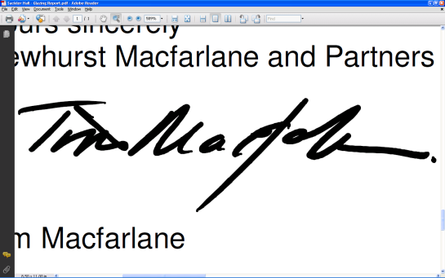

Tim Macfarlane CEng MIStructE RDI Hon FRIBA