List Entry Summary
This building is listed under the Planning (Listed Buildings and Conservation Areas) Act 1990 as amended for its special architectural or historic interest.

Name: No name for this Entry

List Entry Number: 1113267

Location
34-37, PERCY STREET
The building may lie within the boundary of more than one authority.
County: Greater London Authority
District: Camden
District Type: London Borough
Parish:

National Park: Not applicable to this List entry.

Grade: II

Date first listed: 25-Jul-1989

Date of most recent amendment: Not applicable to this List entry.

Legacy System Information
The contents of this record have been generated from a legacy data system.

Legacy System: LBS

UID: 477754

Asset Groupings
This List entry does not comprise part of an Asset Grouping. Asset Groupings are not part of the official record but are added later for information.

List Entry Description

Summary of Building
Legacy Record - This information may be included in the List Entry Details.

Reasons for Designation
Legacy Record - This information may be included in the List Entry Details.

History
Legacy Record - This information may be included in the List Entry Details.

Details
CAMDEN
TQ2981NE PERCY STREET
798-1/99/1301 (North side)
25/07/89 Nos.34-37 (Consecutive)
GV II
4 terraced houses. 1766-70; refronted 1950s. Flemish bond
brick; mansard slate roof with brick ridge and end stacks and
dormers.
EXTERIOR: 3 storeys and attics; 11 window range. Stucco
semicircular arched architrave with fanlight to mid-C18
6-panelled door to No.34, C20 door to No.35, C20 door framed
by pilasters to No.36 and early C19 panelled door set in early
C19 reeded architrave to No.37. Gauged red brick flat arches
over 12-pane sashes and 9-pane second-floor sashes; plain
storey bands. Cornice and blocking course.
INTERIORS: No.36 has mid C18 open-well staircase with fine
foliated wrought-iron balustrade, mid C18 panelled doors set
in moulded architraves, enriched and moulded cornicing to
ground and first floor rooms; 1st floor has moulded dado rail
to front room which has mid C18 double doors with original
hinges opening into rear room with fine mid C18 fireplace
having central swag and fluted frieze. No.36 has similar mid
C18 doors and cornicing, early C19 marble fireplaces, mid C18
moulded skirtings and dado rails and early C19 open-well
staircase with stick balusters. No.34 has similar mid C18
doors and cornicing. No.35, interior not inspected.
Listing NGR: TQ2955381574

Selected Sources
Legacy Record - This information may be included in the List Entry Details.

Map

National Grid Reference: TQ 29553 81574
The below map is for quick reference purposes only and may not be to scale. For a copy of the full scale map, please see the attached PDF - 1113267.pdf
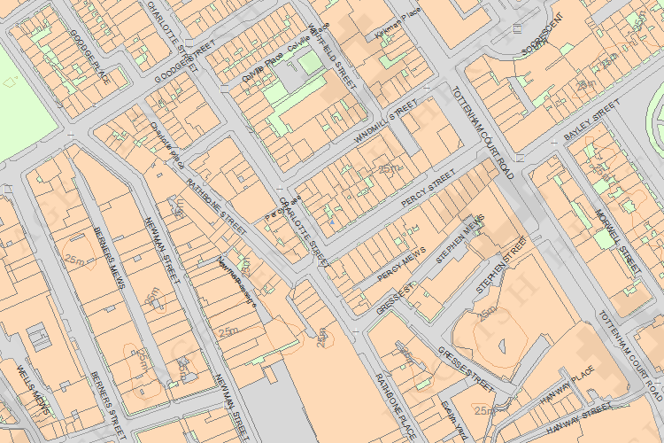
© Crown Copyright and database right 2012. All rights reserved. Ordnance Survey Licence number 100019088.
© British Crown and SeaZone Solutions Limited 2011. All rights reserved. Licence number 102006.006.

This copy shows the entry on 05-Jun-2014 at 11:44:52.

