Nathaniel Lichfield & Partners
14 Regents Wharf
All Saints Street
LONDON
N1 9RL
14 Regents Wharf  All Saints Street  LONDON  N1 9RL |  | Application Ref: 2014/2986/P
 |  | Please ask for: Gideon Whittingham
 |  | Telephone: 020 7974 5180
 |  | 16 May 2014

Dear Sir/Madam

DECISION

Town and Country Planning Act 1990 (as amended)
Town and Country Planning (Development Management Procedure) Order 2010
Prior Approval Required - Approval Refused

Address:
5 & 6 Cliff Villas
London
NW1 9AL

Proposal:
Demolition of buildings.
Drawing Nos: Method Statement for Dismantling Works, prepared by Heydon and Carr and Appendix 1: Risk Assessment Record, Structural Engineer's Report prepared by Price and Myers, PL 002, PL 003,PL 004, PL 005, PL 006, PL 007, PL 008, PL 009, PL 010, PL 011,PL 012, PL 013, PL 014, PL 015, PL 016, PL 017.

The Council has considered your application for prior approval of siting and appearance in respect of the demolition described above and hereby refuses approval for the following reasons.

Reason(s) for Objection

1 | In the absence of adequate details of the proposed Method of Demolition, the proposed works are likely to result in harm to local air quality, cause obstruction, congestion, inconvenience and danger to pedestrians and other road users and damage to pavements, and cause harm to local amenity, contrary to policies CS5 (Managing the impact of growth and development), CS11 (Promoting sustainable and efficient travel) and CS16 (Improving Camden's health and well-being) of the London Borough of Camden Local Development Framework Core Strategy and policies DP20 (Movement of goods and materials), DP26 (Managing the impact of development on occupiers and neighbours), DP28 (Noise and vibration) and DP32 (Air quality and Camden's Clear Zone) of the London Borough of Camden Local Development Framework Development Policies.
2 | In the absence of an adequate details of the proposed restoration of the site, the proposed demolition is likely to result in harm to the appearance of the local environment, contrary to policies CS5 (Managing the impact of growth and development) and CS14 (Promoting high quality places and conserving our heritage) of the London Borough of Camden Local Development Framework Core Strategy and policy DP24 (Securing high quality design)of the London Borough of Camden Local Development Framework Development Policies.

In dealing with the application, the Council has sought to work with the applicant in a positive and proactive way in accordance with paragraphs 186 and 187 of the National Planning Policy Framework.

Yours faithfully
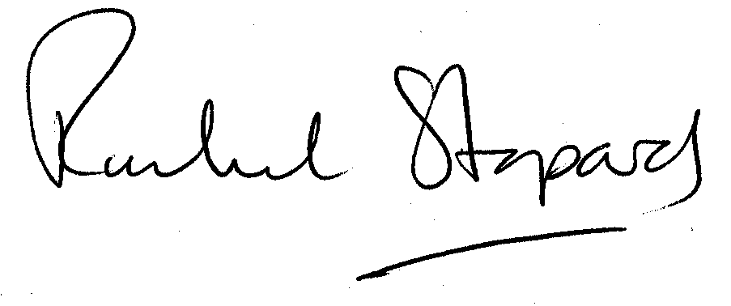
Rachel Stopard
Director of Culture & Environment

It’s easy to make, pay for, track and comment on planning applications on line. Just go to www.camden.gov.uk/planning.
It is important to us to find out what our customers think about the service we provide. To help us in this respect, we would be very grateful if you could take a few moments to complete our online survey at the following website address: www.camden.gov.uk/dmfeedback. We will use the information you give us to help improve our services.

