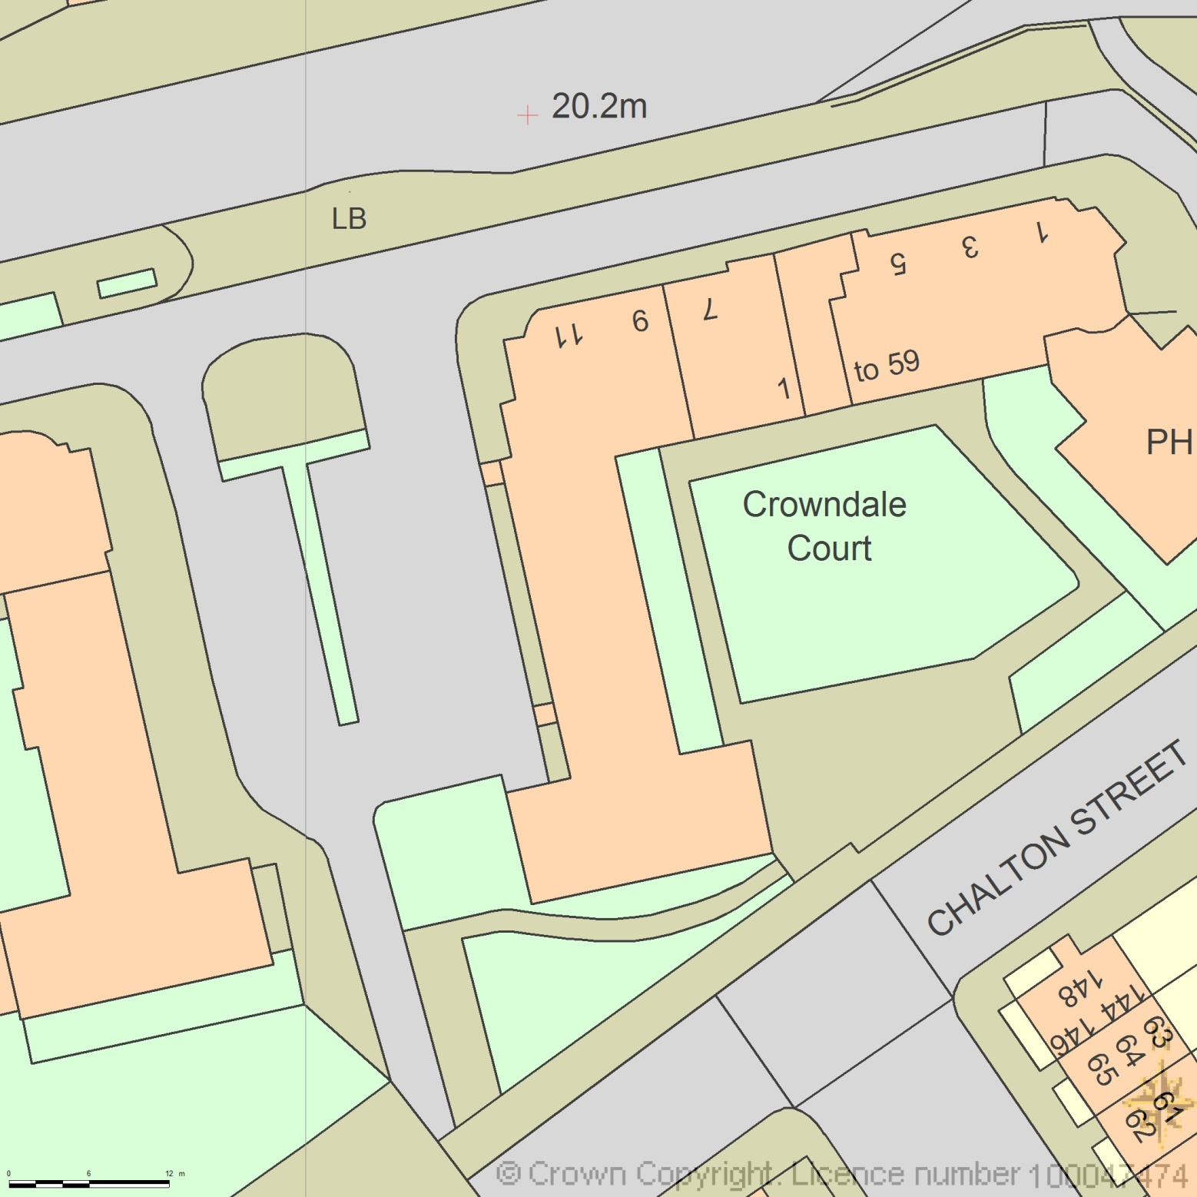BLOCK PLAN

AREA 90m x 90m

SCALE 1:500 on A4

CENTRE COORDINATES: 529522, 183446



Supplied by Streetwise Maps Ltd

www.streetwise.net

Licence No: 100047474

17/06/2014 11:06:08