SITE LOCATION PLAN
AREA 2 HA
SCALE 1:1250 on A4
CENTRE COORDINATES: 529522, 183446

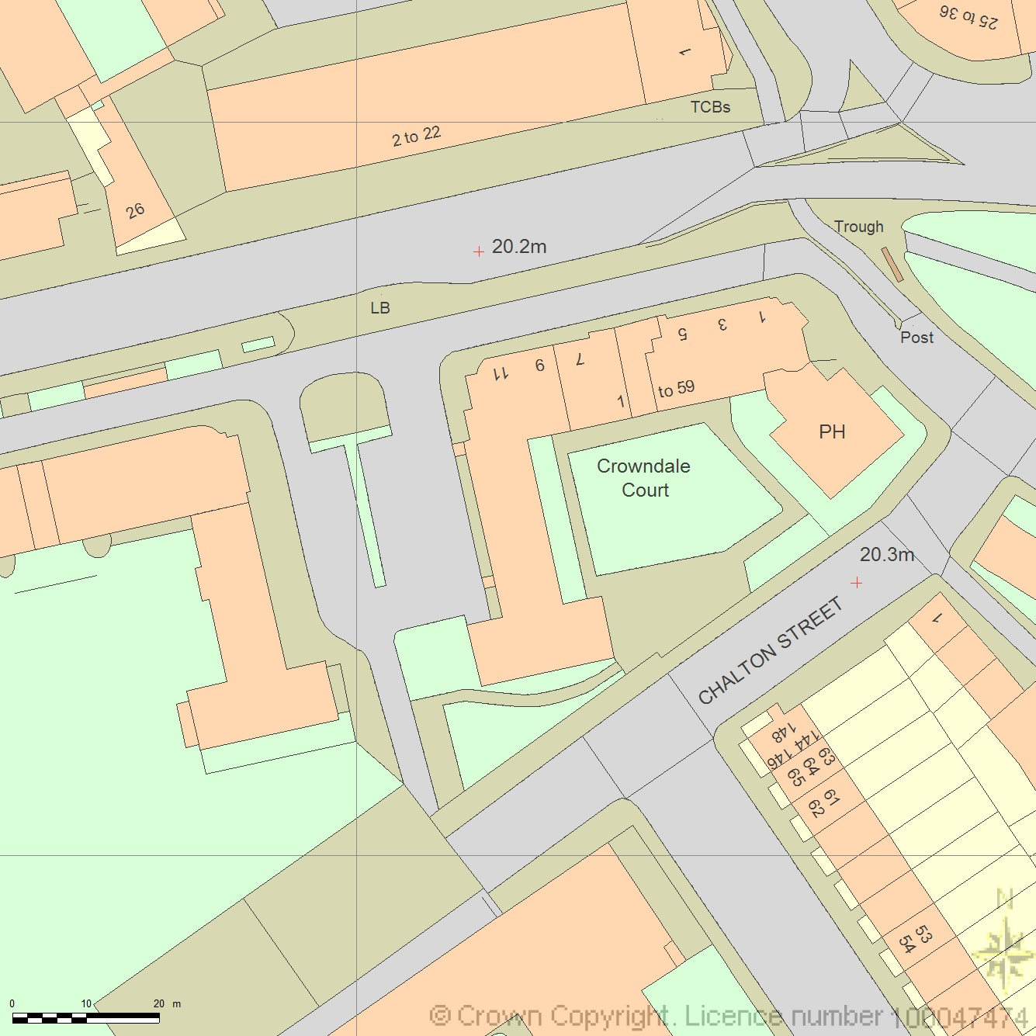



Supplied by Streetwise Maps Ltd
www.streetwise.net
Licence No: 100047474
29/07/2026 12:05

