Mr David Bache
Harrison
15 Coleshill Street Sutton
Coldfield
Birmingham
B72 1SD
15 Coleshill Street Sutton  Coldfield  Birmingham  B72 1SD |  | Application Ref: 2013/5792/P
 |  | Please ask for: Charles Thuaire
 |  | Telephone: 020 7974 5867
 |  | 28 October 2013

Dear Sir/Madam

DECISION

Town and Country Planning Act 1990 (as amended)
Town and Country Planning (Development Management Procedure) Order 2010
Town and Country Planning (Applications) Regulations 1988

Full Planning Permission Granted

Address:
King's Cross Station
Euston Road
London
N1 9AP

Proposal:
Installation of altered shopfront and new signage for retail unit in reconfigured circular ventilation shaft on new southern square, as approved on 16.1.12 (ref:2011/4782/P).
Drawing Nos: 2908/100, 101*, 102 Rev A, 200A, 01/A, 'Kings Cross Kiosk C' (fascia sign) Rev C

The Council has considered your application and decided to grant permission subject to the following condition(s):

Condition(s) and Reason(s):

1 | The development hereby permitted must be begun not later than the end of three years from the date of this permission.  Reason: In order to comply with the provisions of Section 91 of the Town and Country Planning Act 1990 (as amended).
2 | All new external work shall be carried out in materials that resemble, as closely as possible, in colour and texture those of the existing building, unless otherwise specified in the approved application.  Reason: To safeguard the appearance of the premises and the character of the immediate area in accordance with the requirements of policy CS14 of the London Borough of Camden Local Development Framework Core Strategy and policies DP24 and DP25 of the London Borough of Camden Local Development Framework Development Policies.
3 | The development hereby permitted shall be carried out in accordance with the following approved plans - 2908/100, 101*, 102 Rev A, 200A, 01/A, 'Kings Cross Kiosk C' (fascia sign) Rev C.  Reason: For the avoidance of doubt and in the interest of proper planning.
Informative(s):

Your proposals may be subject to control under the Building Regulations and/or the London Buildings Acts which cover aspects including fire and emergency escape, access and facilities for people with disabilities and sound insulation between dwellings. You are advised to consult the Council's Building Control Service, Camden Town Hall, Argyle Street WC1H 8EQ, (tel: 020-7974 6941).

In dealing with the application, the Council has sought to work with the applicant in a positive and proactive way in accordance with paragraphs 186 and 187 of the National Planning Policy Framework.

Your attention is drawn to the notes attached to this notice which tell you about your Rights of Appeal and other information.

Yours faithfully
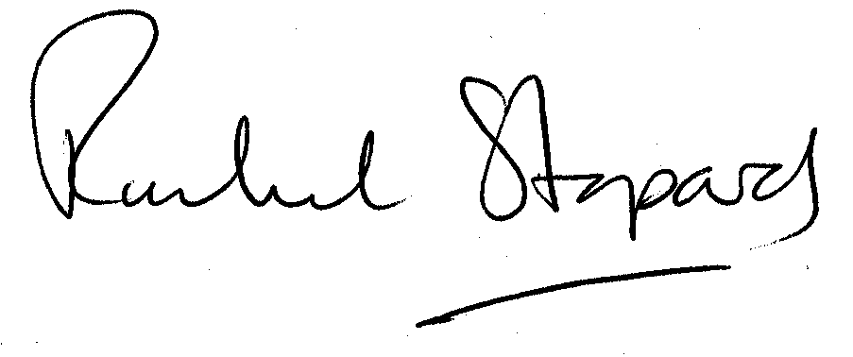
Rachel Stopard
Director of Culture & Environment

It’s easy to make, pay for, track and comment on planning applications on line. Just go to www.camden.gov.uk/planning.
It is important to us to find out what our customers think about the service we provide. To help us in this respect, we would be very grateful if you could take a few moments to complete our online planning applicants’ survey. We will use the information you give us to monitor and improve our services.

