Form London

Unit 22

1-7 Grenville Road

London

N19 4EH
Unit 22  1-7 Grenville Road  London  N19 4EH |  | Application Ref: 2014/1062/P
 |  | Please ask for: Niall Sheehan
 |  | Telephone: 020 7974 3968
 |  | 3 July 2014

Dear Sir/Madam

DECISION

Town and Country Planning Act 1990 (as amended)

Full Planning Permission Refused

Address:
110 Gloucester Avenue
London
NW1 8HX

Proposal:
Formation of curtain walling to existing external staircase to front of the building to provide a sheltered enclosure with associated front door. Alteration to the front facing gable end to form eaves and double dual pitch roof to southern element. Raising of the eaves and roof ridge to northernmost element to the front. Raising of eaves to rear and installation of 9 x windows to rear to create second floor level.

Drawing Nos:
Existing: 339 - 009P1, 010P1, 011P1, 012P1, 050P1, 051P1, 060P2, 061P1, 062P1, 063P1.
Proposed: 339 - 001, 099P4, 100P5, 101P4, 102P4, 150P6, 151P4, 152P5, 160P5, 161P6, 162P5, 163P4.

The Council has considered your application and decided to refuse planning permission for the following reason(s):

Reason(s) for Refusal

1 | The design of the proposed extension in terms of form, height, bulk, massing and detailed design would appear incongruous as an overly large and incompatible addition to the host building and the wider Primrose Hill Conservation Area, contrary to policies CS14 (Promoting high quality places and conserving our heritage), DP24 (Design) and DP25 (Conserving Camden's Heritage) of the London Borough of Camden Local Development Framework Core Strategy and Development Policies.

In dealing with the application, the Council has sought to work with the applicant in a positive and proactive way in accordance with paragraphs 186 and 187 of the National Planning Policy Framework.

You can find advice about your rights of appeal at:

http://www.planningportal.gov.uk/planning/appeals/guidance/guidancecontent

Yours faithfully
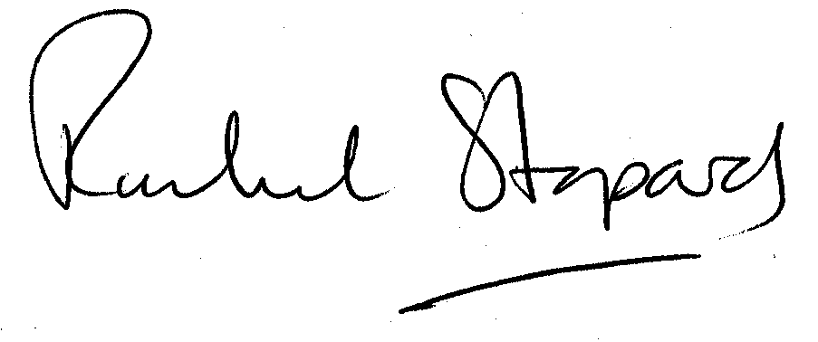
Rachel Stopard
Director of Culture & Environment

