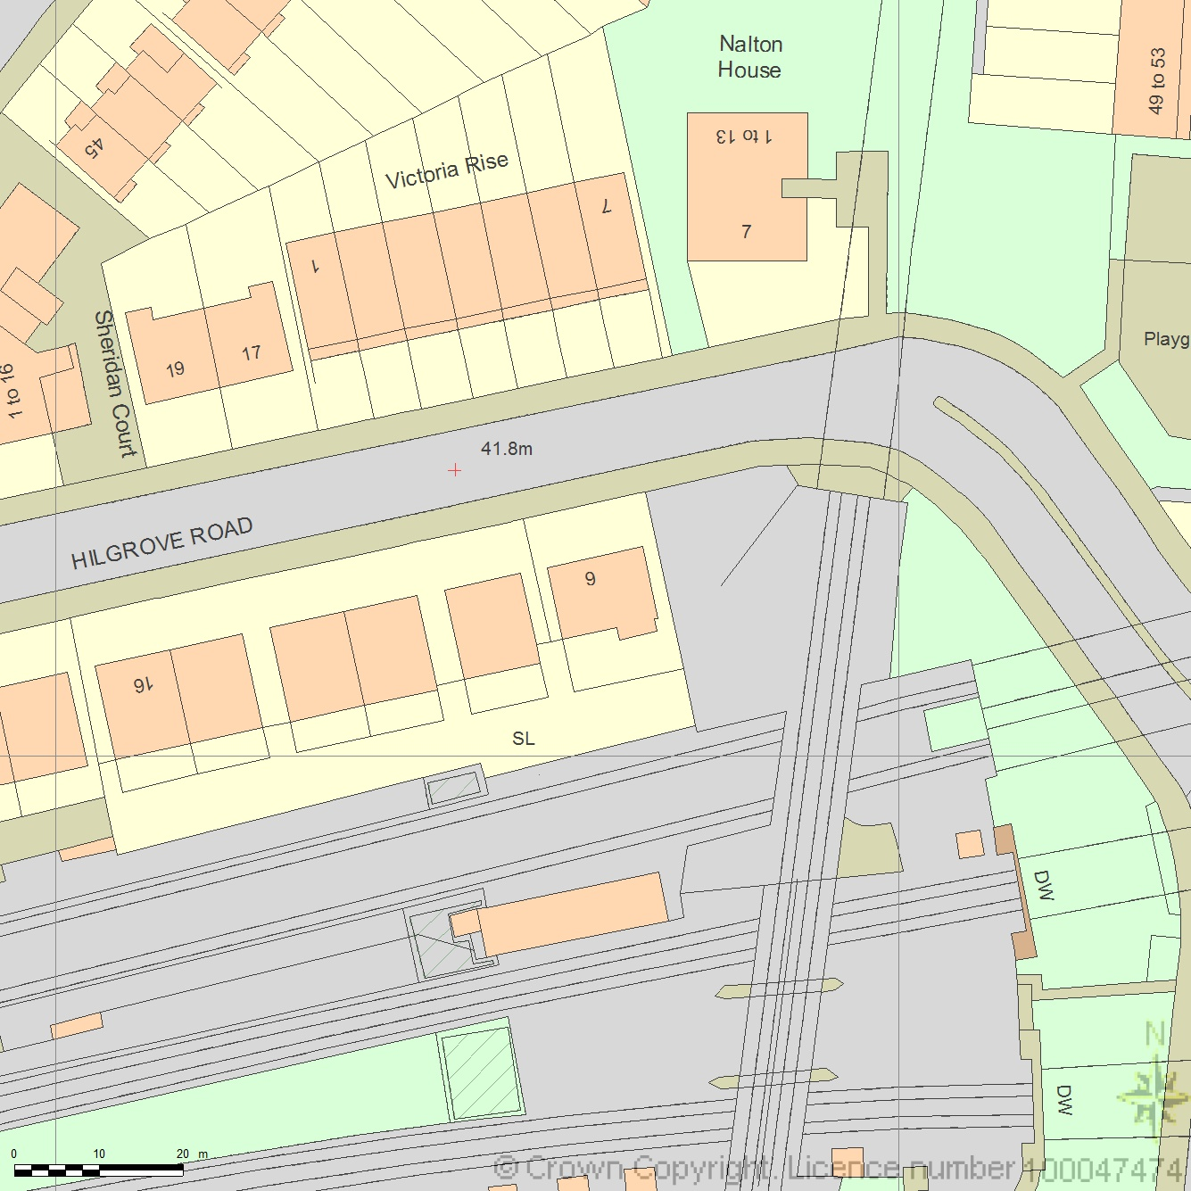
SITE LOCATION PLAN
AREA 2 HA
SCALE 1:1250 on A4
CENTRE COORDINATES: 526464, 184119



Supplied by Streetwise Maps Ltd
www.streetwise.net
Licence No: 100047474
29/07/2026 06:41

