IDOX CHANGES TO WEBSITE FOR PENDLETON REVIEW

5. MF1.131 On Monthly list of Decisions screen at url http://www3.camden.gov.uk/templates/planning/monthlylist.htm

When search is run on a date, the following report displays:

Current Screen

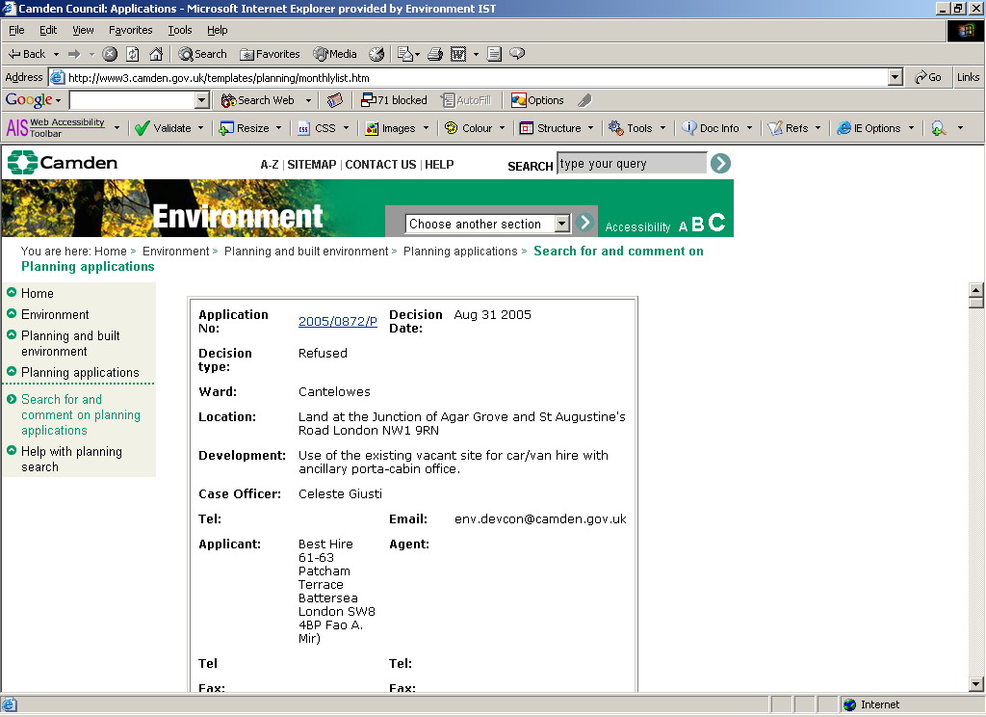

At the top of the screen, add the statement:
“Any Conditions and Reasons associated with the applications listed can be viewed on the scanned Decision Notice. To view the notice click on the Application Number link”

- MF1.132 From the link “search the 'old' planning online system” , url http://www3.camden.gov.uk/templates/planning/

Current screen – top half

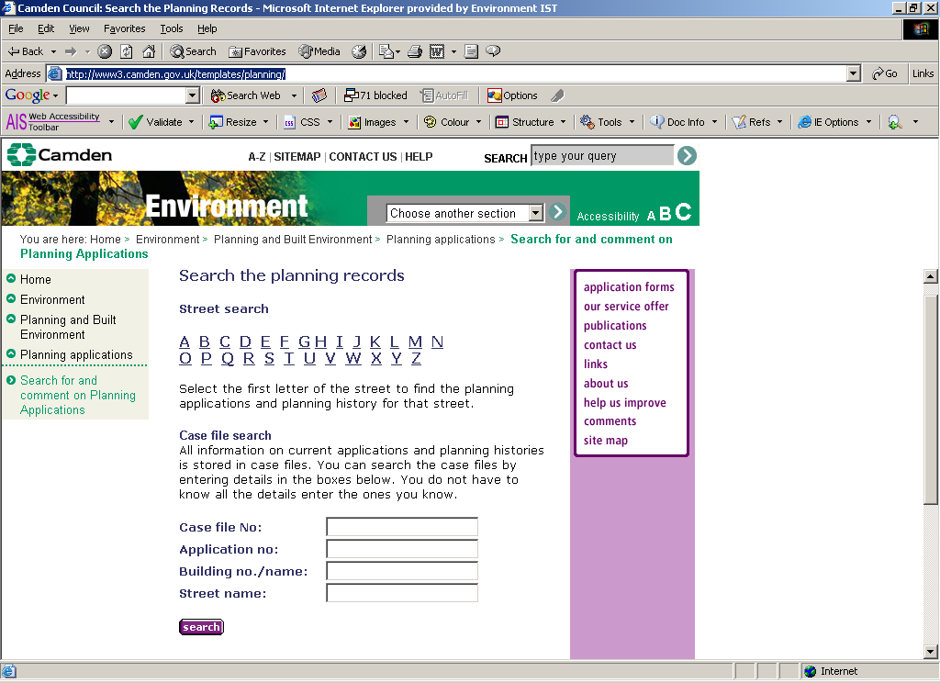

The links on the right hand side do not work and can be removed

Change the Header “Search the Planning Records” to “Search for old Planning Records, 1947 – 1985”

Add statement directly below
“These are historical records and are no longer updated”

Bottom half of current screen -

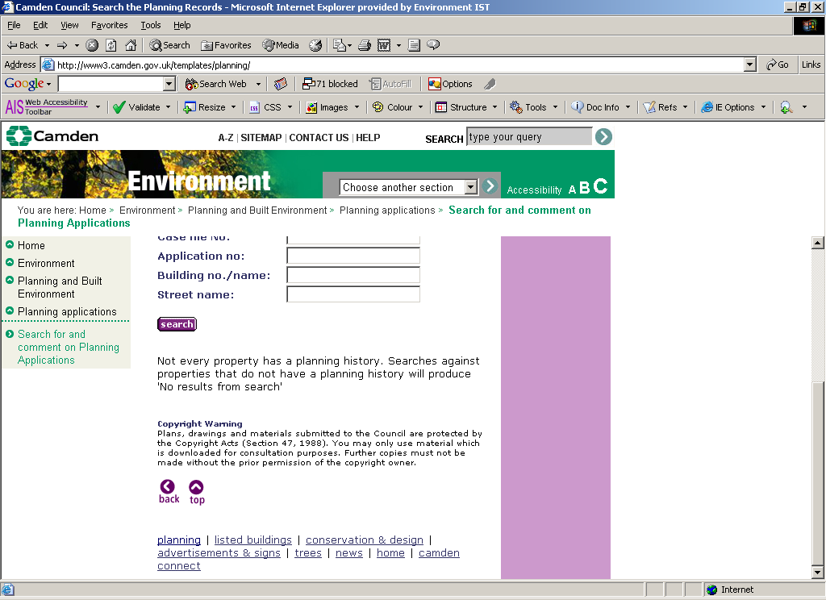

The links at the bottom of the page no longer work, and need to be replaced with Camden’s standard footer

