Existing
Proposed
Location

Photograph

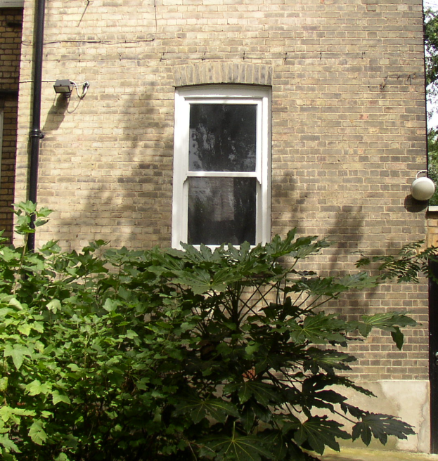

Window facing south-west

Additional Information

- The application is for the conversion of storage room 2 and storage room 7 on the ground floor of Dunrobin Court into 1 self-contained dwelling
- There is at least 1 large window in each habitable room, facing south-east and south-west
- The proposed development benefits from ceilings over 3 meters high
- Dunrobin Court ground floor currently consists of 6 flats (1, 2 and 3 bedrooms) and storage rooms
- All work to be carried out in accordance with applicable building regulations
- All work to be internal, no external alteration to the outside of the building
- The proposed development includes the redecoration of the hallway leading to the front door of the new dwelling
- Electricity, gas and fresh water supplies all available nearby

