Dunrobin Court Proposed Development

Site Photographs

September 2006

South-west facing wall

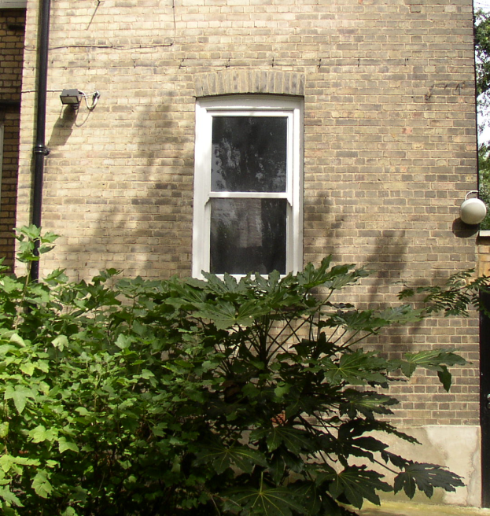

South-east facing wall (1)

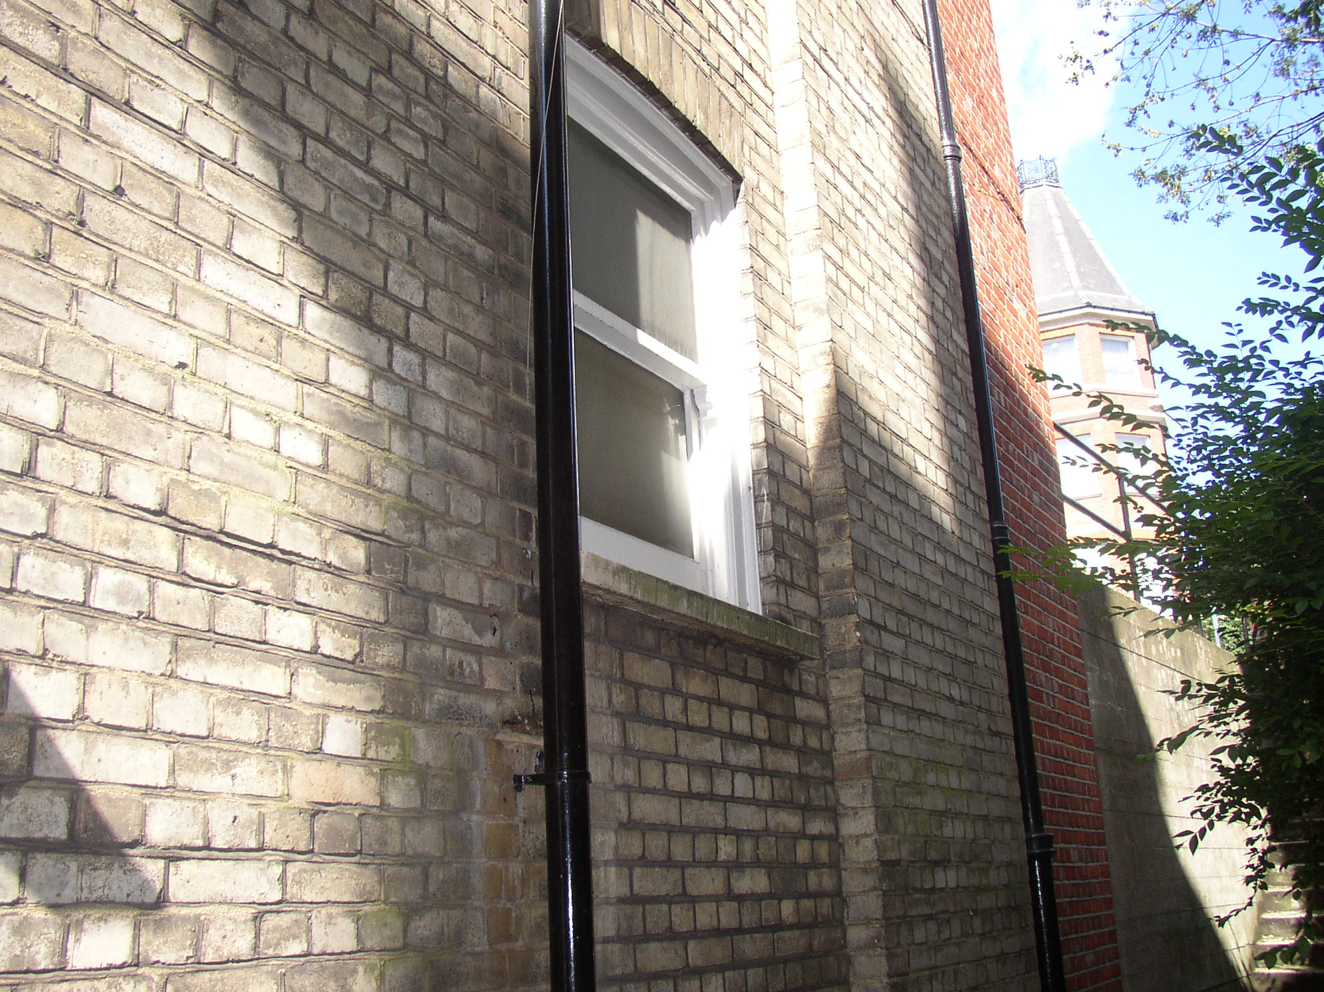

South-east facing wall (2)

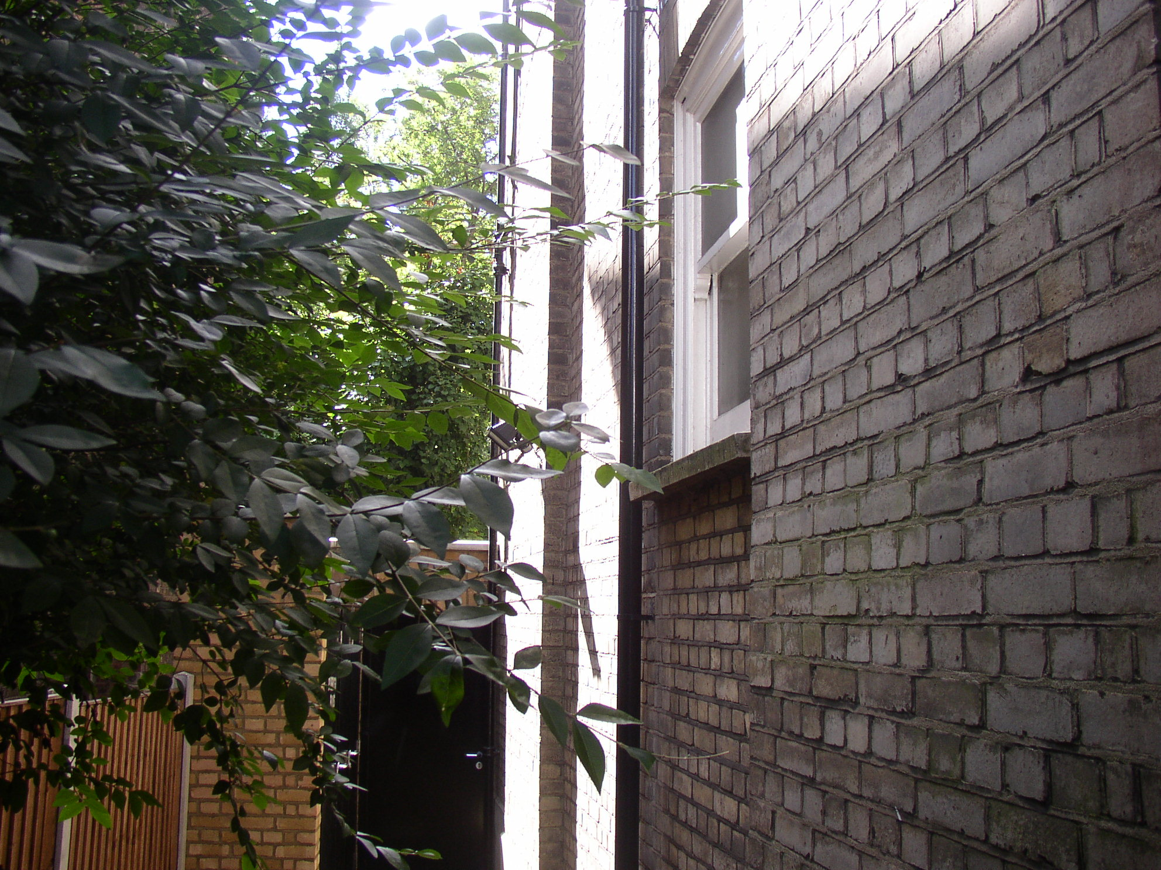

North-east facing wall

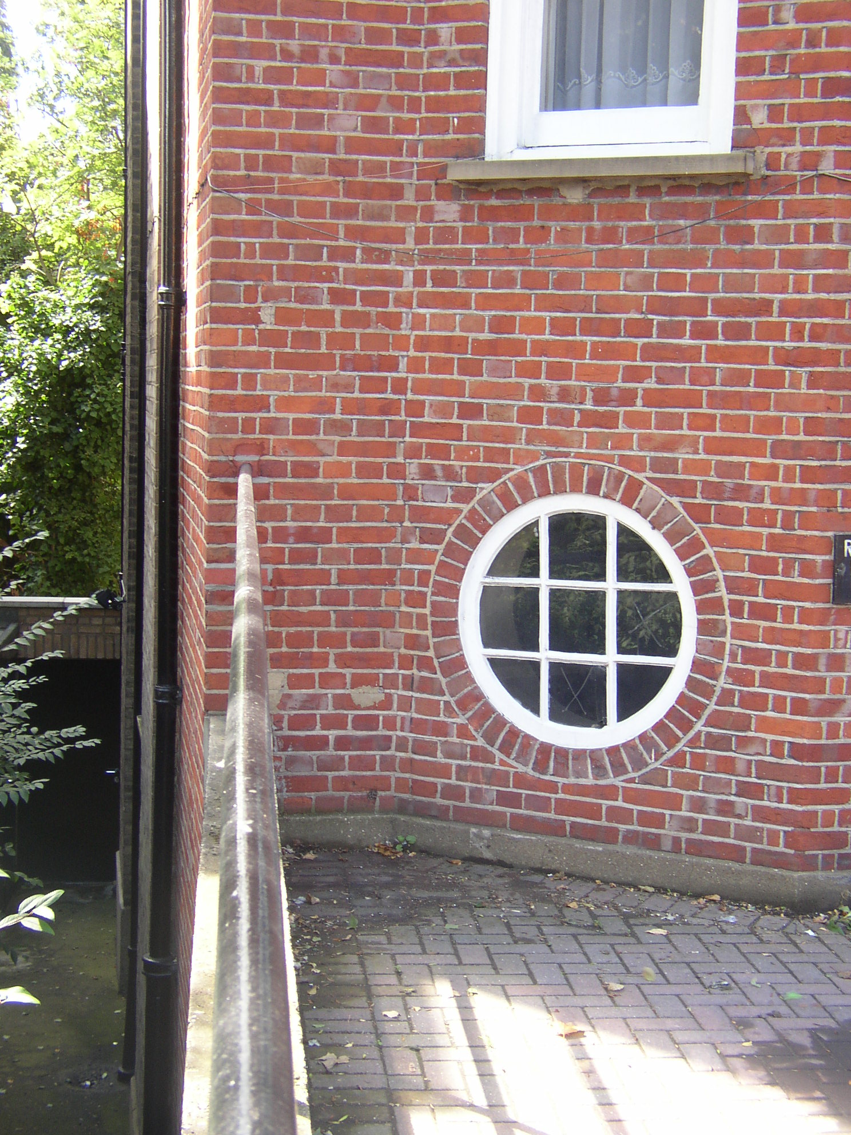

Dunrobin Court

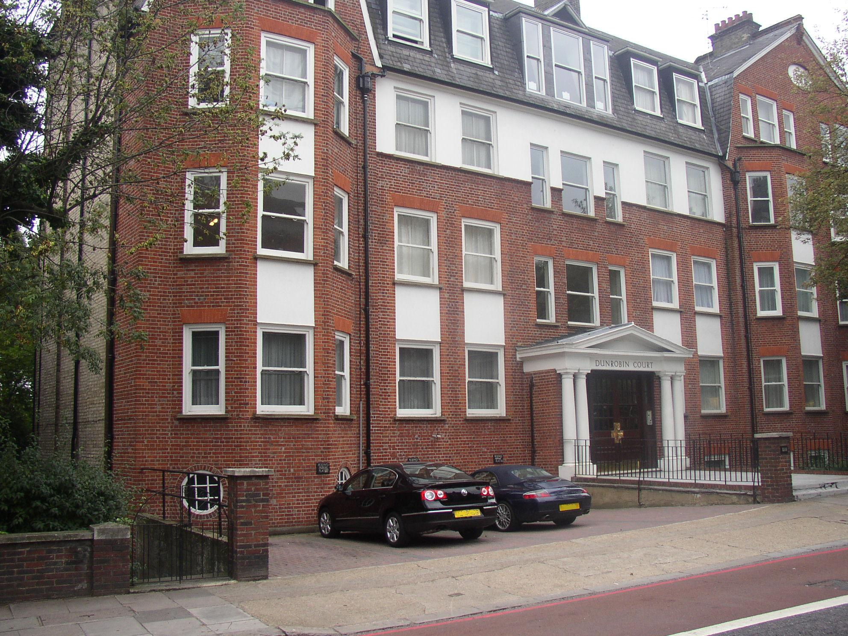
Site of the proposed development

