Marc Charlier
Flat 7 Dunrobin Court
389 Finchley Road
London
NW3 6HE
26 September 2006

Development Control
Planning Services Environment Department
London Borough of Camden
Town Hall Extension
Argyle Street
London WC1H 8ND

Dear Planning Officer,

Please find enclosed the information regarding planning application 2006/3701/INVALID,
as requested in your letter dated 17 August 2006.

- Interested parties: Dunrobin Court freeholder registered at flat 9b Dunrobin Court has been kept informed of all developments at all times and no objections were raised. Please note that the proposed development does not require any external alteration and therefore the number of potentially interested parties is limited.

- Additional plans: 9 floor and section plans with 5 photographs of the site are attached.

- Storage rooms usage: the 2 rooms are currently used solely by my wife and I for the purpose of storing personal items. They can be emptied at any time.

The files which have been attached on-line with this application are:
- Cover letter (this document)
- Floor plans (9 plans)
- Dunrobin Court Photos (5 photos)
- Additional notes (3 pages excl. front page)

Do not hesitate to let me know if you need any further information.

Yours sincerely,

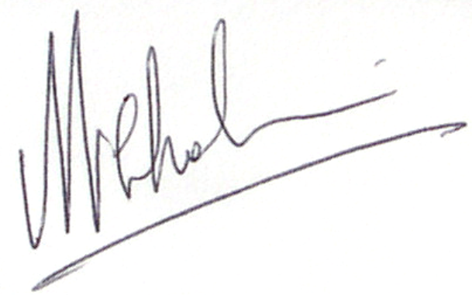

Marc Charlier
07787 522 579

