Marc Charlier
Flat 7 Dunrobin Court
389 Finchley Road
London
NW3 6HE

13 August 2006

Development Control
Planning Services Environment Department
London Borough of Camden
Town Hall Extension
Argyle Street
London WC1H 8ND

Dear Planning Officer,

Please find enclosed the planning application for the conversion of 2 storage rooms in Dunrobin Court into 1 self-contained dwelling. The application was filled in on-line and the required floor plans are attached. Do not hesitate to let me know if you need any further information.

Yours faithfully,

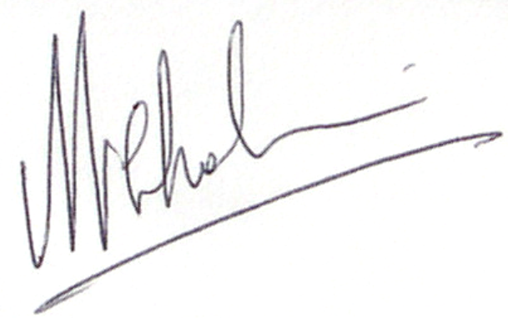

Marc Charlier
07787 522 579

