DESIGN AND ACCESS STATEMENT

17 Keats Grove,
London.
NW3 2RS

CgMs Ltd.

Ref: TG/MS/6831
Date: March 2007

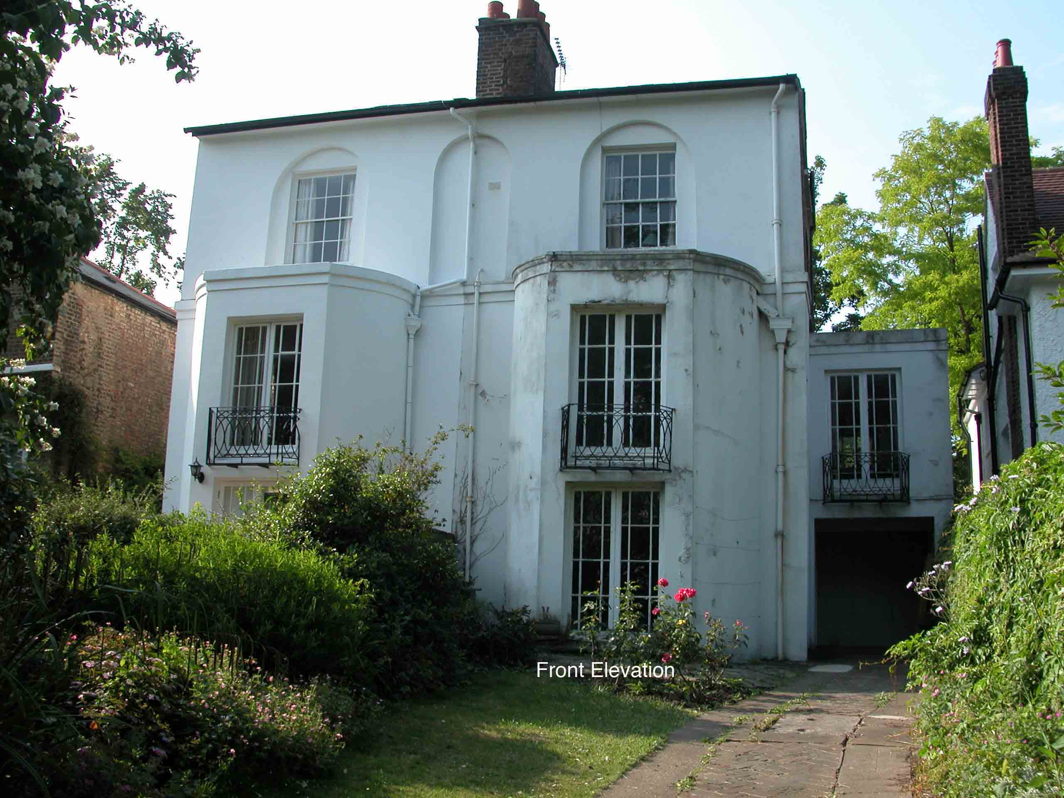

1.0 Introduction
- This statement sets out both the design principles and concepts that have been applied to the proposed alterations and how issues relating to access to the development have been dealt with.
  - These have been informed by previous negotiations with the Conservation and Design Officer, local planning policies and national legislation and guidance and with particular regard to the special interest of the Grade II listed building. They have also been advanced with regard to the planning history of the site. Camden Council granted listed building consent (2006/2861/L) and planning permission (2006/2859/P) for the extension and general refurbishment of the building in 2006. The ownership of the property has changed since these consents were granted and the new owners seek modifications to the interior in line with their own requirements. An application for other internal works has been submitted alongside this application.
  - The proposals have been advanced with consideration of Policy B6- Listed Buildings in the Replacement Unitary Development Plan (adopted June 2006) and advice set out in PPG15.
  - This statement has been produced in conformity to the provisions of Circular 01/2006 and Section 327A of the 1990 Act. This statement has followed the guidance contained within the CABE guidance booklet ‘Design and Access Statements – How to write, read and use them’.

Design

  - This Section explains the design principles and concepts that have been applied to particular aspects of the proposals.

  - proposals seek to create a corridor to the rear of the staircase, linking the front and rear rooms, at first floor level.

  - These proposals have been advanced with a thorough knowledge and understanding of the special interest of the building. Documentary research has uncovered an article from ‘Homes and Gardens’ (dated January 1939) which provides useful documentary evidence of alterations which were made to the building in 1939. It includes a floor-plan which shows prior to 1939 a cupboard existed to the rear of the staircase at ground and first floor level. However, these were removed in 1939 to increase the size of the landing area.

Use
  - The building is currently unoccupied but the new owner is seeking to sensitively restore and adapt the building for modern functional purposes as a single family dwelling. The building was designed as a single family dwelling and was modified, most notably in the 1930s, to create additional accommodation at attic level and significantly refurbished with the addition of applied panelling, dados, niches, doors and architraves.
  - Prior to 1939 there existed large cupboards to the rear of the staircase which were accessed from the principal rooms. Accordingly the existing arrangement of spacious landings is not part of the original character of the building and is a 20th century alteration.
  - The proposals seek to create access between the front and rear rooms at first floor level. This would reintroduce a narrowed landing but would echo the appearance and proportions of the original landing area. A doorway from the rear bedroom into the cupboard existed in this location previously therefore this would restore an original feature. An additional opening would be required within the front room to provide access into the corridor. The proposals would largely recreate the original arrangement, except for requiring an additional opening from the front room.

Amount

- The proposals would require the loss of only a minor amount of historic fabric. Taken literally, the building could function as it has done for the past 70 years with no access behind the staircase. However, in order for it to adapt to modern uses it seems that the convenience resulting from the alterations will:
(i) Encourage easier and more flexible use between the front and rear rooms, thereby making it more suitable for modern living standards.
(ii) Outweigh the loss of a small amount of historic fabric that is in itself partly altered (rear bedroom) and of little architectural value.
iii) Retain evidence of the original spatial layout and proportions of the rooms.
iv) Encourage the continuation of an established use as a single family dwelling, the use for which it was originally designed, in accordance with guidance in PPG15.

Scale
  - The scale of the works propossed constitute a minor alteration which would result in the removal of a minor amount of historic fabric but would resinstate to some degree the original character and proportions of the staircase landings. The works would allow for the original character and appearance and proportions of the principal rooms to remain unharmed whilst allowing the building to function to a much better degree than the internal configuration would allow.

Landscape
  - There are no landscaping issues which would be raised by the proposals.

Appearance
2.14 No.17 Keats Grove was built c.1820 and forms one half of a pair of identical semi-detached houses on the north side of Keats Grove within the Hampstead Conservation Area. It is three storeys high plus basement, one bay wide and has a slated, pitched roof with projecting eaves. The front elevation is rendered, the side and rear elevations present exposed brickwork. A canted bay rises to beneath the second floor window to the main frontage and a single storey extension, which shares a hipped roof with the adjacent property, projects to the rear. A two-storey flat roofed garage extension was added on the east side in 1939. The brickwork on the side elevation and at ground floor level on the rear elevation demonstrate the alterations that have been made to the building, notably at high level to provide a greater degree of habitable attic space.

  - An article printed in Homes & Garden Magazine, dated October 1933, describes and illustrates the house prior to the alterations made by the new owners in 1939. The 1939 alterations included the rebuilding of the side extension with the inclusion of the garage, replacement of some fireplaces and general modernisation of the interior including application of panelling to the dining room at ground floor level and niches and fireplace at first floor level (Robinson, 2005). The article notes that the staircase was also considerably improved by taking away large cupboards which originally opened out of the bedrooms. In addition the attic rooms were heightened involving alterations to the roof form. The internal character of the house was therefore much altered in the 1930s.

  - The proposals would partially restore the original appearance of the stairwell and the rear room at first floor level through the creation of the corridor. The insertion of a corridor in this location would retain evidence of the original floorplan and reinstate it to a greater degree.

Materials
  - The doorway into the corridor to the rear of the staircase would be of timber construction and echo the six panelled raised and fielded doors approved as part of the previous listed building consent (reference 2006/2861/L).

Demolition
2.22 Only a small amount of historic fabric will be lost as part of the creation of the corridor as the fabric to be lost within the rear room is later fabric where the earlier door into the cupboard will have been infilled. The only historic fabric to be removed will therefore be within the front room. The amount of demolition is therefore minimal.

Sustainability
2.23 The proposals would allow the building to adapt to modern living requirements whilst retaining evidence of the original proportions and character and appearance of the building.

Access
  - There will be no changes in terms of vehicular access to the property.
  - There is currently no access to first floor level other than the principal staircase which is an original fixture and forms part of the historic character of the building. The alterations do not take into account disabled access given that significant changes would need to be made to the staircase primarily.
4.0 SUMMARY
4.1 The proposals seek to make modifications to the listed building to suit the needs of the current owner whilst ensuring no harm to the special interest of the building.

  - The proposals would not result in the loss of any significant historic fabric and would in part restore the original plan form to a greater degree than the existing building which reflects the alterations made in 1939.

  - All of the works proposed have been advanced with a thorough understanding of the special interest of the listed building.

4.4 This statement demonstrates that the proposals accord with Policy B6 of Camden Council’s adopted Replacement UDP.

