DESIGN AND ACCESS STATEMENT

17 Keats Grove,
London.
NW3 2RS

CgMs Ltd.

Ref: TG/MS/6831
Date: March 2007

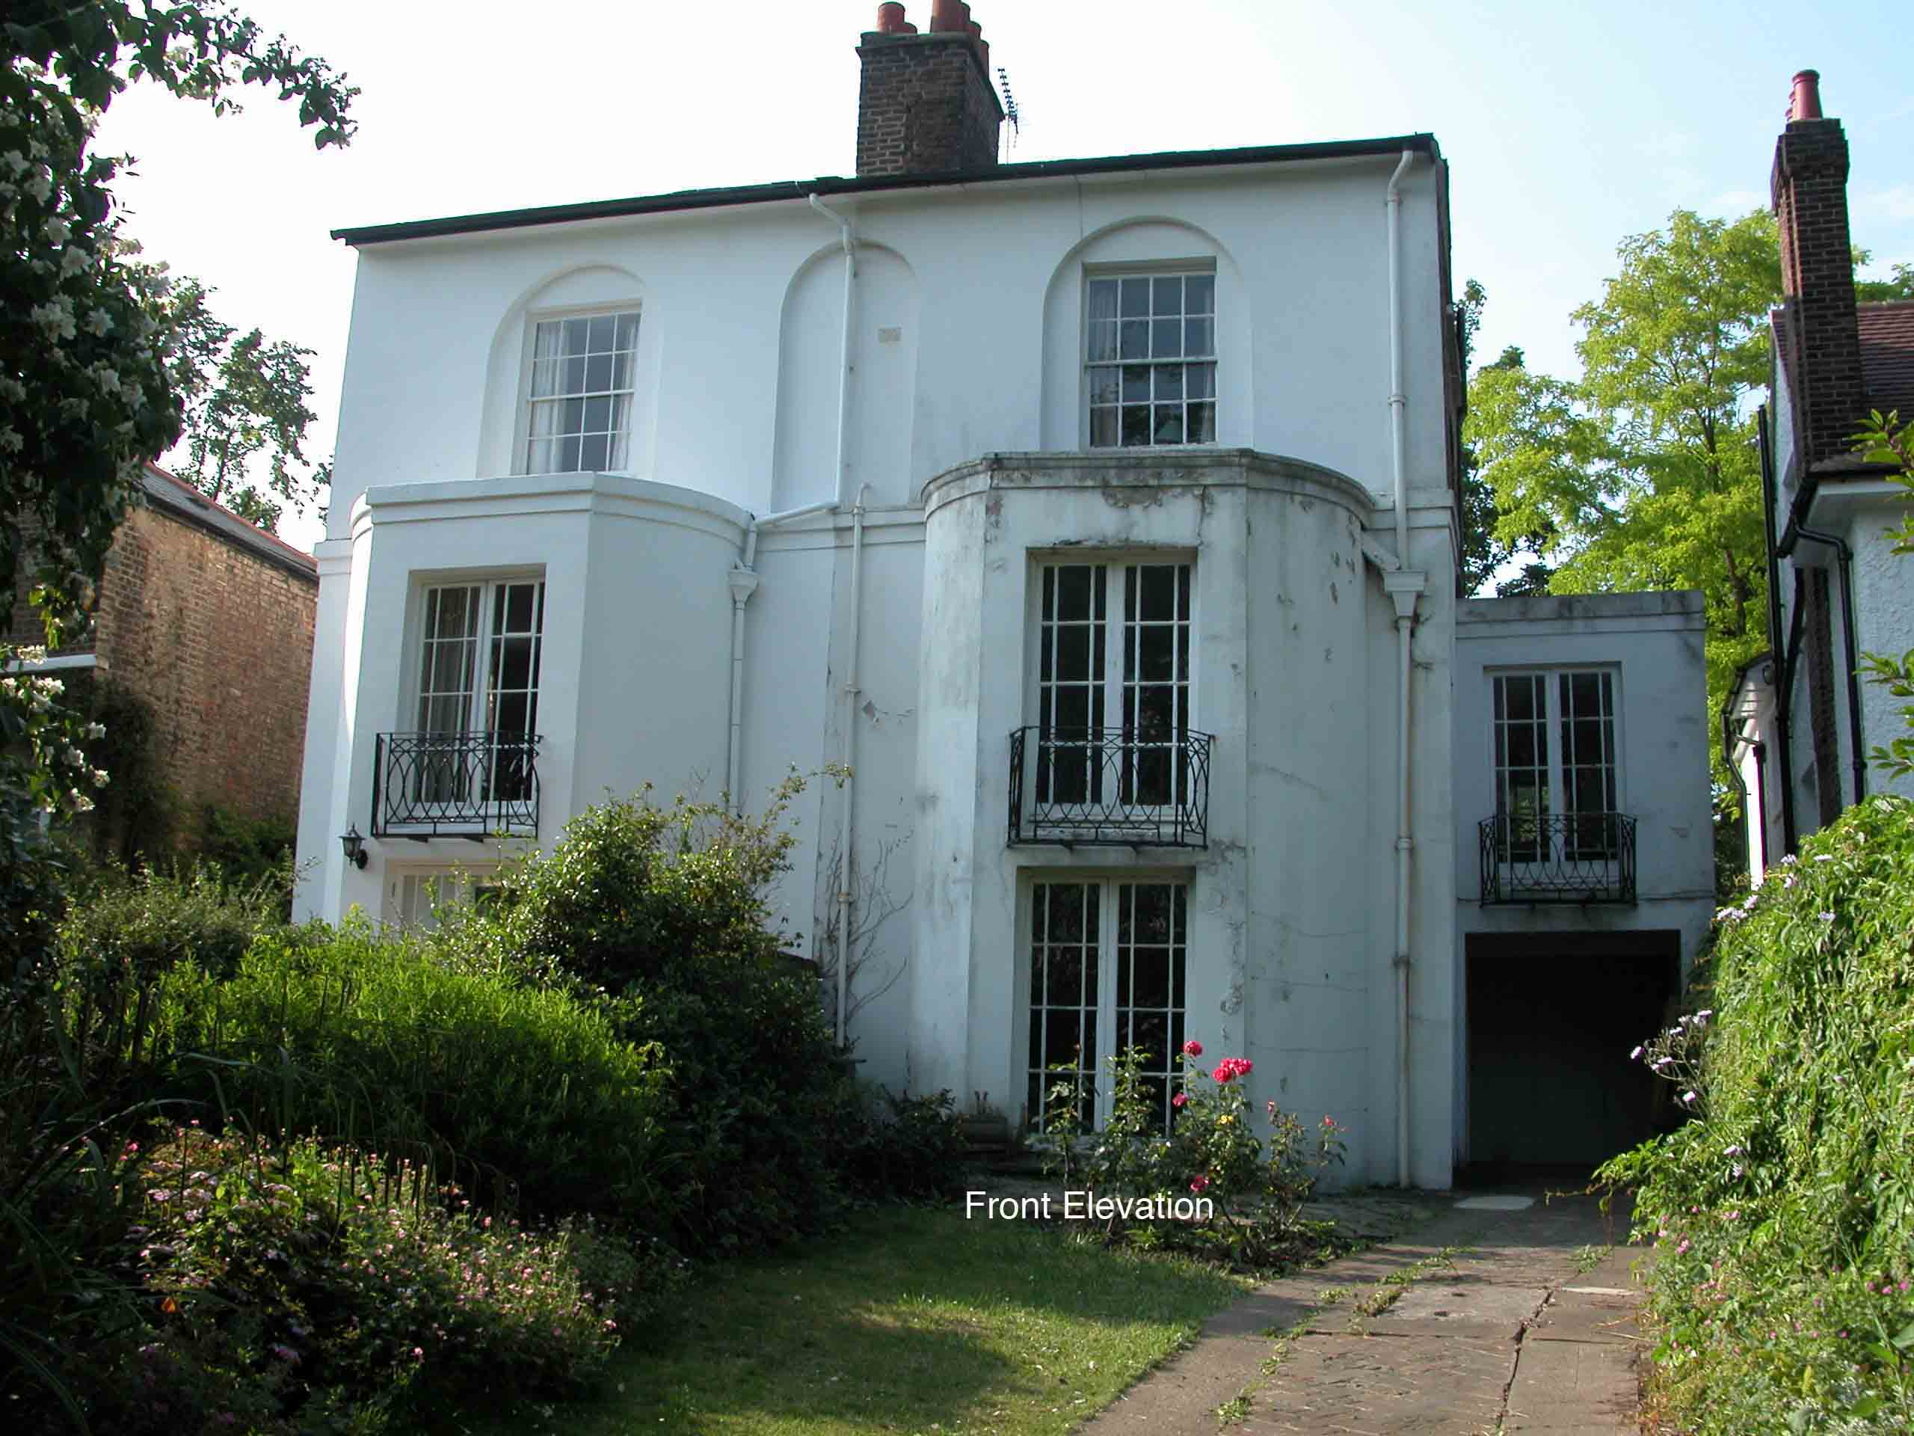

1.0 Introduction
- This statement sets out both the design principles and concepts that have been applied to the proposed alterations and how issues relating to access to the development have been dealt with.
  - These have been informed by previous negotiations with the Conservation and Design Officer, local planning policies and national legislation and guidance and with particular regard to the special interest of the Grade II listed building. They have also been advanced with regard to the planning history of the site. Camden Council granted listed building consent (2006/2861/L) and planning permission (2006/2859/P) for the extension and general refurbishment of the building in 2006. The ownership of the property has changed since these consents were granted and the new owners seek modifications to the interior in line with their own requirements.
  - This statement has been produced in conformity to the provisions of Circular 01/2006 and Section 327A of the 1990 Act. This statement has followed the guidance contained within the CABE guidance booklet ‘Design and Access Statements – How to write, read and use them’.

2.0 Design
  - This Section explains the design principles and concepts that have been applied to particular aspects of the proposals.
  - The proposals seek to make the following alterations to the building:
    - Incorporation of high level glazing within the basement to provide a limited amount of light and ventilation
    - Associated shallow lightwell
    - Creation of toilet beneath stairs at ground floor level
    - Reduction in size of approved rooflight to the side extension
    - Modification of the top three treads of the staicase at third floor level
    - Creation of an en-suite within rear bedroom at second floor level

  - These proposals have been advanced with a thorough knowledge and understanding of the special interest of the building. Consideration has been given to the planning history of the site, Replacement Unitary Development Plan Policy B6 and national guidance, namely PPG15.

Use
  - The building is currently unoccupied but the new owner is seeking to sensitively restore and adapt the building for modern functional purposes as a single family dwelling. The building was designed as a single family dwelling and was modified, most notably in the 1930s, to create additional accommodation at attic level and significantly refurbished with the addition of applied panelling, dados, niches, doors and architraves.
  - The previous listed building consent (2006/2861/L) and planning consent (2006/2859/P) approved a full width rear extension with basement beneath and general refurbishment of the property internally and externally and. All of these proposals were considered to be sensitive to the special interest of the building.

Amount

  - The proposals take account of the special interest of the building and an analysis of how the building can be modified without resulting in the loss of a significant amount of historic fabric and maintaining the integrity of the interior.
  - The proposals do not seek any additional floor space but seek to make alterations to the interior to accommodate the needs of the new owner. The changes proposed will have a limited impact on historic fabric and the character and appearance of the original building will remain unharmed.

Scale
  - High level glazing at rear basement level is proposed to provide light and some ventilation into the basement. A shallow, narrow lightwell will be created but will be sufficiently minimal to ensure the basement remains barely visible from the garden, except very close to the building, and will certainly not be visible from the public realm. Thereby the apparent scale of the building will remain largely unaltered.
  - The toilet beneath the staircase at ground floor level will require some excavation to provide the necessary floor to ceiling height beneath the staircase. There is a cupboard in this location at present therefore little historic fabric, except for ground soil, will be removed. A short flight of timber steps will provide access to the toilet. These will have a simple in profile to provide evidence that this is a later alteration whilst ensuring the principal staircase remains the dominant feature. The floorboards in this location not original.
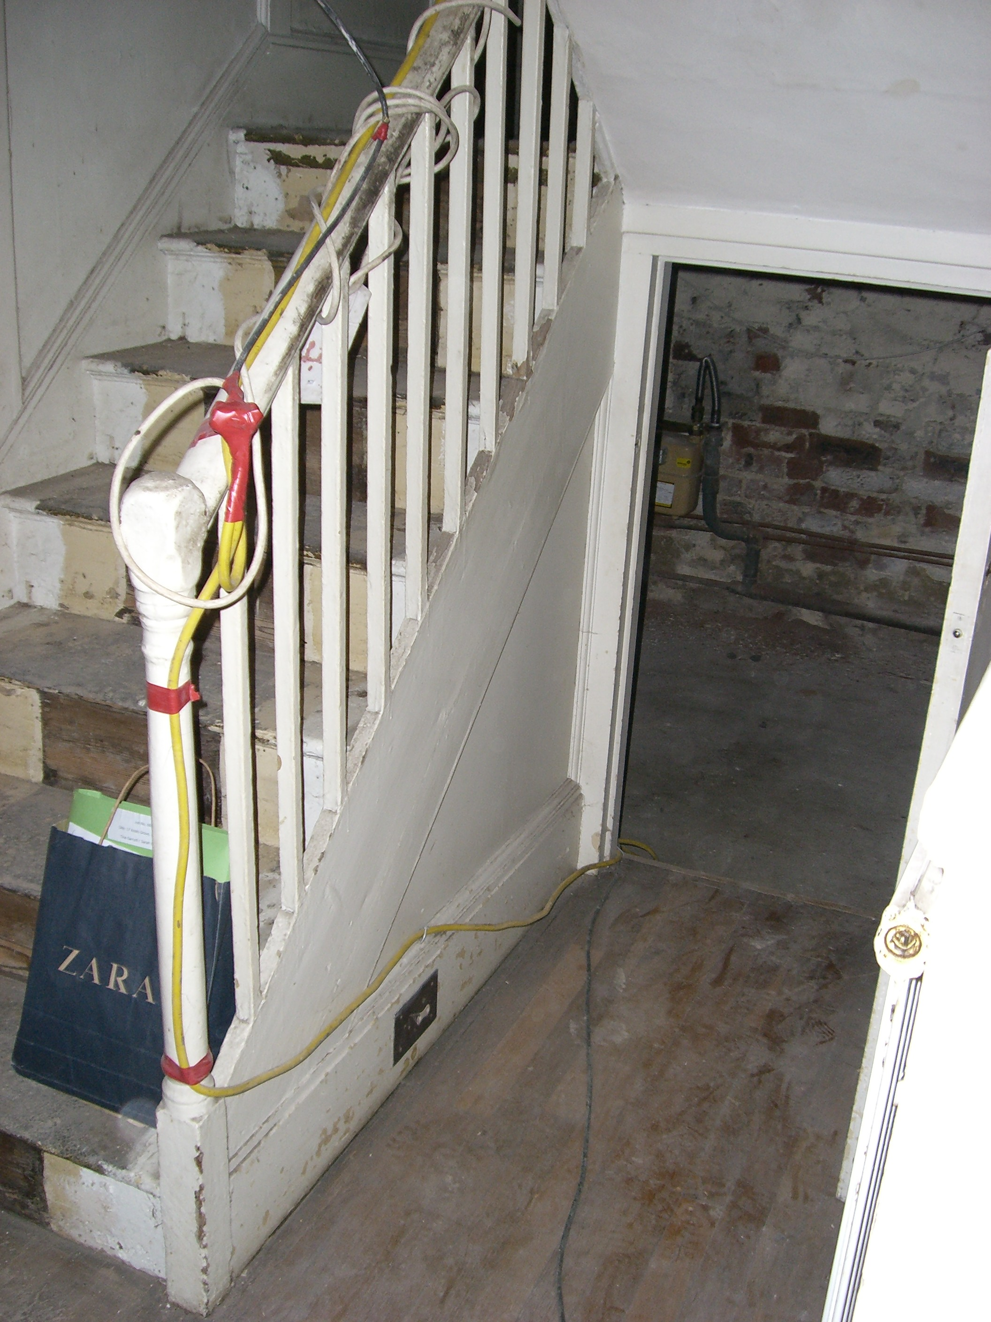

  - A sliding skylight within the flat roof of the side extension was approved as part of the previous applications. Reconfiguration of the interior of the extension, which is a 1930s addition (albeit it replaced an earlier extension in this location), no longer necessitates such a large rooflight. The form, materials and profile of the rooflight will remain the same as that approved and it will remain masked by the parapet roof. Therefore the appearance of the building will remain unaltered.
  - The top three treads of the existing staircase at attic level are split to provide dual access at the top of the stairs. Whilst the staircase appears to be original, this configuration is dangerous and fails to provide an adequate amount of tread for safe usage. The attic floor of the building is to be used as habitable living accommodation thus the staircase will be well used. In its present form it is dangerous and the proposals therefore seek to modify the top three treads to create a safer staircase. This will necessitate the removal of only a small amount of historic fabric. Evidence of the dual access will remain in the form of a blocked door (to right).
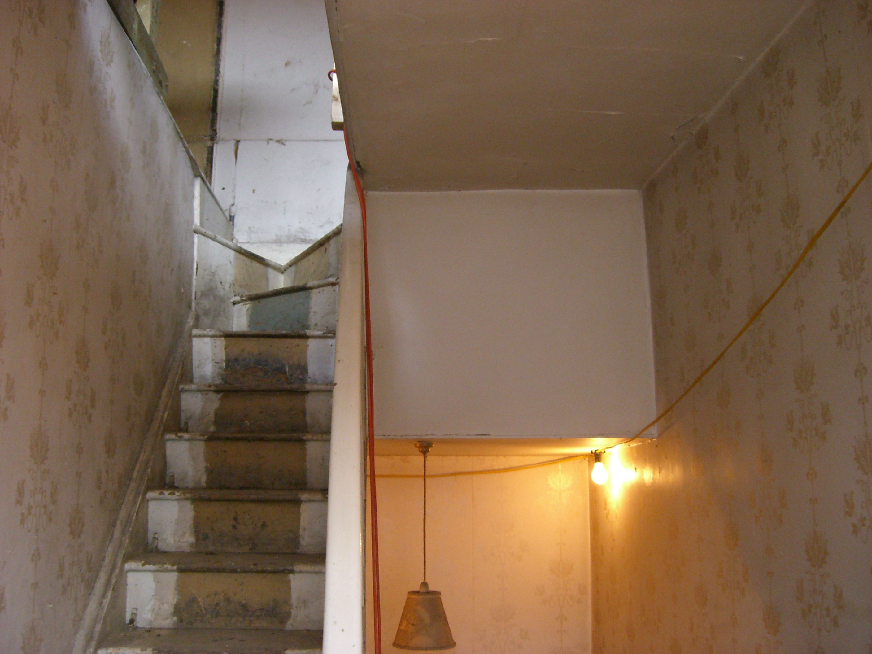

Landscape
  - The basement lightwell at the rear of the property will be sufficiently narrow to ensure there is little impact on the appearance of the garden or the setting of the building. The balustrade on either side of the bridge over the lightwell will be formed of boxed section steel posts with glass infill panels and a stainless steel handrail. This will echo the contemporary appearance of the rear extension.

Appearance
2.14 No.17 Keats Grove was built c.1820 and forms one half of a pair of identical semi-detached houses on the north side of Keats Grove within the Hampstead Conservation Area. It is three storeys high plus basement, one bay wide and has a slated, pitched roof with projecting eaves. The front elevation is rendered, the side and rear elevations present exposed brickwork. A canted bay rises to beneath the second floor window to the main frontage and a single storey extension, which shares a hipped roof with the adjacent property, projects to the rear. A two-storey flat roofed garage extension was added on the east side in 1939. The brickwork on the side elevation and at ground floor level on the rear elevation demonstrate the alterations that have been made to the building, notably at high level to provide a greater degree of habitable attic space.

  - An article printed in Homes & Garden Magazine, dated October 1933, describes and illustrates the house prior to the alterations made by the new owners in 1939. The 1939 alterations included the rebuilding of the side extension with the inclusion of the garage, replacement of some fireplaces and general modernisation of the interior (Robinson, 2005). The article notes that the staircase was also considerably improved by taking away large cupboards which originally opened out of the bedrooms and the attic rooms were heightened through alterations to the roof. The internal character of the house was therefore much altered in the 1930s.
  - A full-width glass extension has been approved on the rear of the building with basement beneath. The basement, as approved, does not have any form of glazing or ventilation. Accordingly the proposals seek the creation of a small lightwell and high level glazing at basement level for light and ventilation purposes. It is considered that this would make a more habitable living space whilst ensuring this would not impact on the appearance or proportions of the building to any significant degree.

  - It is proposed to install a toilet beneath the stairs at ground floor level which will require some excavation but will require the removal of any significant historic fabric given that a cupboard currently exists in this location. The short flight of steps leading down to the toilet will have simple squared timber treads and will appear subservient to the main stair. The doorway to the toilet will be designed to match the 6-panel raised and fielded doors approved as part of the previous application.

  - The rooflight within the side extension will not be visible from the public realm and will echo that previously approved. Therefore the appearance and special interest of the building will not be harmed.

  - The top three treads of the staircase at attic level will be adapted to create a more usable staircase. Whilst this will alter the appearance of the top of the staircase it is considered that given the location (at high level within the building) and of little architectural significance that the safety benefits outweigh the conservation benefits in this case. The two doorways at the top of the staircase will remain to provide evidence of the existing configuration but that to the right will be blocked.

  - The stud wall within bedroom two at second floor level will be scribed around the original skirting and will be sited so that it does not interfere with the window frame. The siting of the wall seeks to retain evidence of the original proportions of the room and would be a reversible alteration.

Materials
  - The high level windows to the basement will be constructed of timber, which will echo the glazing on the original building. Timber will also be used to construct the staircase at ground floor level providing access to the toilet. The new treads at attic level will also be constructed of timber to match the existing fabric and will detailed to match the existing in profile.

Demolition
2.22 A small amount of historic fabric will be lost as part of the creation of a toilet beneath the stairs at ground floor level and the modification of the staircase at attic level. None of the proposals will result in the loss of any significant historic fabric, fixtures or fittings thereby preserving the special interest of the building.

Sustainability
2.23 The proposals seek to use sustainable materials. The creation of a toilet at ground floor level echoes the principles of lifetime homes and is of benefit to the building in terms of providing access for disabled users. The staircase could be modified to a ramp in the future should this be necessary.

Access
  - There will be no changes in terms of vehicular access to the property.
  - The proposed changes to the staircase are intended to provide for safer access at attic level. The existing staircase is dangerous and would be greatly improved through the alteration of the top three treads.
  - The proposed toilet at ground floor level will benefit disabled and elderly users who would otherwise have to use the toilet at first floor level.
4.0 SAUMMARY
4.1 The proposals seek to make modifications to the listed building to suit the needs of the current owner whilst ensuring no harm to the special interest of the building.

  - The proposals would not result in the loss of any significant historic fabric and would retain the historic and architectural integrity of the building.

  - All of the works proposed have been advanced with a thorough understanding of the special interest of the listed building.

4.4 This statement demonstrates that the proposals accord with Policy B6 of Camden Council’s adopted Replacement UDP.

