33 Pond Street - Basement Extension and Rear Elevational changes

INTRODUCTION

No 33 Pond street is part of a pair of houses opposite the Royal Free Hospital on Pond Street, Hampstead. Originally built in the 18th Century and refaced in facsimile in the early 20th Century. The house is grade II listed and retains some panelling to the interior upper floors and orginal features to the front elevation.

The listing entry is as follows
Date of listing: Aug 11 1950 12:00AM 798-1-133028

“Pair of terraced houses with studio extension forming No.35A. Early C18, C20 refacing in facsimile; No.35A, a studio extension built c1946 for graphic designer Frederick Henrion with later rear extension by Richard Rogers. Red brick with plain brick bands between storeys. 3 storeys and semi-basement. No.33, 3 windows; No.35, 2 windows. No.35A, 2 storey 3 window studio extension to right. Rusticated Doric pilaster doorcases with carved friezes and flat hoods on console brackets, No.35 with cherub and rams' heads to frieze; patterned overlights and part glazed panelled doors approached by steps with cast-iron railings. Recessed sashes; No.33 retains original cased frames. No.33, with parapet; No.35, with cornice and blocking course. INTERIORS: not inspected but noted to retain good panelling, No.35 with staircase having turned balusters.”

The building was extended at the rear during the 1970’s and was further modified with wider door openings to the rear extension in 1975 Ref HB1289.

In 1996 the house underwent major refurbishment including the addition of a rear conservatory at lower ground floor level (Listed Buildings consent Ref 9570030R2 , Planning consent Ref 9500185R2).

The rear of the house has therfore been substantially altered over the last 50 years, as have the rears of adjoining buildings at 31 , 35 and 35A Pond Street. To the rear of No 35 a series of studio buildings were constructed in the 1970’s / 80’s, designed it is belived by Richard Rodgers.

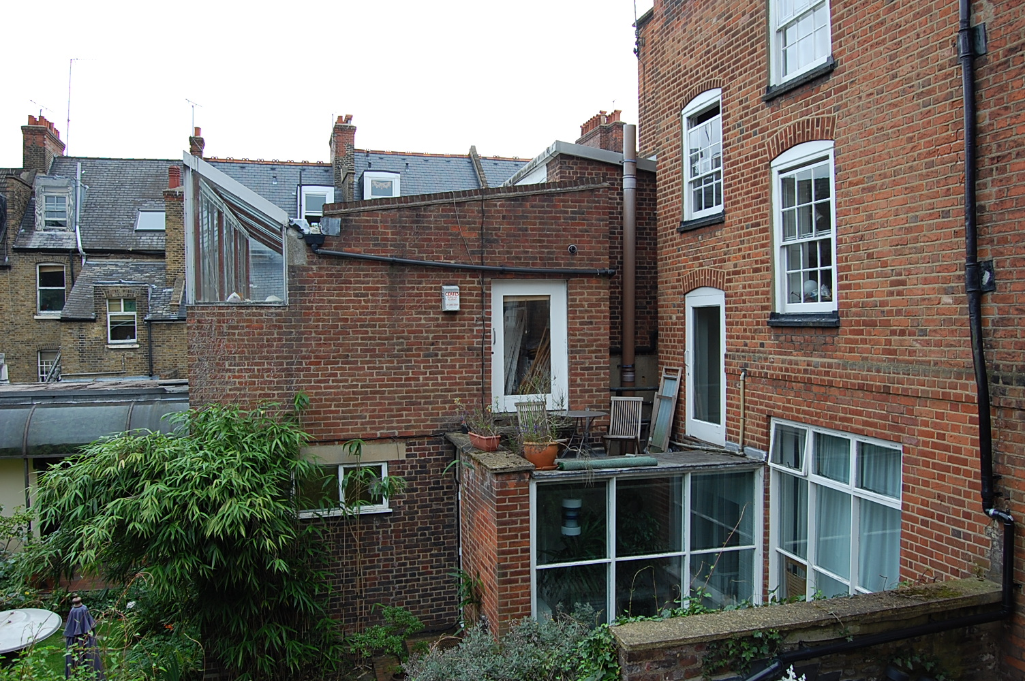
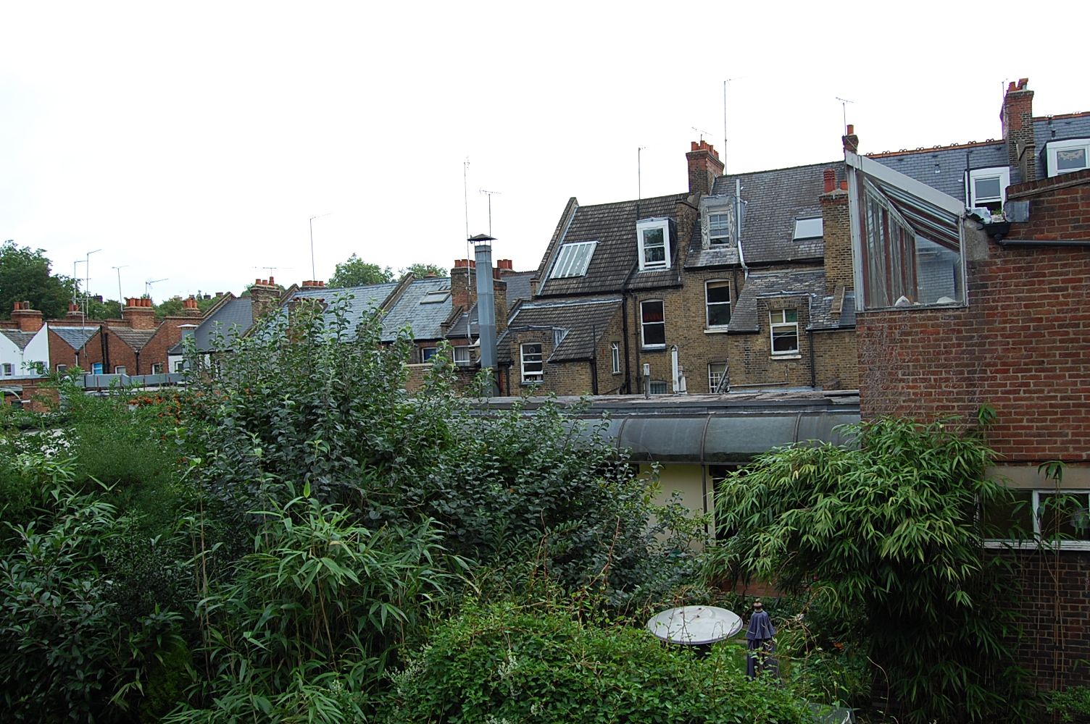

VIEW OF REAR OF 35 AND 36 SHOWING EVIDENCE OF LATER DAY ADDITIONS INCLUDING SINGLE STOREY STUDIOS EXTENDING INTO THE GARDEN

PRE APPLICATION CONSULATION

Sketch proposals were submitted to Camden during the summer of 2007, and discussions had with Paul Woodvale in the planning department. In summary it was believed that the proposal to amend the new build extension at the rear would be acceptable on the basis that it was distinct from the original listed building. This was subject to Camden’s normal criteria that any extension works would not adversely effect adjoining neighbour’s amenity. It was suggested a detailed planning application was submitted so these detailed criteria could be assessed.

THE PROPOSAL AND DESIGN

The existing single storey 1970’s extension was constructed of red brick in a mock period style, and merges the boundaries between the original listed building and the later day additions. There is a part basement below the extension which currently houses a utility room and boiler room.

The proposal is to re–elevate the rear extension with an elegantly detailed contemporay approach, incorporating a greater percentage of glass to create a lighter feeling to the extension element. This will respect the listed property by creating a clear distinction between the original building and the later additions.

In addition the proposal is to extend the existing basement to the full extent of the rear extension and create a lightwell onto the garden to allow natural light down to the lower level. As part of the work the exsiting structure of the conservatory will be replaced in a contemporary style using fewer glazing bars to match the appearance of the extension.

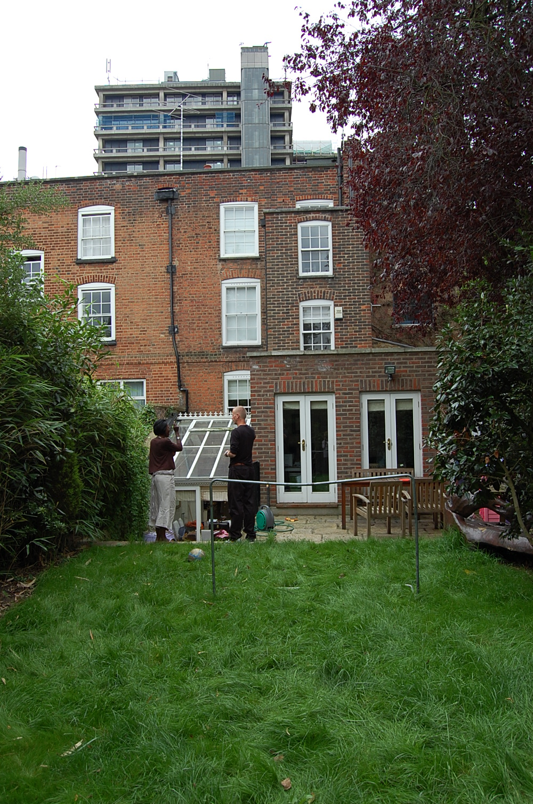

EXISTING REAR TO 33 POND STREET

EFFECTS ON NEIGHBOURS AMENITY

It is not proposed to raise the parapet wall to the existing extension above it’s current height, or project the rear elevation out beyond the existing rear face of the building. The proposals would therefore not have any effect to the amenity to the property at 31 Pond Street.

The existing conservatory will be built out to line through with the existing extension, but owing to it’s low relative level will not have any impact on the amenity to 35 or 35A Pond Street.

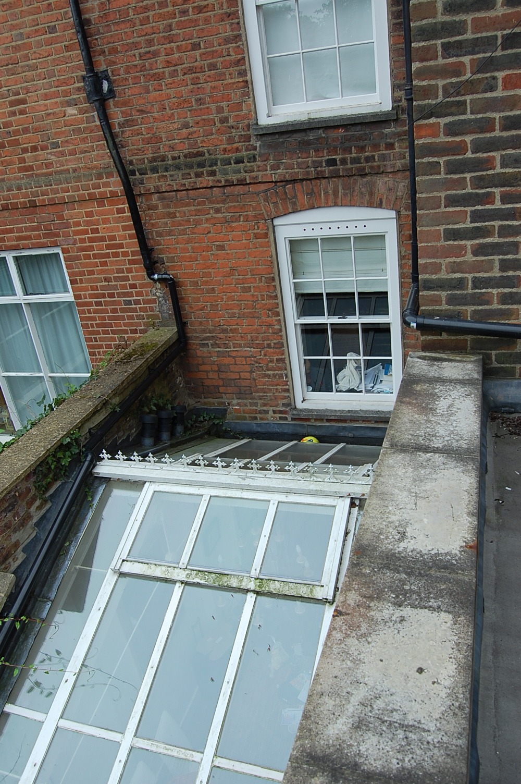
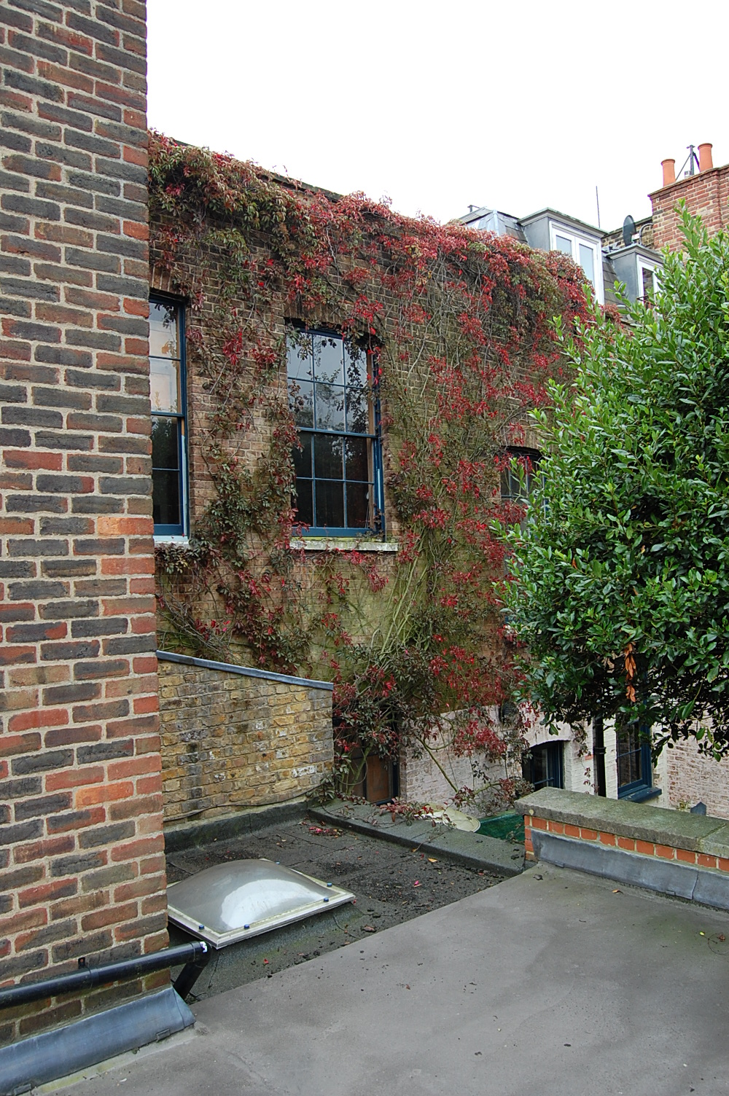

VIEW FROM FLAT ROOF OF EXTENSION
HEIGHT OF PARAPET WALLS RETAINED TO 35a AND 31 POND STREET
ACCESS

Access into the house from the street will not be effected.

Access within the basement level of the property will be improved

CONCLUSION

- The changes to the appearance of the rear extensions will create a lighter more contemporary feel to the later additions and serve to distinguish them clearly from the original listed building.

- The additional basement accommodation will have very little visual impact owing to it’s low relative level.

- Minimal changes to the footprint of the rear extension and no increase in maximum height of parapet walls to the boundary mean that the proposed works would have little or no effect on the amenity of adjoining neighbours.

END

