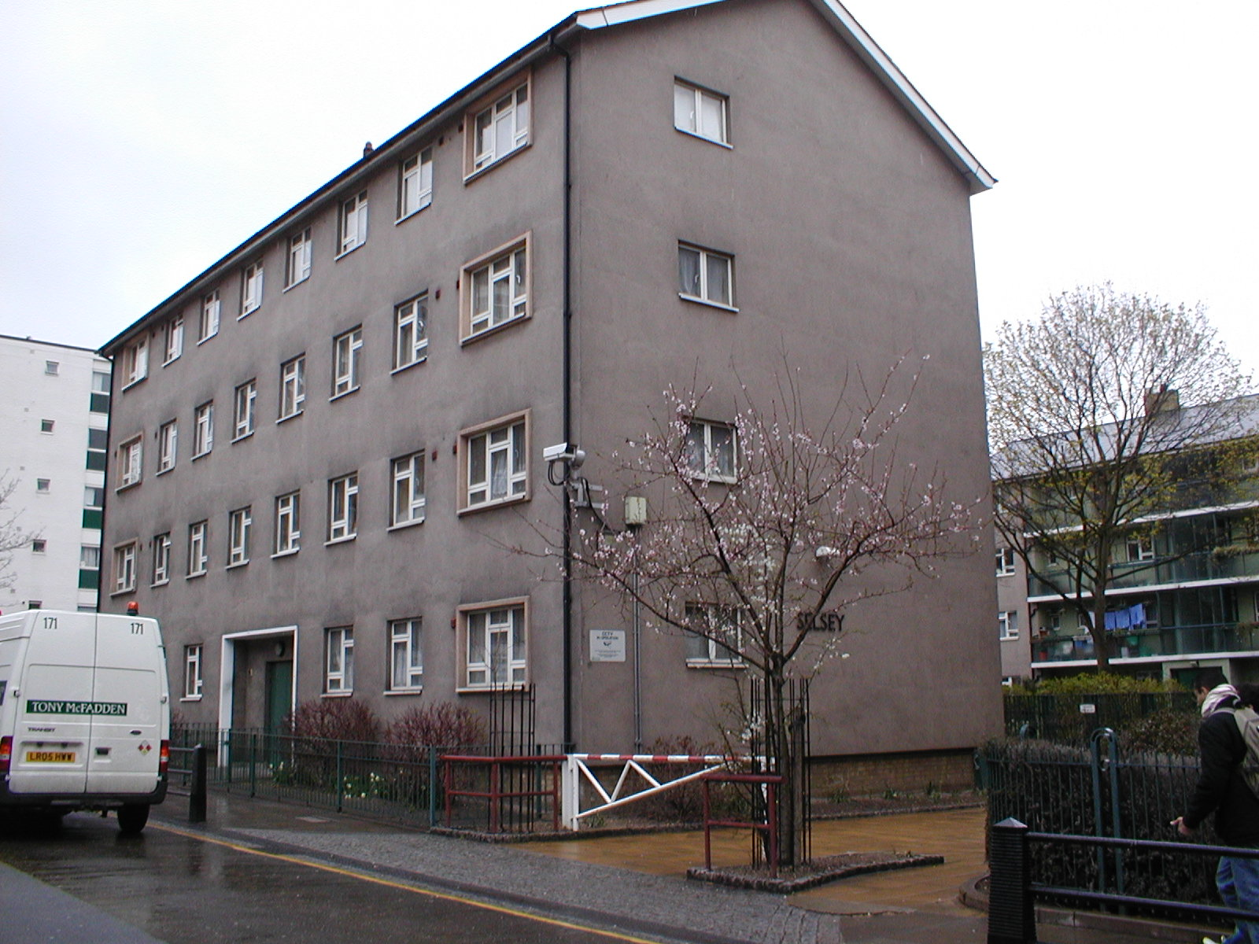

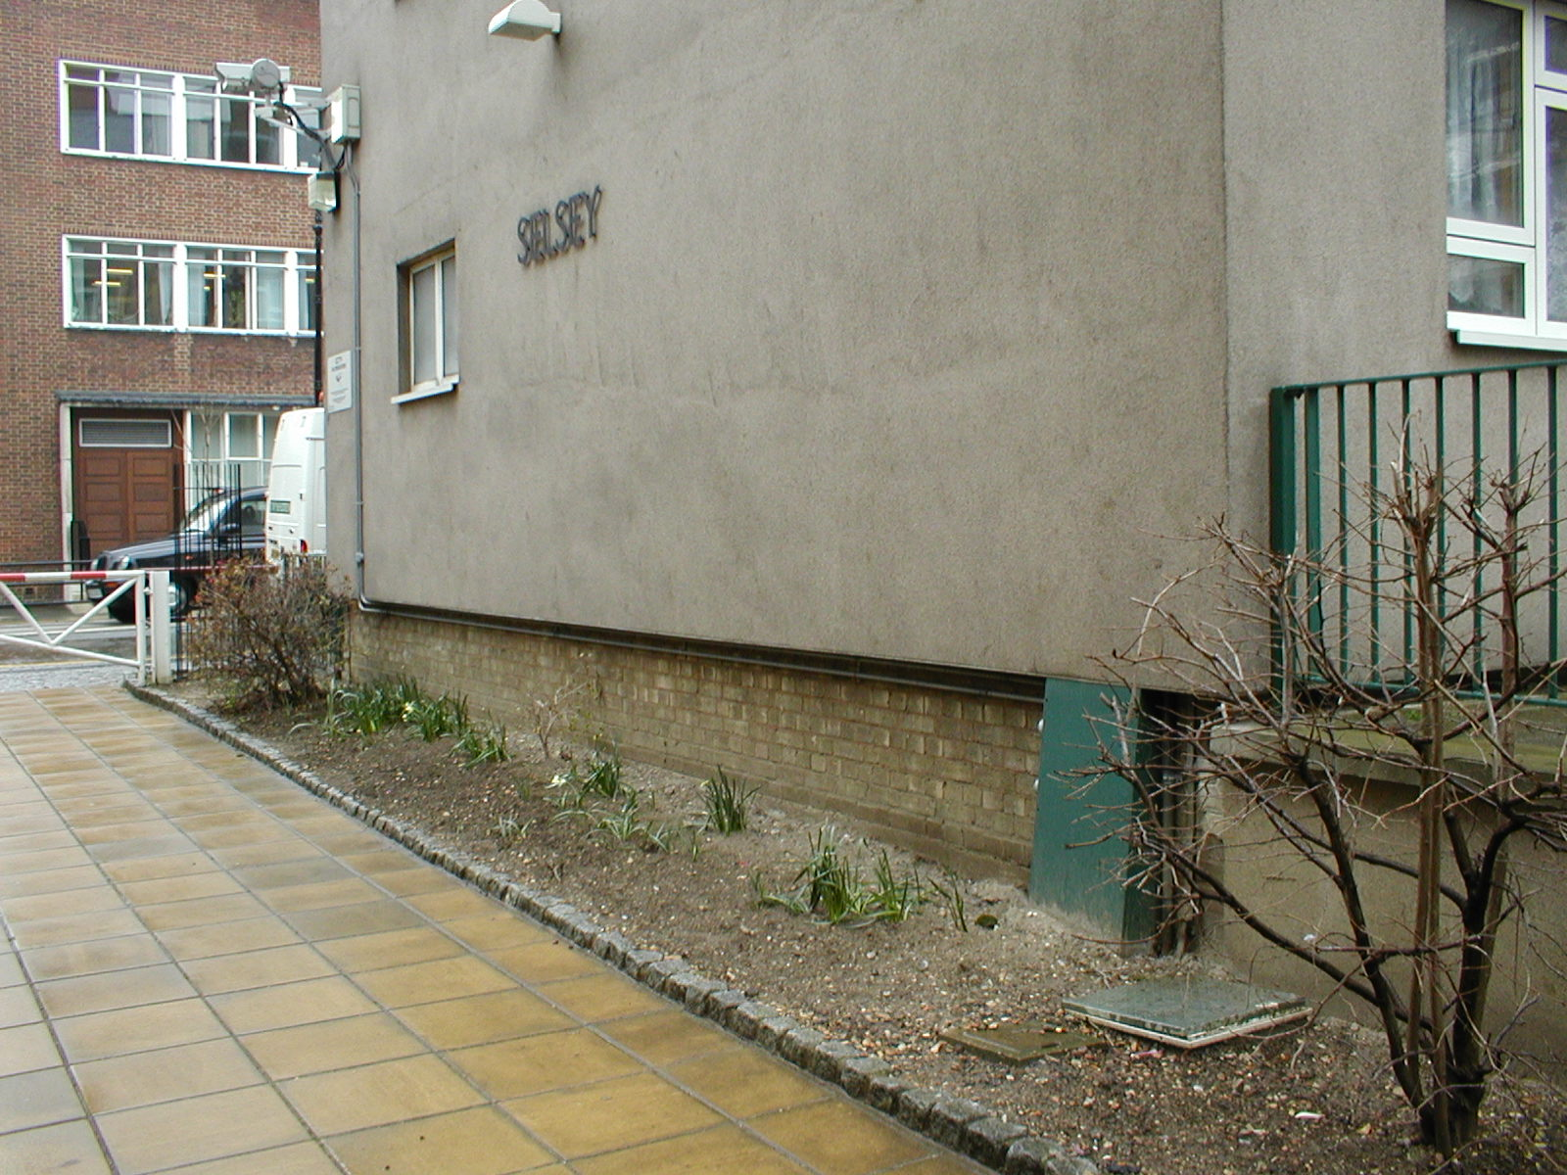

EXTERNAL VIEWS OF EAST GABLE WALL OF SELSEY HOUSE

