

Our Ref: Primrose Hill/PCP030&034/WO/JL

Tel: 01634 661556

Email: Planning@harlequinltd.co.uk

The Planning Officer
London Borough of Camden Council
Camden Town Hall
Judd Street
London
WC1H 9JE

26th May 2011

Dear Sir/Madam,

NOTIFICATION OF THE SUBMISSION OF PRIOR APPROVAL APPLICATIONS FOR THE INSTALLATION OF VARIOUS OPENREACH BROADBAND CABINETS WITHIN THE PUBLIC HIGHWAY.

PART 24 OF THE TOWN AND COUNTRY PLANNING (GENERAL PERMITTED DEVELOPMENT ORDER) (AS AMENDED) 1995 AND ALSO REGULATION 5 OF THE ELECTRONIC COMMUNICATIONS CODE (CONDITIONS AND REGULATIONS) 2003

Please find enclosed Prior Approval applications made under the legislation detailed above. Detailed below are the numbers of the PCPs where the applications have been submitted.

For ease of validation a copy of the applications has been included on a CD-Rom and has been enclosed with this letter. A cheque for the figure of £670.00 pounds is enclosed to cover the fee for the 02 (two) sites detailed below.

PCP030 Adamson Road, O/S Swiss Cottage Hotel, 4 Adamson Road, London, NW3 3HP,
526783 184406

PCP034 Fitzroy Road, O/S 26 Fitzroy Road, London, NW1 8TY, 528073 183981

Attached are details pursuant to each of the proposed cabinets. I have included a location plan, a photomontage and a line drawing. Please note that Openreach refers to each site with a PCP reference. As such the locations above relate to the PCP numbered below on the site details.

Should you have any queries or concerns arising from this matter please do not hesitate to contact me.

Yours faithfully,

William Osborne MRTPI
Harlequin Ltd.

Harlequin Ltd • Innovation Centre • Maidstone Road • Chatham • Kent ME5 9FD
T: +44 (0)1634 683635 E: Planning@harlequinltd.co.uk

Offices: Livingston (Scotland), N. Ireland, Chatham (Kent) • Directors: David Summers BSc (Hons) MRICS MInstD, Andrew Wood, Ian McIntosh BEng (Hons) CEng MICE, Russell Frith BSc (Hons)

Registered in England and Wales • Registered Number: 2836322 • Registered Office: Innovation Centre •Maidstone Road • Chatham • Kent ME5 9FD

www.harlequin.info

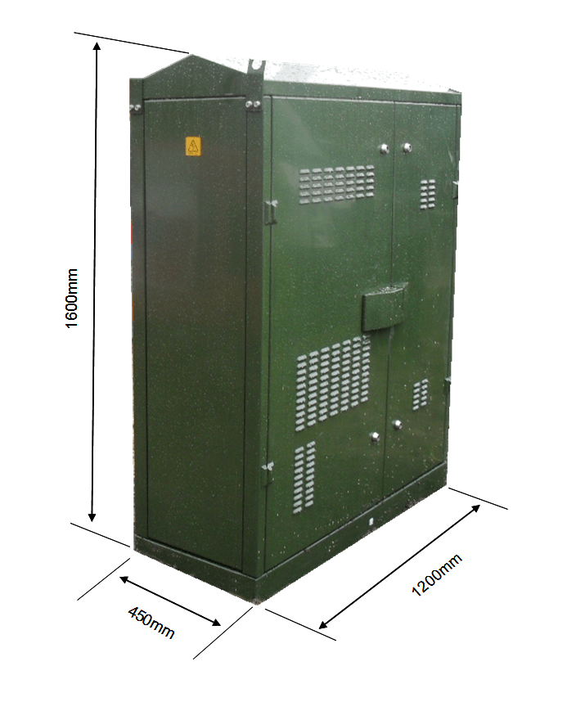

PCP030 Adamson Road, O/S Swiss Cottage Hotel, 4 Adamson Road, London, NW3 3HP,
526783 184406

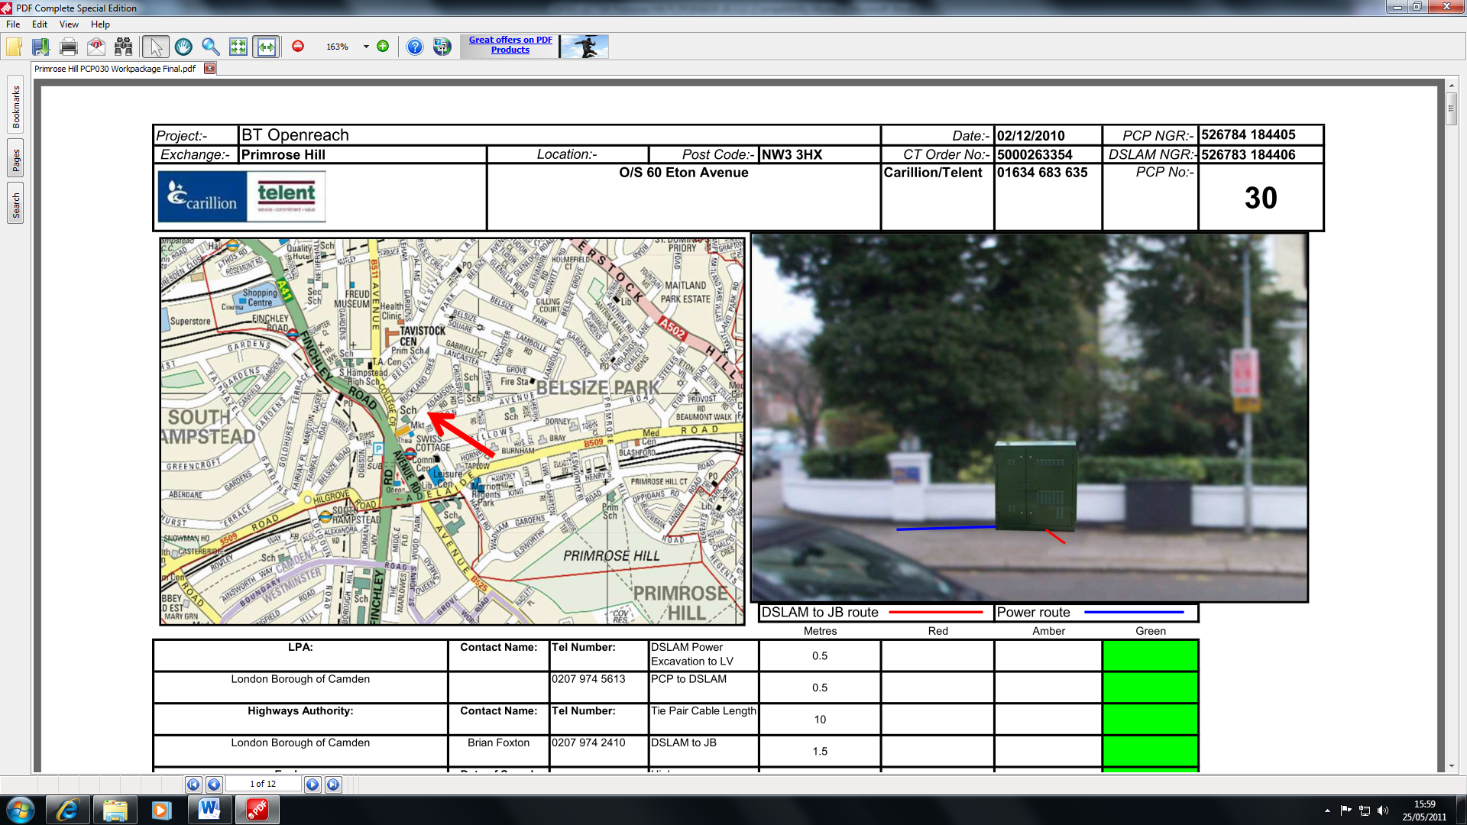

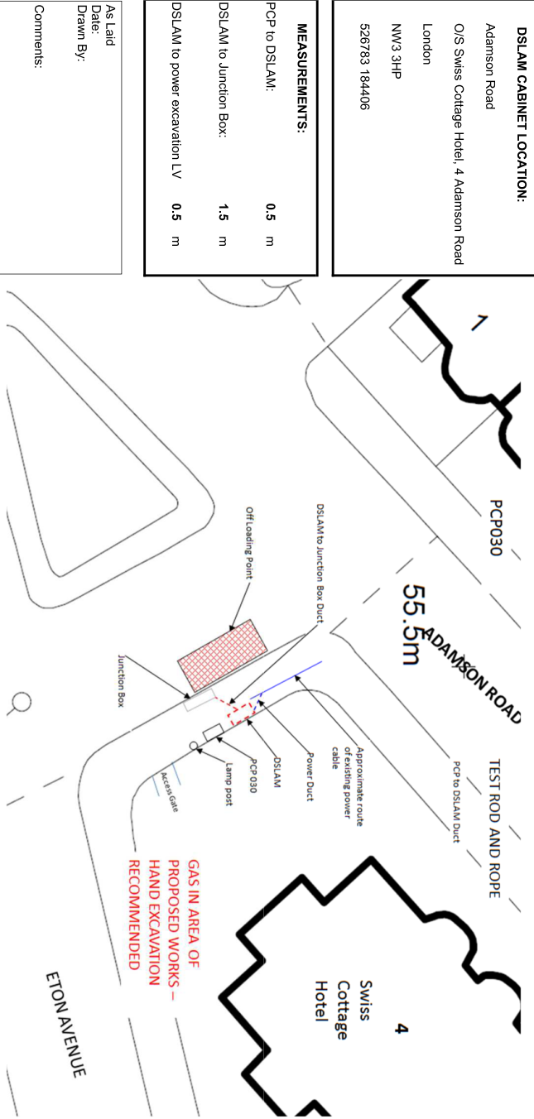

PCP034 Fitzroy Road, O/S 26 Fitzroy Road, London, NW1 8TY, 528073 183981

