35 Marsden Street
London NW5 3HE
October 2011

Design and Access Statement – Notes accompanying plans 110C, 111C and 116 B.

This planning application is to address two modifications to the plans granted in application 2011/0387/P:
i. A modification concerning the aesthetics of the half width first floor extension
ii. A minor modification to the detail of the party walls containing the extension

A photograph of the original rear elevation of the property is provided as reference below.

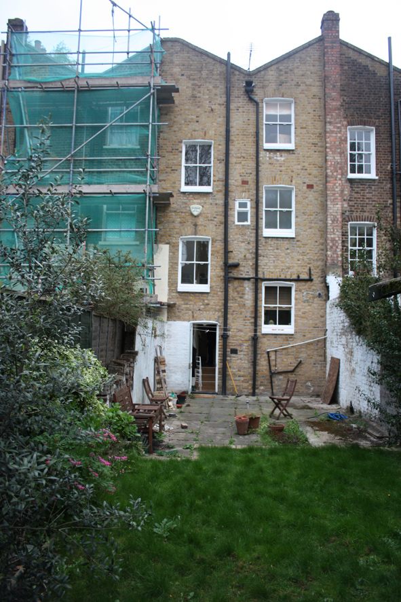

1. The property is a Victorian Terrace on three floors. Originally built with a two storey extension to the rear, this portion of the property was demolished in the recent past (1970s-80s) and the remainder of the property refurbished.

We are not aware of any planning policies that affect our proposal.

The site is within the Conservation Area of West Kentish Town. The rear extension is not visible from anywhere in the street and is shielded by large trees from views from the neighbouring terrace to the rear.

The planned rear extension is of a classic contemporary design that seeks to be sympathetic to the character of the host building, terrace and conservation area. The changes proposed in this application pertain primarily to the half width first floor extension. The first floor element is limited in width and depth, making it in overall terms a small and subordinate addition. The intention is to clad this portion of the extension in dimensionally stable, treated timber of a light, natural colour with 10mm gaps (samples can be provided). The timber cladding is proposed in order that the character of the whole extension is distinct and tastefully respectful of the host building rather than appearing as a contemporary structure to the ground floor with a heavy looking, pastiche of a more traditional construction above. The use of natural materials in light tones will complement the existing building and those around it.

The proposed changes to the window in the new first floor element (from a traditional style sash to a timber clerestory style window) are to afford Miss Stone and her neighbours greater privacy. The sash window in the granted application would afford clear views from Number 35, directly across to the opposite terrace as well as into the garden of number 37 Marsden Street. Miss Stone’s neighbours would also have been able to see into the new room which is a bathroom. The proposed orientation and position of the new window will mean that Miss Stone’s view out is solely of the sky and tops of the trees opposite and will prevent Miss Stone being overlooked in the bathroom.

The plan to change the flat green roof section of the ground floor extension to a sloping green roof, following the line of the glazed portion, is to remove the possibility of light pollution to number 37 from the side of the glazed roof on the ground floor extension and to reduce likely maintenance requirements by providing better drainage.

The building is not listed.

2. The development is for the sole use of Ms Stone, the resident and owner of the property, and her family. They have no special needs to be considered in the design.

The immediate neighbours to the property, at numbers 33 and 37 Marsden St, will be affected by the proposal with respect to the appearance of their boundary walls with number 35. Ms Stone has consulted both these neighbours and the changes proposed in this application have been requested by the neighbours who are fully supportive of this application.

The ground floor element of the extension sits almost entirely below the level of the original garden walls except for where it joins the main dwelling on the eastern side boundary. The changes proposed in this application involve extending the boundary wall with number 33 up to enclose this section of the extension and provide a 150mm parapet to the glazed roof in order to prevent light pollution to Miss Stone’s neighbours at number 33 and to guard against the passage of fire from number 35 to number 33.

The proposal will involve the reconstruction of both original boundary walls which are in a dilapidated condition. Although both these walls are party walls, the full cost of reconstruction will be met by Ms Stone.

The boundary wall between 35 and 37 will be raised within the proposal and the profile changed so that the party wall follows the line of the sloping green roof above the kitchen to guard against light pollution from the glazed roof section or the risk of fire to 37 from 33. The side of the wall facing into the garden of 37 will be rendered and painted according to their wishes in order to maximise the sense of light and space.

The garden faces due south so any shading will be kept to a minimum.

3. There will be no change to the front elevation of the property and the proposed usage of the space remains unchanged from that in the approved application 2011/0387/P.

The proposed extension to the ground floor provides dining and kitchen accommodation and releases living accommodation on the ground floor, which had been accommodated on the first floor. The present living room on the first floor has been changed to a bedroom/study.

Above the kitchen extension is an additional half storey extension comprising a new bathroom. A clerestory window has a southern aspect. The sedum green roof to the extension will accommodate the rain water pipe from the existing roof.

The lowering of the ground level to the kitchen dining extension lessens the impact of the proposed extension on the neighbouring properties.

The Garden to the rear of the property will be landscaped and enhanced in keeping with its existing arrangement. The patio will be relocated and repaved in stone pavings. The retaining wall to the lawn will be repaired and rebuilt enhancing what is a very pleasant garden. No trees will be affected.

- There are no proposed changes to the dimensions of the extension granted in application 2011/0387/P.

The development extends into the garden by 5 metres and extends across the width of the property at ground floor. The proposed development on the first floor is 2.725m in width. The height of this element is 5.18m in height from the property’s garden but 4.81m in height from the neighbours’ gardens.

There is proposed one new clerestory window, designed and positioned to afford Miss Stone and her neighbours maximum privacy, to the rear of the upper storey of the extension in place of the granted sash window. There is proposed a bi fold door extending across the width of the kitchen / dining room at garden level.

- There are no proposed changes to the external landscaping granted in application 2011/0387/P

The existing site comprises a paved patio area and steps up to a grassed area. The boundary walls are in bad repair. We are proposing to enhance the exterior paved area to the proposed garden extension and rebuild a retaining garden wall to the boundary walls and to new steps up to a reduced grassed area. No trees will be affected.

- The materials for the half width first floor element of the proposed development will be dimensionally stable, treated timber and a high, clerestory window to afford the resident and her neighbours maximum privacy.

There are no other changes to the materials proposed in the granted application 2011/0387/P
The flat roof to the upper storey element of the extension, and the sloping roof to the portion of the ground floor extension projecting from beneath the upper storey, will be a green sedum roof with gravel edging surrounded by a brick on edge and brick course parapet. Details of this green roof are being provided by separate cover.
Rainwater gutters and downpipes will match existing. The glazed roof and bifold patio doors will be double glazed and aluminium composite units. The development aims to use a mix of premium modern materials to introduce maximum light into the rear of the house and deliver additional living space without detracting from the appearance of the property.

7. No changes have been made in access arrangements.

8. The development of the property will enable the resident to further the use of the dwelling in the future to a three bedroomed modern family home.

