Design and Access statement – 9 Primrose Gardens (Adam Grint).

Work: Proposed maintenance staircase at 9 Primrose Gardens, NW3 4UJ.

Introduction:
This planning application relates to the proposed work to install an external staircase to allow access to the roof above for the purpose of maintenance. It also involves the slight widening of the existing balcony.
The staircase would extend from the left side of the existing balcony, up to the flat roof above.
Purpose:
It is important to emphasise that the intention is not to extend the habitable space of the property. There currently exists a series of roof windows that require regular cleaning. At present this is a dangerous exercise involving a access to the roof area via a stand alone ladder with precarious and certainly fatal drops should the user slip and fall. The intention is to create a safe way to access the roof area in order to clean the roof windows and also perform periodic repairs to the roof which has occasional leaks from time to time.

Design / situation:
The proposed staircase is to the rear of the property and is not viewable at all from the road at the front of the property.
The design of the staircase and railings would be exactly in keeping with what currently exists as would be the materials used. i.e. black painted iron work of a simple, functional design.

Surrounding area:
I am conscious and respectful that the property is in a conservation area and hence the planned work should not impact on the overall aesthetic of the building and those that surround it. As can be seen from the photographs attached in my application, there is no uniformity amongst the surrounding properties to the external balustrade, balcony or dormer roof designs and indeed my proposal would be more in keeping with the aesthetic of the property than many of the developments that are already in existence.

It might be noted that on looking at an aerial perspective of the site, almost all of the original roofs have been altered. All properties in Primrose Gardens have dormer roofs, all mismatching and some with roof terraces in place also. So, to this extent, the original roof line when the properties were built has been already sullied somewhat. As shown in the picture below:

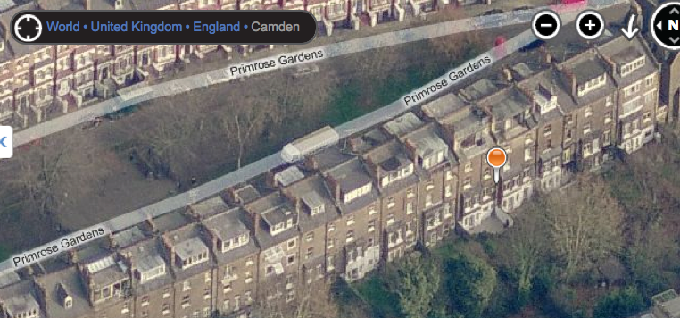

Precedent:
What I am proposing is quite a bit less than already exists at neighbouring properties. The property immediately next door (11 Primrose Gardens), have a staircase and rail installed as can be seen in the supporting photographs below:
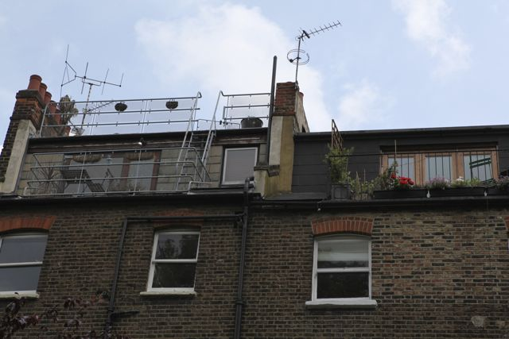

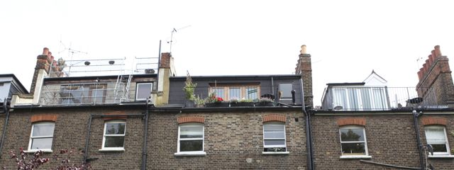

What I propose is almost exactly the same as is next door, except a slightly safer design.

Also, further up the road, at 31,35, 41, 43, 51 Primrose Gardens, all look to have greater developments on the upper roof level than I propose. As show below in the screen grabs from Bling maps below:
31 Primrose Gardens (Rail to the rear):
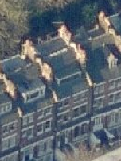

35 Primrose Gardens (Roof Terrace):
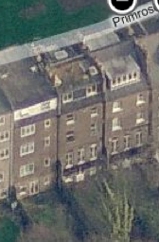

51 Primrose Gardens (Roof Terrace):
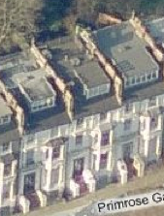

No 41 Primrose Gardens in particular has an extensive roof terrace development as shown in the aerial photo below and in the view from the front of the property, also below:
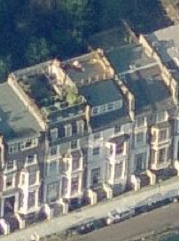

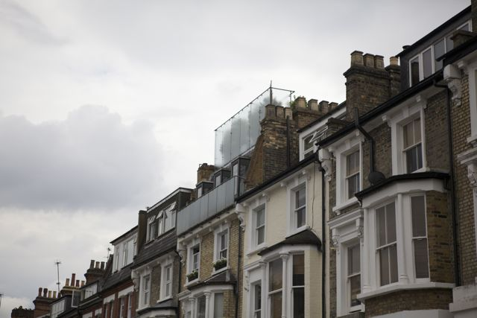

Consequently, I would hope that as many others in close proximity to my property have installed entire roof terraces, that my proposal for an access staircase for maintenance might be looked at as a less substantial proposition.
Widening of balcony:
The work would also involve a slight widening of the existing balcony, so as to approximate the appearance of the balcony at no 7 Primrose Gardens, as shown in the photo below:

Overlooking:
I understand that this is an important issue where extensions are concerned. The existing external balcony overlooks the gardens below at present. The occasional use of the small area of flat roof above, would not in my view increase this overlooking to any significant degree. The only difference it seems is that you are about 6 ft higher, with almost exactly the same overlooking perspective. In addition, the views to the left and right are obscured by the party walls on either side of the property.

I am flexible over the plans and design of the proposed works, so if there are any alterations that need to be made in order for the plans to comply with planning regulations that I have omitted so far then please do let me know.

