Dear Victoria / Alan,
As requested under the Listed Building Consent consent (condition 3) for 6 New Square (2011/4072) at Lincoln’s Inn (attached for ease of reference) for bressummer strengthening works, please find attached the following information):
- 2 pdf’s showing the timber strengthening experience of the specialist timber repair contractor, RG Services.
- Our construction structural drawings for the project (as agreed under the consent).
- R G Services method statement.
- The main contractor’s method statement (Rise Contracts).
The main contractor is starting work this Saturday and the 1st slot into a bressummer will be cut at 7.30am on Monday morning.
Recently some more investigations have been carried out on site and all ceilings appear to be plaster board without historic ceilings hidden above.
Please do not hesitate to contact me if you have any queries.
Regards,
Robert Dean
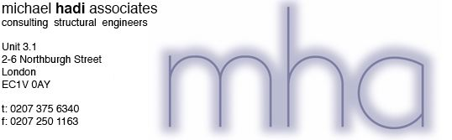
www.mha-consult.co.uk
Registered in England and Wales
Company No. 04718155
This email and any attached files are confidential and intended solely for the use of the addressee. Please advise us
by return if, inadvertently, you receive this email and destroy all copies. Although the e-mail and any attachments are
believed to be virus free we accept no responsibility for damage caused by viruses.

