Planning Application: Design and Access Statement

Brief Outline

I am submitting an application for planning permission to convert a 1-2 foot loft (that currently lies above our two bedroom top floor flat) into a one bedroom flat. My father currently owns the whole of the third floor, with a 140 year lease and a small loft space that we would like to build into and above it whilst respecting the architecture around and making the extension fit considerably better with the surrounding buildings. Pictures of the exiting space here below.
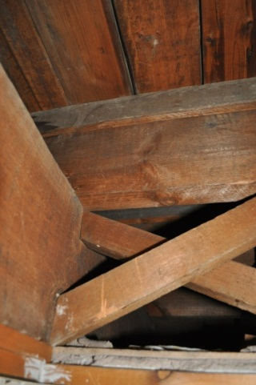
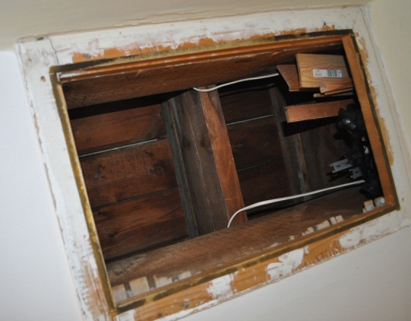

< Entrance to loft from
flat 5 living room

> Existing Loft
(53 cm deep)

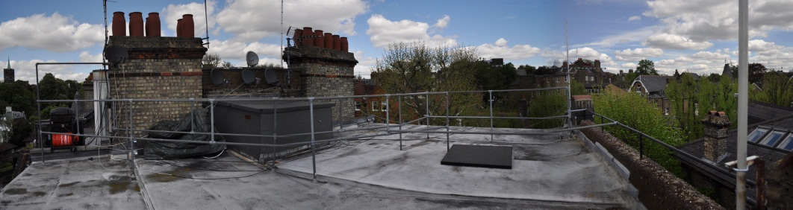
Picture of roof before

Planning Submitted

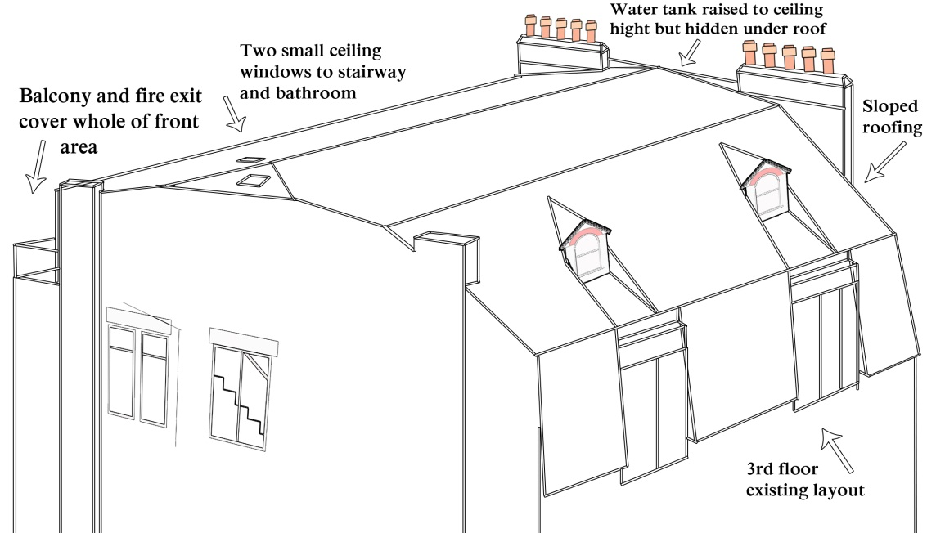

Detailed Description of Proposal

The new space will have sloped ceilings, a balcony and two protruding windows (See page 2). We will remove the dirty flat roof that currently leaks every few years and replace it with a smart slated sloped roof that would not be seen much from the road, and will better match the surrounding buildings. All the houses on our road have wooden slashed window and a sloping roof (see Location Plan and Pictures document for Pictures) In order to make our roof design similar to them we will need to have a sloped roof too.

The maximum height of the extended the roof will be 210cm (see page 5,6,7 &8) in the middle and the height should not need to go any higher than the exciting middle wall because we already have a small loft that we can build down into and prevent the plan from extending any higher than it needs to. The roof will slope down at the front of the property so that it meets the top of the exiting roof. Having the roof like this should mean that only a small amount of the new roof should be seen from the road. Room 1 (underneath the front sloped roof) will make the most of any space and will end when the wall is 3 feet high (Page 1). The roof on the back of the property will also be sloped, but not as much as the front, as this part of the house cannot be seen from the road. The room underneath the back part of the property will be 180cm at the edge and 200cm in the middle..

The chimneys on the inside of the building can stay as they are, but the two chimneys on the outer side of the building will need to be raised by 4-5 feet (they are already 2 foot high) (page 5,6&7). Once this change has been made long metal structures can go across the width of the building to support the new sloped roof and water tank.

This new area will create a room space for a one bedroomed flat, but because of the sloped roofs and balcony it will not be as big as the flats below it and will much have lower ceilings.

The proposals also builds in a new flight of stairs in the space above the exiting staircase and this will continue up on the outer edge of the wall and to lead to a hallway with fire exit door (leading to the balcony) at the end of it. (Page 2)

Design an Access Statement

14 Ellerdale Road is a semi-detached late Victorian house consisting of five flats, which was once one complete residential house. The house aims to impress by towering upwards and showing of its height and thick yellow London brick walls. The nicest thing about the building that it is situated on a hill and has some very impressive views, views which only houses on our side of the street can see as the houses this side were purposely made high so that they can make the most of the site. Our building currently does not make the most of this feature, as the space at the top is never used and access to it is too dangerous.

As there are properties to the right and left of the building I have not added any windows to this side of the property, so that the buildings to the left should not be concerned about any new windows that could over look into their property. (Page 7)

The building face mirrors the one to the right and to the left is another two buildings of a similar style (See ‘Location Plan and Pictures’ Document). Although the front of the buildings is very similar all have completely different roof tops and all the other buildings on the street are quite different in every way, but they all have a sloped roof and wooden slashed windows… all the houses except our property that is. Our roof (built in the 40’s) just ends (unfinished) at the top. A sloped roof is important for it finishes the building off and makes it look far grander and true to its character. Having a sloped roof will also make the most of the unused space, without being seen too much from the road. It will also restore the building to how a typical late Victorian property should look with semi-circular doll house styled protruding windows that match the building next door and many of the other properties in the area. See ‘Location Plan and Pictures’ to see detailed pictures of other house on our street to more info on what other house have done)

The roof to the right is sloped at the front, flat for parts of the back and it also has a 4th floor conservatory where the stair case to the roof lies (Page 3 in ‘Location Plan and Pictures’ Document). The two semi-detached buildings to the left: one has a sloped roof with protruding windows on one side and has four protruding windows (one to the front and three to the side) and a small 4th floor conservatory room near the chimney (Page 5 in ‘Location Plan and Pictures’ Document)..

Our roof currently looks dirty, unsafe and abandoned…(page 1 on this document) not something that you would expect to see in a nice area like Hampstead (but the next door neighbour thinks it makes a good bike shed…), the roof also leaks and has caused much damage to our ceiling in the past. It has to be replaced every 10 years, which is expensive for the house. The property (when first built) would have had a sloped roof, but this went a long ago… The positive out come to this is that there is now an amazing view and plot of space for a penthouse suit that will round off the building and give it a finishing touch that currently it does not have (Page 8).

Another great thing about the properties to right and left are their protruding arched wooden slashed windows at the top of the house; however, this no longer exists within our property. Which is something I would love to bring back to the house. This will enhance the house and bring back its original doll house quality.

If you are still hesitant to the approval we can also agree to replace the cheap aluminium windows on the 3rd floor flat and replace them with wooden slash windows that would better match all the houses around.

Fire Exit

None of the plans will affect the entrance of the property, vehicle access or parking. The conversion only affects the unused flat roof, the water tank and the existing fire exit. This fire exit is important, so in order to keep the fire exit I have included in the new plan a proper fire exit, which includes a proper staircase that leads up to the fire door. From the fire door I have had to leave a small portion of the roof exactly how it currently is so that this balcony can act as a fire exit to lead people safely to the building next door and vice versa if there was a fire next door to lead neighbours along the balcony to exit from our house, so a proper fire exit staircase would be of benefit to all the occupants in our building and of the flats next door. This plan is better than the existing wobbly ladder and square ceiling exit. A window will be added to the fire door for any occupant who wants to make the most of the house.

The new construction will also create a safer home with a proper fire exit and a safer way to check on the water tank. The worst thing about the property is that the fire exit is so dangerous (2nd image on Page 8). I have lived in the property all my life and as a child I loved going onto the roof and never thought about how dangerous it actually was to climb up a wobbly ladder and go on a windy roof with badly built banisters. My dad two months ago fell off this wobbly ladder and over the balcony on the 3rd floor down to the steps on the 2nd floor level. He was put on a stretcher and raced to hospital by ambulance. It could easily have been serious than it was due to his ages and the fact that he hit his head on the wall leaving a nasty dent in the wall. A proper stair case to the roof and water tank is really needed to prevent any future accidents. The house wants this change, but many flats will not pay for their share of the construction, but if I get permission to convert I will happily pay for everything.

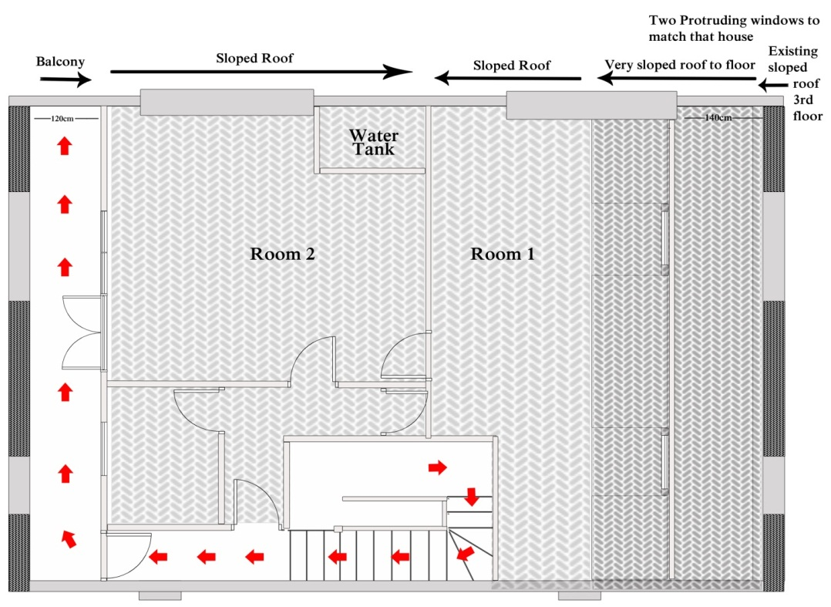
The New Fire Exit >

The Site

The flat will be; Flat six on the 4th floor of 14 Ellerdale Road (Page 10). We could have the entrance to the extension leading from the middle of our flat as another option, but the new building will block the old fire exit and so a staircase from the main stairway of the house needs to be added to create a new and better fire exit (see page 2). Since this exit is required it would make sense, therefore, to have an entrance to the extension there… but a second staircase joining our two flats could be included, if required. Currently our flat (flat five) has a 140 year lease and our flat includes a 1-2' loft. The entrance to this loft is currently in our living room. The conversion will be built directly above flat five and will use the existing loft space to decrease the height as much as possible.

There are four other flats below us and all have been notified of what I plan to do. The lower ground floor (garden) flat has its own front door and so will not be affected and the other three flats not affected much because the only shared space that we will change will be the fire exit and in return we will provide them a much better and safer fire exit, with an extra 4th floor corridor that leads onto a balcony.

Trees
There are two big trees to the front of the house where the road is and one big tree to the back in our garden… no tree speeds into the area considered, so they will not affect the building… but having this balcony could help as an easy way of trimming the trees without needing to pay for a tree cutter to climb all the way to the top via the tree.
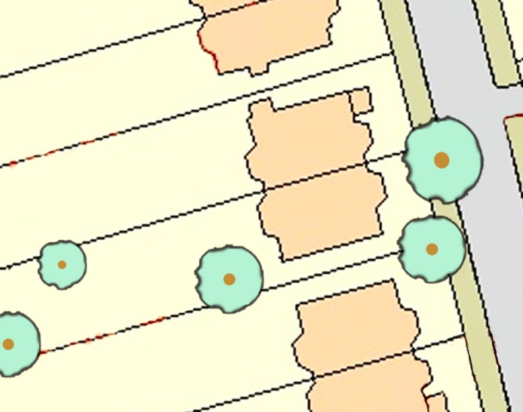

Reasons why the plan should be approved:

- A flat roof needs to be replaced far more often than a sloped roof, so the build would be much more cost effective for the neighbours in our building, of whom many are already struggling to pay for the high maintenance of the building.
- The flat roof was replaced 10 years ago and cracks caused by the rain to our living room ceiling are already starting to come back.
- Our flat roof is nothing like any other building in our street.
- A sloped roof, with arched rounded windows, would enhance the street.
- The other tenants would benefit because any hallway cleaning or future building repairs and costs would be divided into more divisions.
- The fire exit is very dangerous how it is and my dad recently even fell off the current metal pull down ladder and had to be taken to the emergency services at St Mary’s Hospital because of it.
- The fire door will benefit people in our building and the building next door.
- Next door also have a similar exit/entrance to their roof.
- The water tank is very old fashioned and has not been changed since….… we will agree to cover all costs in constructing a new one with modern materials.
- Hampstead is very popular and so there is a need for more accommodation here.

