Rear Elevation of 147

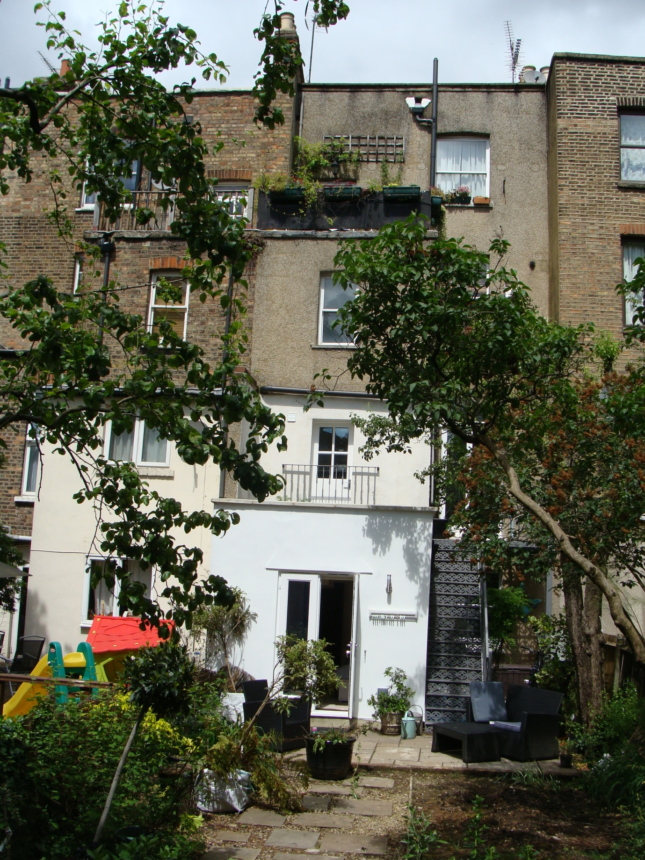

Balcony on 155
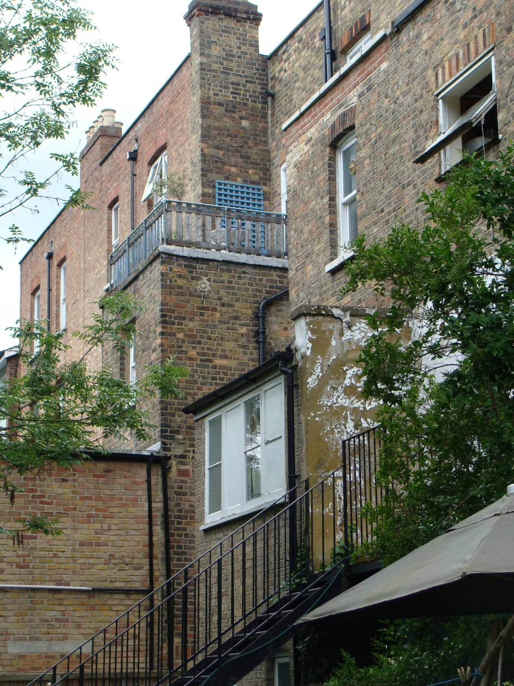
Recessed flat roof for proposed roof terrace. Erect railing from bathroom wall of 147 to wall of 145. Replace existing window with French doors and transom widow.
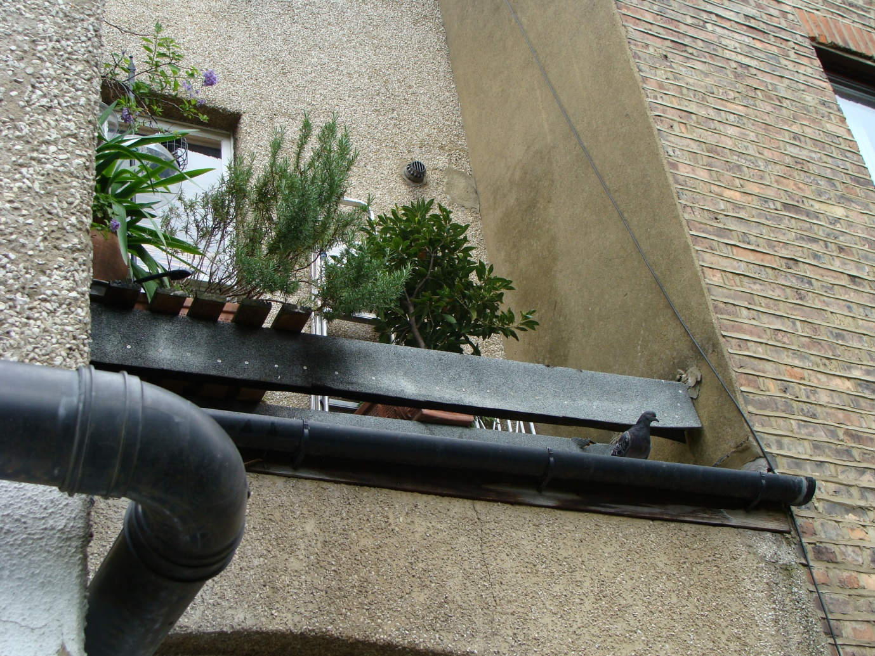

Recessed Flat roof for proposed terrace above French doors and stair landing of 147a. Proposed French doors and transom window to match 147a.
