DESIGN AND ACCESS STATEMENT
10TH June 2012
147 Goldhurst Terrace, NW6 3EU
DESIGN AND ACCESS STATEMENT
The design process
147 Goldhurst Terrace is a maisonette, comprising the first and second floors, of a mid terrace four story building, within a conservation area.
At present the layout is structured with the kitchen on the rear of the property which faces South. There is a small flat roof outside the kitchen window. The adjacent property 145 protrudes out so the flat roof has a wall on this side. The rear of 147 also extends out for the bathroom so the roof is surrounded by 3 walls.
Alteration of kitchen window to provide access to existing recessed rear flat roof. Erection of a metal railings across the width of the roof to use as terrace as shown on four unnumbered drawings named '1st Floor Plan as is', ‘1st Floor Plan proposed’, 'Rear elevations', and ‘Location plan’. As the roof is recessed the flat roof is in line with the adjoining property 145. There is no blockage light for the adjoining property at 145 Goldhurst Terrace. The Bathroom of 147 extends further out and there is no view of the property of 149 therefore no privacy issue. There is a tree in the garden of 147 which prevents overlooking of the gardens of 145 and 147. There is no change in the rear elevation.
Amount of development
It is proposed to install French doors in place of the existing kitchen window. Install a metal railing from the wall of the bathroom of 147 to the existing wall of 149.
Use – As a small terrace.
Trees – No trees will be affected
Precedents:
147a has installed French doors with a transom window with stars and landing towards the garden as part of redesign of the property. Ref application 2011/4604/p
147 has French doors with a transom window onto its roof terrace. Ref application no: 9005216
149 and 155 has doors onto their roof terrace.
Layout- No change to internal layout.
Scale – Not applicable
Appearance – The French Doors and railings will be the same design and specifications for the existing French doors and railing. They doors will be constructed in Wood and the railings in Metal.
Externally - There is no proposed change to the front elevation or the rear elevation.
Internally – No changes
Landscaping – Not applicable
Access – No changes to the main access

1st floor plan As Is
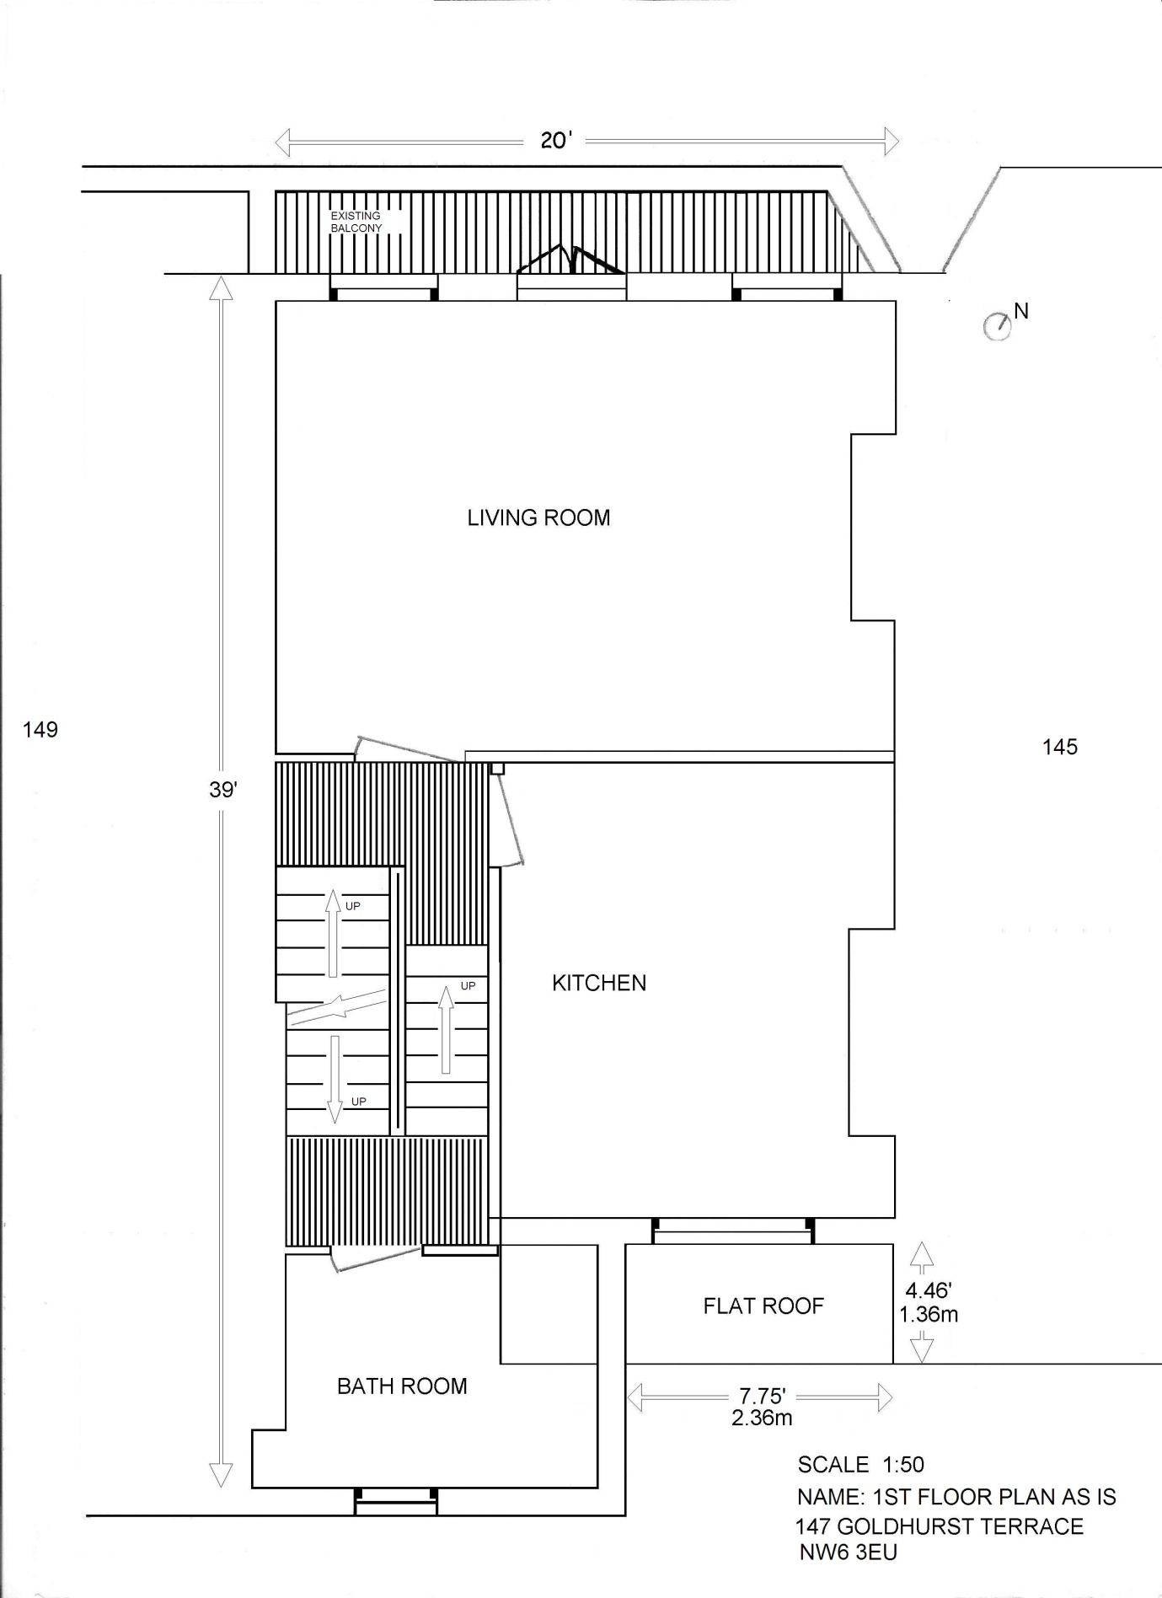

1st Floor Plan Proposed
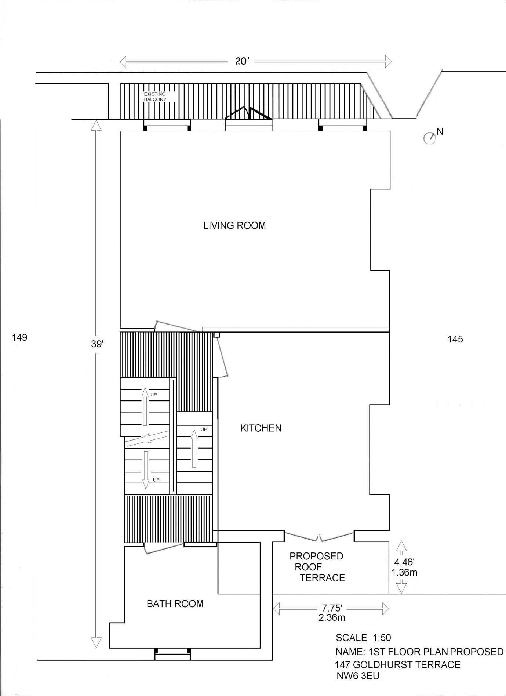

Rear Elevations
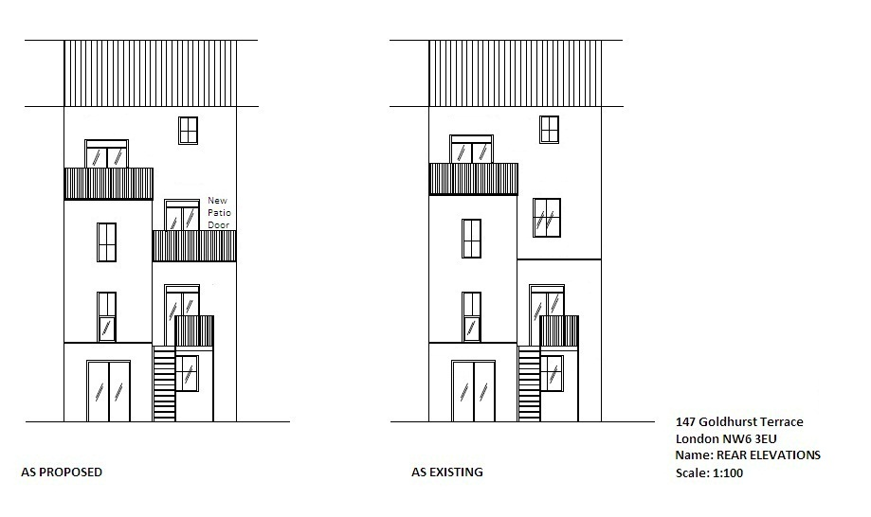

Location
