Treescapes
40 Chimes Avenue
Palmers Green
LONDON
N13 5HX
40 Chimes Avenue  Palmers Green  LONDON  N13 5HX |  | Application Ref: 2012/3980/T
 |  | Please ask for: Tom Little
 |  | Telephone: 020 7974 5283
 |  | 30 July 2026

Dear Sir/Madam

DECISION

Town and Country Planning Acts 1990 (as amended)
NO OBJECTION TO SECTION 211 NOTICE OF WORKS TO TREE/S IN A CONSERVATION AREA

Address:
8 Belsize Park
London
NW3 4ET

Proposed Work:
REAR GARDEN: 1 x Wingnut - Reduce to previous reduction points.
(tree species amended following email from Jamie Ryan 30/07/2012)

The Council has considered your notification of intended works to trees dated 30 July 2012 and does not wish to object.

Informative(s):

This notice is valid for 2 years from the date of this letter or until the work is completed, which ever is the sooner.

You are advised that the appropriate standards for tree work are set out in BS 3998: 2010. Failure to ensure that the proposed works are carried out to these standards may result in damage to the tree(s) and may result in legal action by the Council.

Please note that any approval given by the Council does not give an exemption from the requirements to comply with the Wildlife and Countryside Act 1981 (as amended), or any other Acts offering protection to wildlife. Of particular note is the protection offered to bats, birds and their nests, whilst being built or in use. For further information contact Natural England on 0300 060 2634.

Yours faithfully
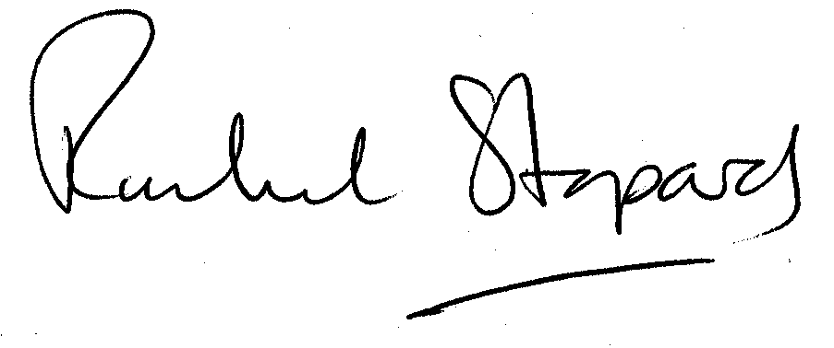
Rachel Stopard
Director of Culture & Environment

It is important to us to find out what our customers think about the service we provide. To help us in this respect, we would be very grateful if you could take a few moments to complete our online survey at the following website address: www.camden.gov.uk/dmfeedback. We will use the information you give us to help improve our services.

