SUPPLEMENTARY AGENDA

Item 5
57-84 & 85-112 MAKEPEACE MANSIONS, MAKEPEACE AVENUE AND 25-54 & 89-112 HOLLY LODGE MANSIONS, OAKESHOTT AVENUE, LONDON, N6 6HD

Clarification
The site location plan on page 95 is incorrect. To clarify the correct site location plan is that found on page 96 (below)
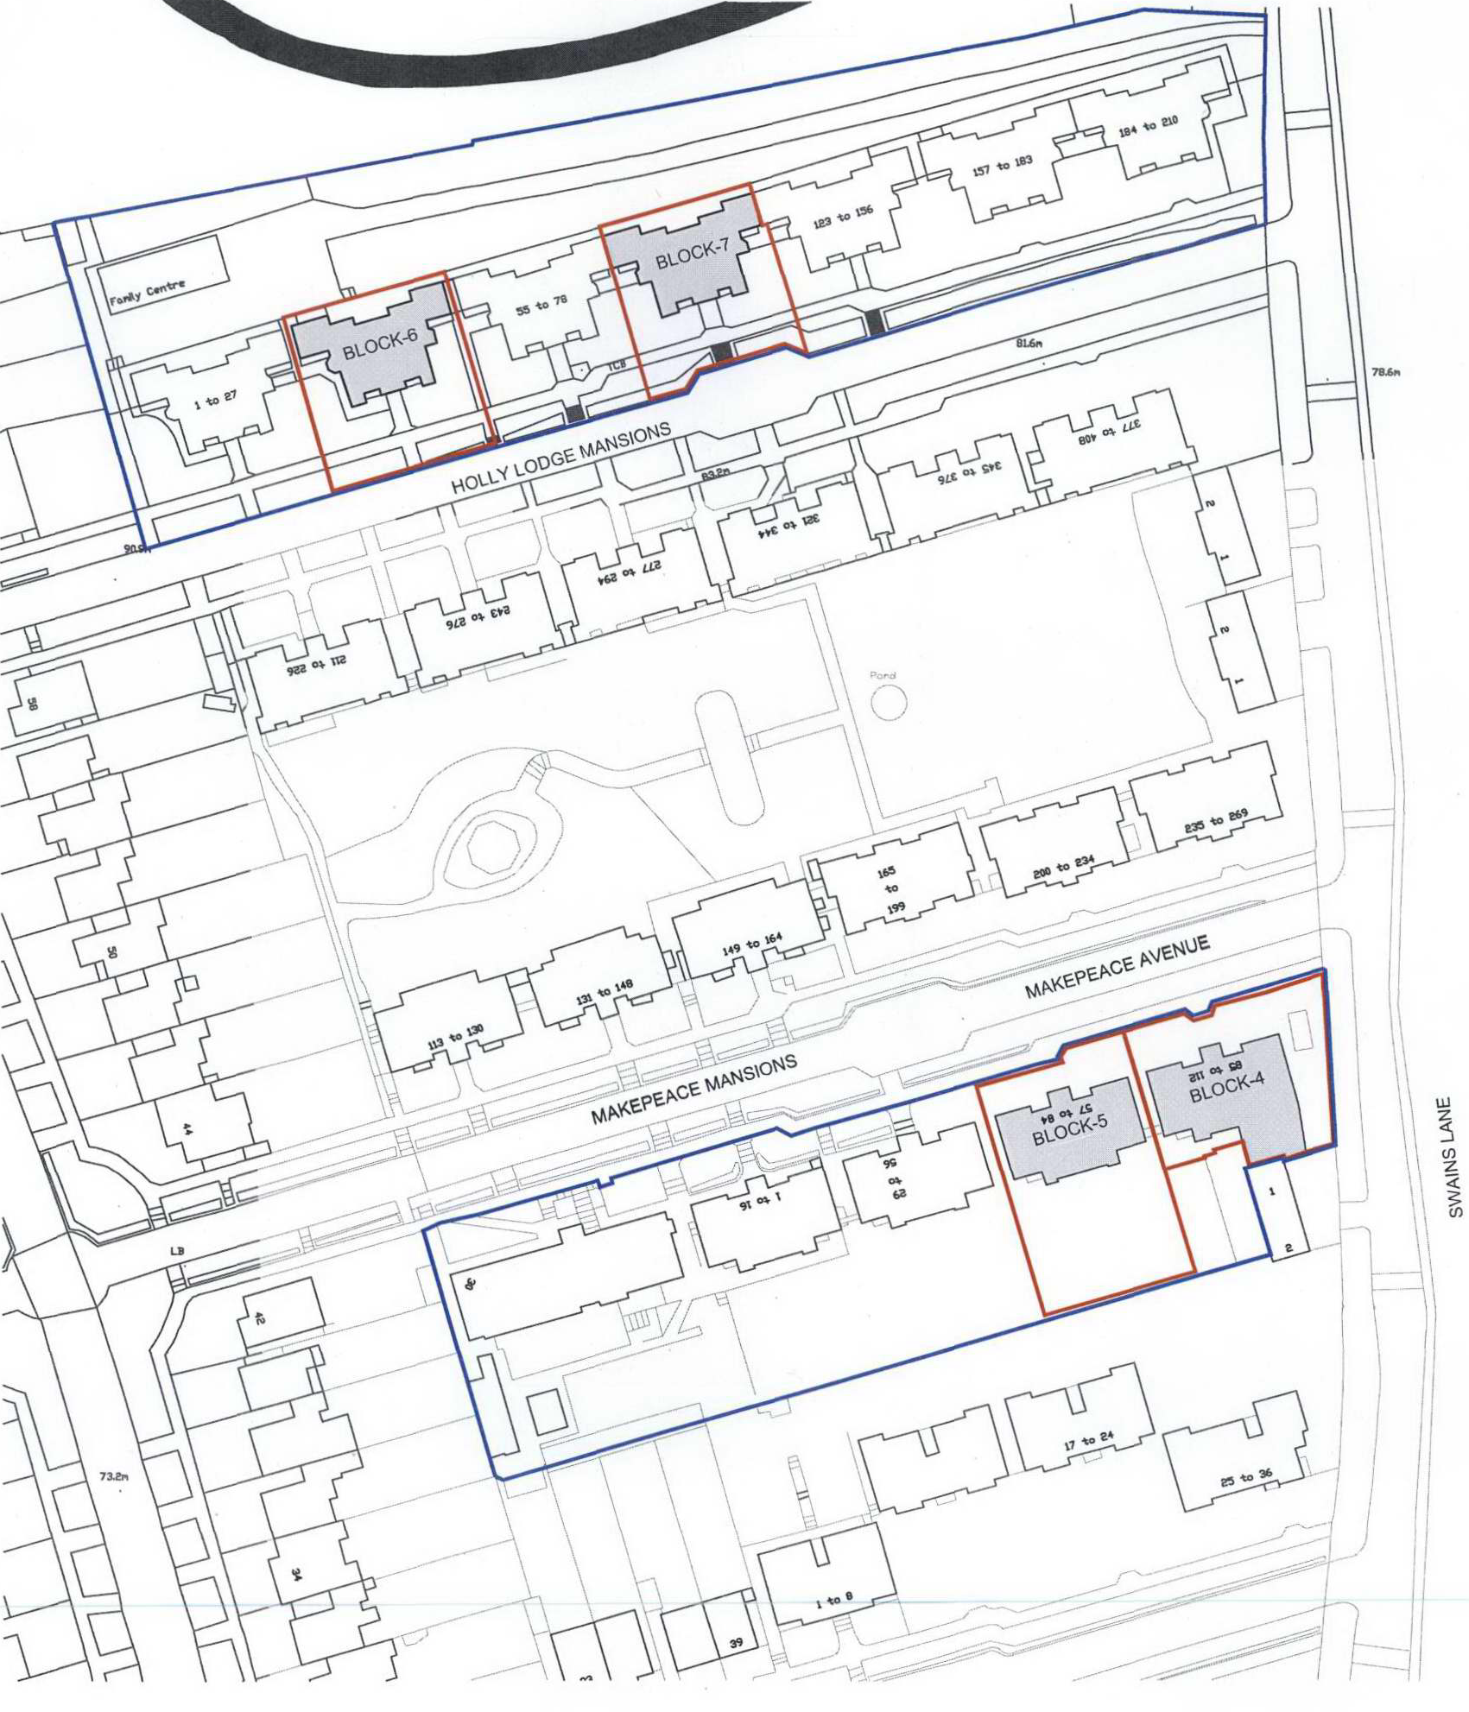
The reason in Condition 7 should refer to community facilities and not education facilities and should therefore read as follows:
“Reason: To ensure that the community facilities in the area can cope with the additional residents in accordance with the requirements of policies CS10 and CS19 of the London Borough of Camden Local Development Framework Core Strategy and policy DP15 of the London Borough of Camden Local Development Framework Development Policies.”

Paragraph 7.22 incorrectly states that the site is within a Controlled Parking Zone.
Consultation responses
The following comments from Cllr de Souza were submitted within the consultation period and are outlined below:
- The conversion of these bedsit flats, combined with earlier and later phases in relation to other bedsit flats on the estate, will increase the need for community facilities for children and other people. It has been many years since all these flats were occupied and when originally built there was more communal space than at present.
- In the circumstances, it is important to ensure there are sufficient facilities for children and other people. This needs to be on the estate because of its isolation being part way up a steep hill and because of the importance of a community centre on site to create/maintain a strong local community. For this reason, I would like to request that there is a condition imposed so that the proposed “section 106 funds” offered by the Housing Dept are earmarked for a new family centre building with play area to replace the temporary family centre building (which the Council regards as being beyond its shelf life). This scheme, developed by the community, offers good value for money and meets the needs of the community. To ensure this centre is built, the condition should state that the flats cannot be occupied until this new building has been constructed and made useable.
- This planning application does not deal with internal works. But I'd like to request that the housing team are asked to refurbish in a manner that maintains as much of the character of the original buildings as possible. Some flats have lost picture rails and other features which residents strongly value.
- I have noted that the application says that some trees will be cut down. I request a full survey of impacts on trees and that the development is conditioned so that it does not involve cutting down mature or semi-mature trees (unless absolutely necessary). This has happened in previous phases of the development and is a justified concern.

Background information
Whilst not a planning matter the applicant has provided the following background information with regard to the offers made to existing leaseholders within the blocks (there are 8):
- Will be offered market value plus up to 10% compensation (also legal fees, removal expenses and stamp duty equivalent to that payable on their current property)
- Will be given an advance marketing opportunity to purchase any of 16 properties within the newly refurbished blocks on the estate currently being completed
- Can receive a higher rate of deposit on their current property should that be required to put a deposit on a new property pending completion of the respective sales
- Can buy under the shared ownership regime
- In cases of hardship may be granted a Council tenancy and be paid a proportion of the market value of the property (25%)

Cycle storage enclosure
Paragraph 7.21 states that there is a requirement for 117 cycle parking spaces as the proposal is for 117 units. This is incorrect as the proposal is for the change of use from 117 bedsit units to 39 self contained units. The requirement is therefore for 39 cycle parking spaces.

The proposed cycle stores to the front/side of blocks 6 and 7 have been removed from the scheme and the proposal is now for the provision of 12 spaces in total (6 to the side of block 4 and 6 to the side of block 5). It is considered that the benefits of the removal of these enclosures and the consequent preservation and enhancement of the conservation area outweigh the fact that the scheme does not provide 39 cycle parking spaces.

Refuse enclosure
The proposed refuse enclosure to the side of block 4 has been amended to be lowered in height from 2.4m to 2.27m. The ground levels have also been verified along with the proposed height of the new boundary fence (approximately 2m) and the drawings have been amended accordingly. The proposed alterations will reduce the scale of the structure and are consequently considered to be acceptable.

Ramp
Paragraph 7.13 states that two of the ground floor units are proposed to be wheelchair units. The proposal has been amended to incorporate a new ramp adjacent to the existing footpath to the main entrance to access this block as there are two steps up to the main entrance. This proposed ramp and associated handrail has been sensitively designed using materials to match the existing path and handrails which are of a simple elegant design. The proposed new ramp is considered to preserve and enhance the conservation area.

