PLANNING APPLICATION
TREE WORKS IN A CA

23 South Grove, London N6 6BB

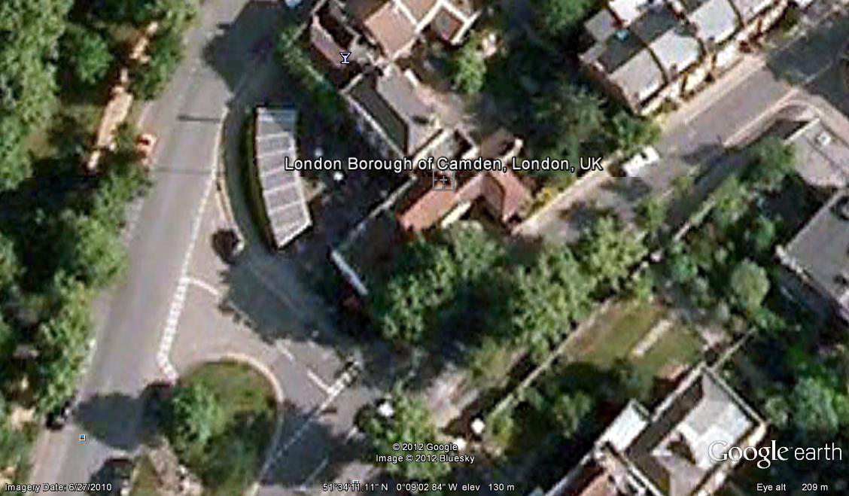

WORKS
Request 30-35% crown reduction to 3 no. Lime trees

