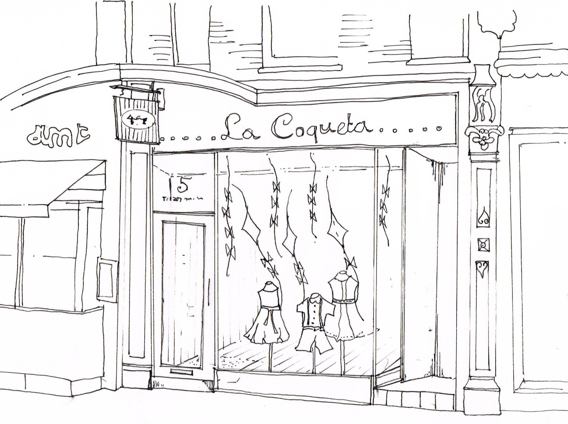

PROPOSED SHOP FRONT SKETCH
5 HEATH STREET HAMPSTEAD NW3 6TP
DWG REF: LC SK01

D GILBEY CONSULTING LTD. T:07787 534682 E;daniellegilbeyuk@aol.com

