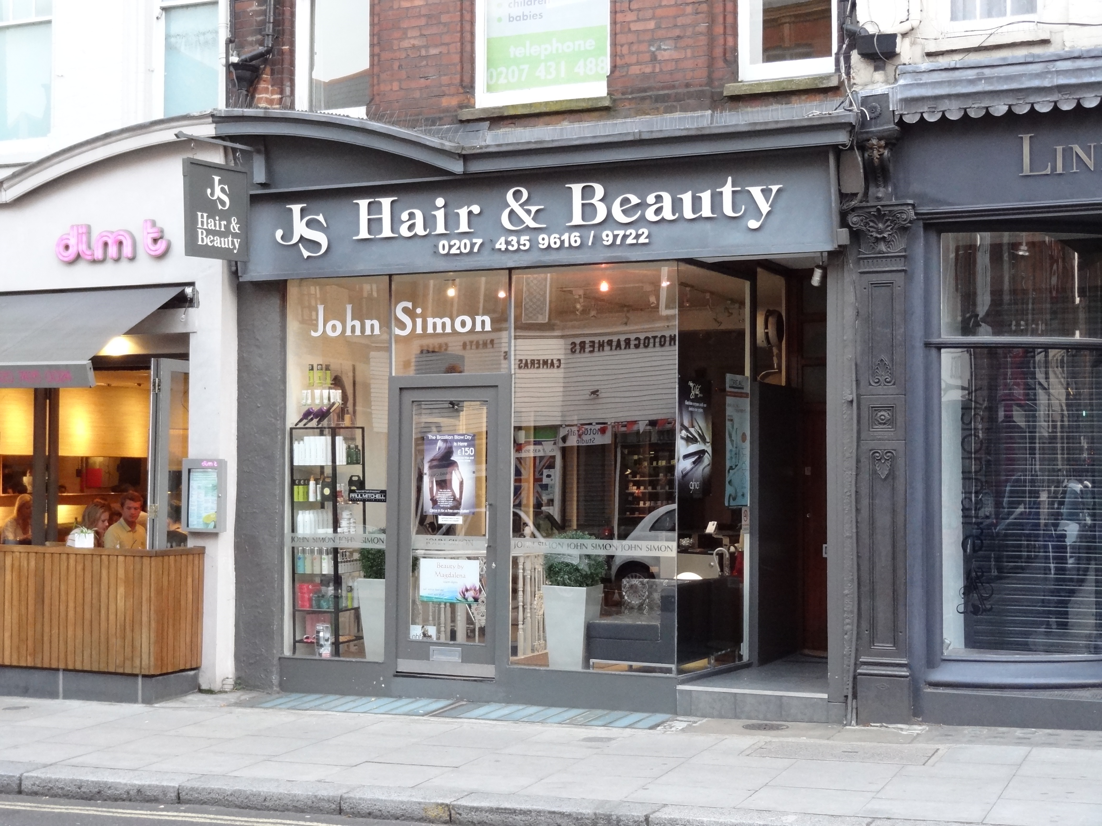

EXISTING SHOP FRONT PHOTOGRAPH
5 HEATH STREET HAMPSTEAD NW3 6TP
DWG REF: LC PHOTO 01

D GILBEY CONSULTING LTD. T:07787 534682 E;daniellegilbeyuk@aol.com

