**Application for Work to Trees at 11 Netherhall Gardens, Hampstead, London NW3 5RN**

**Location Plan: PKS/NTH/TWApp/01**

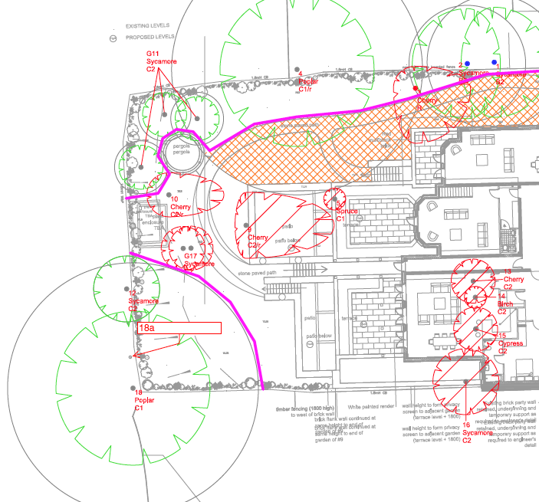

**Works Required:**

**G11** (sycamores) – fell: these sycamores are relics of the scrub woodland that have regenerated in the garden.  They were originally retained as potential screening, but having exposed them by removing surrounding scrub / trees, they are deemed to be poor specimens not fit for purpose. Therefore the applicant wishes to fell and replace them with suitable ornamental native trees.

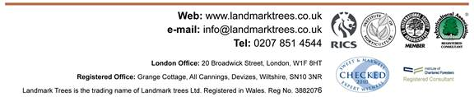**T18a** (lime) - cut back to boundary the overhanging, ivy-smothered limb/stem of 18a lime.