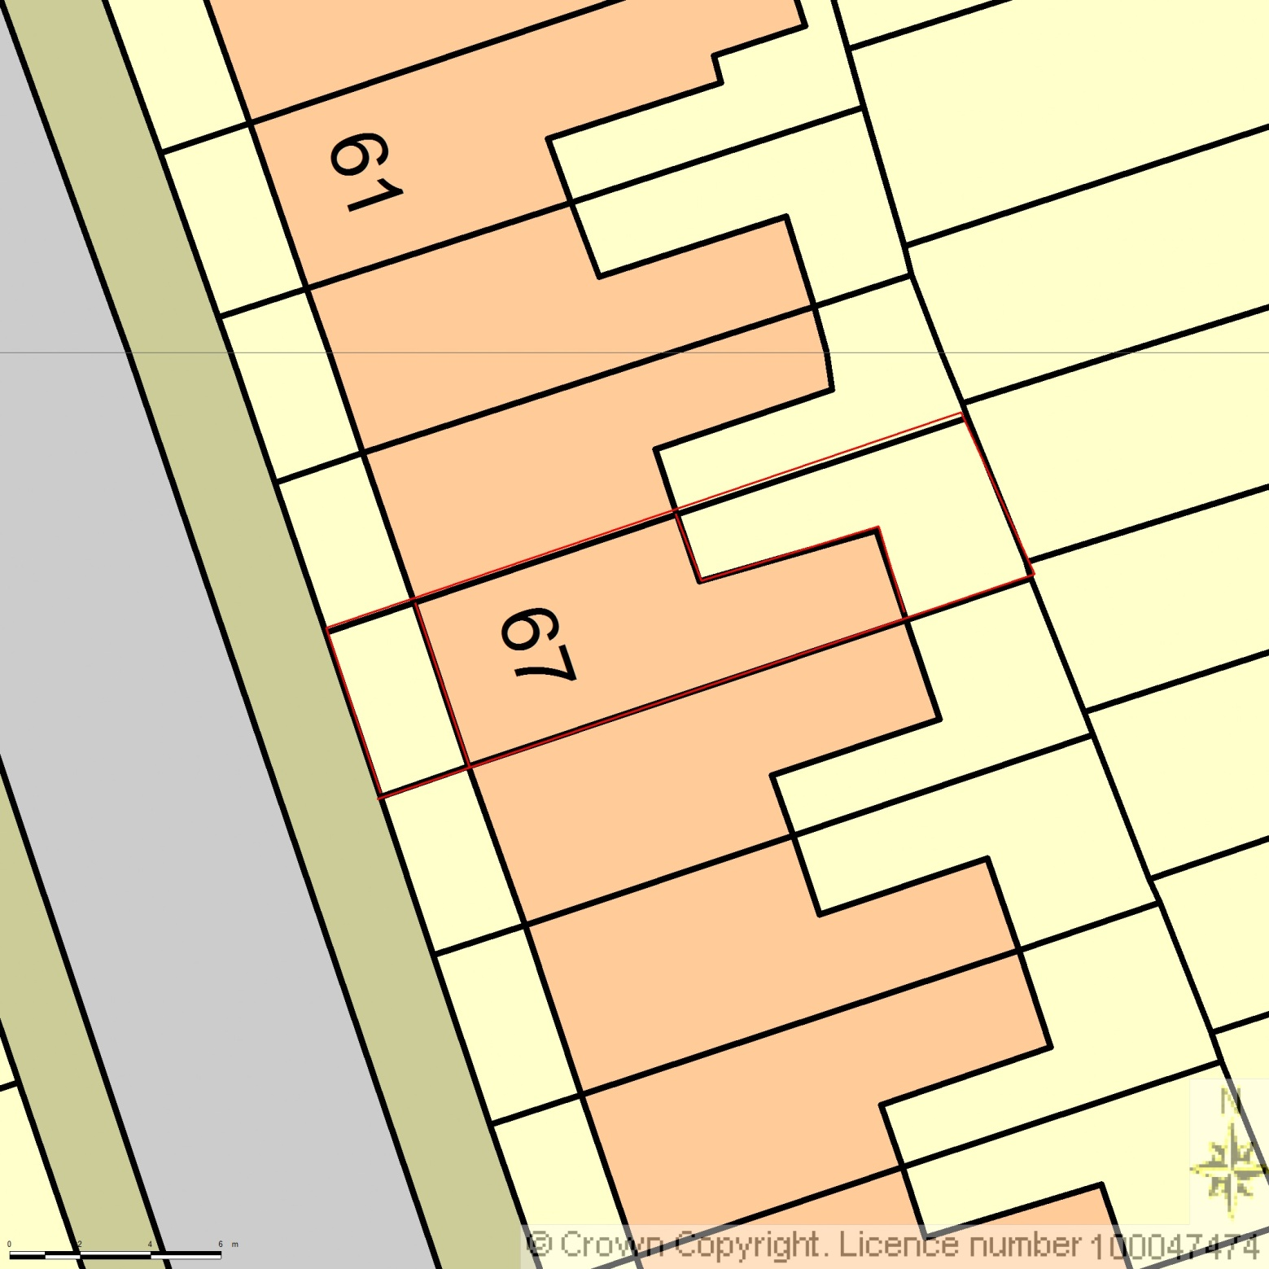
AREA 36m x 36m
SCALE 1:200

CENTRE COORDINATES: 525033, 184992



Supplied by Streetwise Maps Ltd
www.streetwise.net
Licence No: 100047474
30/07/2026 18:32:35

