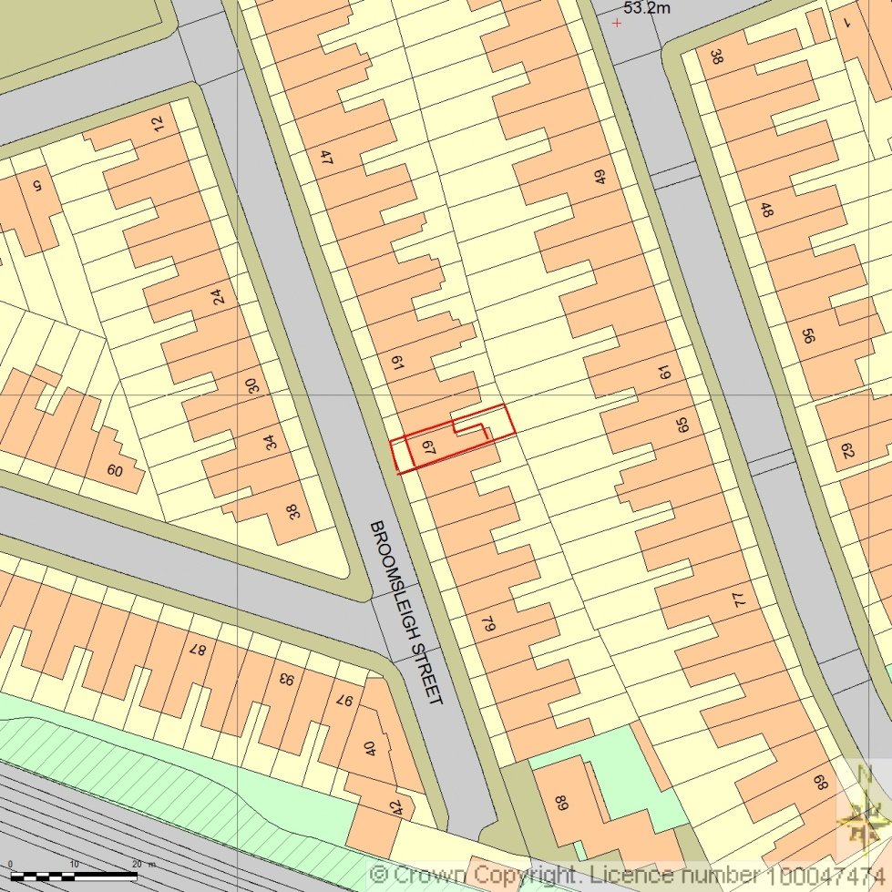
SITE LOCATION PLAN
AREA 2 HA
SCALE 1:1250

CENTRE COORDINATES: 525033, 184992



Supplied by Streetwise Maps Ltd
www.streetwise.net
Licence No: 100047474
31/07/2026 19:26

